Name: ________

Date: ________

Organic Chemistry Practice Exam 3

Questions 1-10: Identify the major organic product for the following reactions

1. 

2. 

3. 

4. 

5. 

6. 

7. 

8. 

9. 

10. 

11. Suppose you are reacting methyl bromide with sodium hydroxide in DMSO. Which of the following changes would cause the rate of the reaction to quadruple:

a. Doing the reaction in half the original volume of solvent

b. increasing the concentration of methyl bromide by a factor of two

c. increasing the concentration of sodium hydroxide by a factor of two

d. increasing both sodium hydroxide and methyl bromide concentration by a factor of two

e. both a and d

f. none of the above

12. Suppose you are an analytical chemistry intern at a major chemical company and are trying to determine the identity of an impurity in a certain product. The desired product has the following functional groups: ketone, alkyne, alkene, and ether. After doing an IR on the mixture, you find that there is a strange peak at 3300 cm-1 that is very strong and broad. What kind of impurity do you suspect is present in the sample? (give general class of molecule)

13. Explain why the Hoffman elimination reaction results in the Hoffman product exclusively on the premise of its transition state. Compare this transition state to the transition state seen in “normal” elimination reactions.

14. Suppose you wanted to perform an SN1 reaction, would water or ethanol be your preferred solvent? Explain your reasoning on the premise of the reaction mechanism. Hint: do not get caught up in the protic vs aprotic schema, this is a more nuanced question.

15. Why do you suspect that secondary alcohols can undergo SN1 reactions much quicker than secondary alkyl halides under acidic conditions?

Questions 16-20: Rank each set of compounds in order of increasing nucleophilicity in DMSO

16. NaSCH3, NaNH2, NaOH

17. NaOAc, NaNH2, Na3PO4

18. NaF, NaCl, NaBr

19. NaOAc, NaF, NaOCOCF3

20. NaOCH3, NaI, NaNH2

Questions 21-25: Rank each set of compounds in order of increasing reactivity with NaOH in DMSO

21. 

22. 

23. 

24. 

25. 

Questions 26-30: Provide a reasonable synthetic route to produce the compounds indicated using carbon-based compound with less than seven carbons and any necessary reagents. The only functional groups that can be in your starting compounds are halides, alcohols, and ethers. Everything else needs to be made from scratch. If you plan to do a Suzuki reaction then you can use any boron-based compound you want as long as the carbon linker abides by the rules above.

26. 

27. 

28. 

29. 

30. 

Questions 31-35: Determine the compound that is most likely to give the IR spectrum shown based off the answer choices.

31. 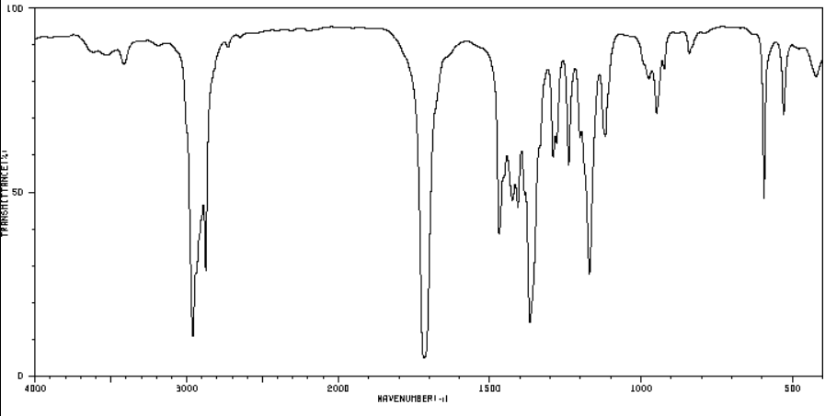

a. 

b. 

c. 

d. 

32. 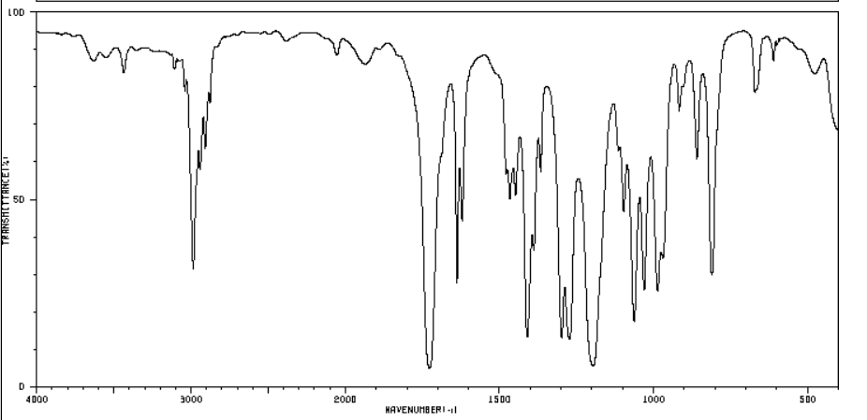

a. 

b. 

c. 

d. 

33. 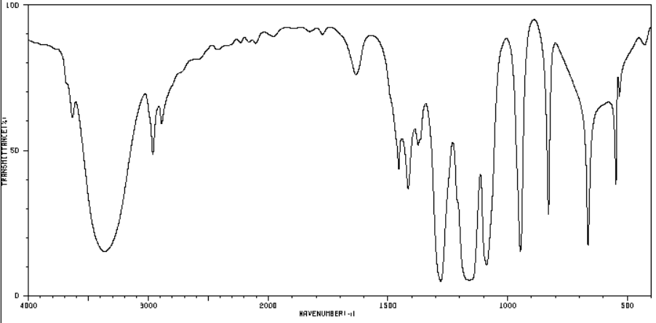

a. 

b. 

c. 

d. 

34. 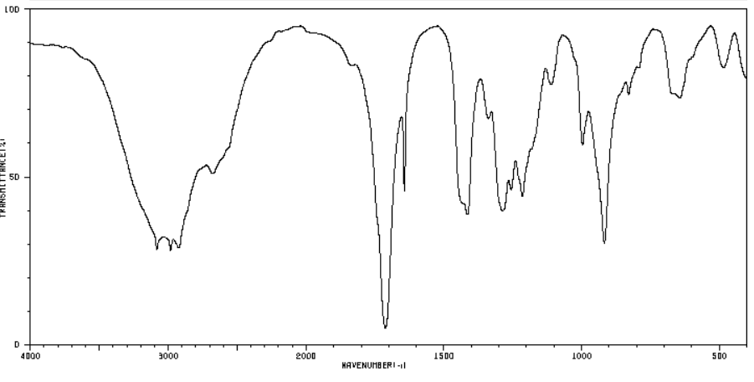

a. 

b. 

c. 

d. 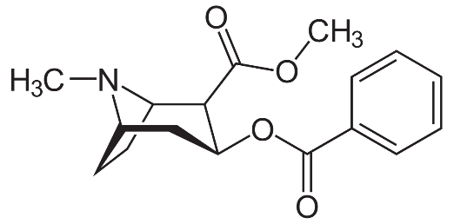

35. 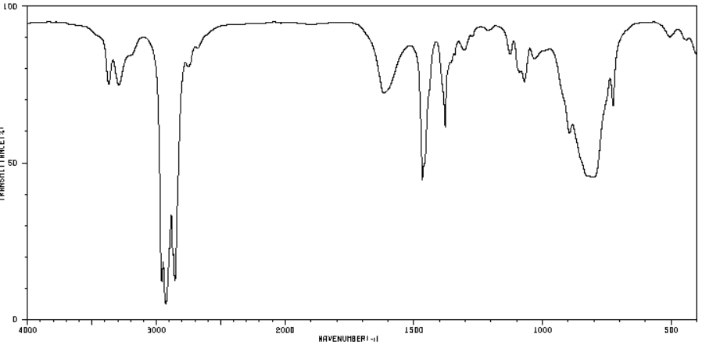

a. 

b. 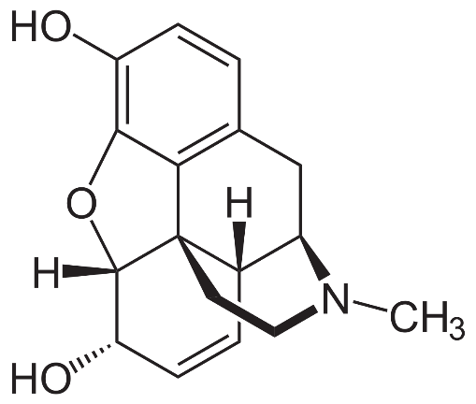

c. 

d. 

Questions 36-39: Determine the compound that is most likely to give the proton and carbon NMR spectrum shown.

36. Molecular formula: C7H16

Proton NMR peaks:

A: 1.378 ppm multiplet (1H)

B: 0.834 ppm singlet (9H)

C: 0.830 ppm doublet (6H)

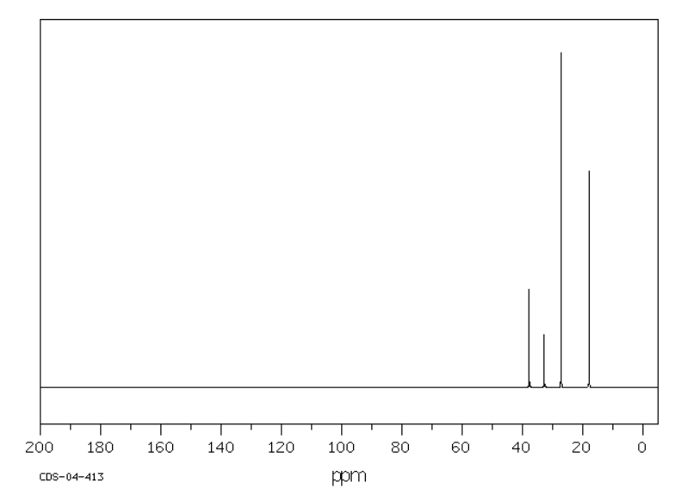

37. molecular formula: C9H13N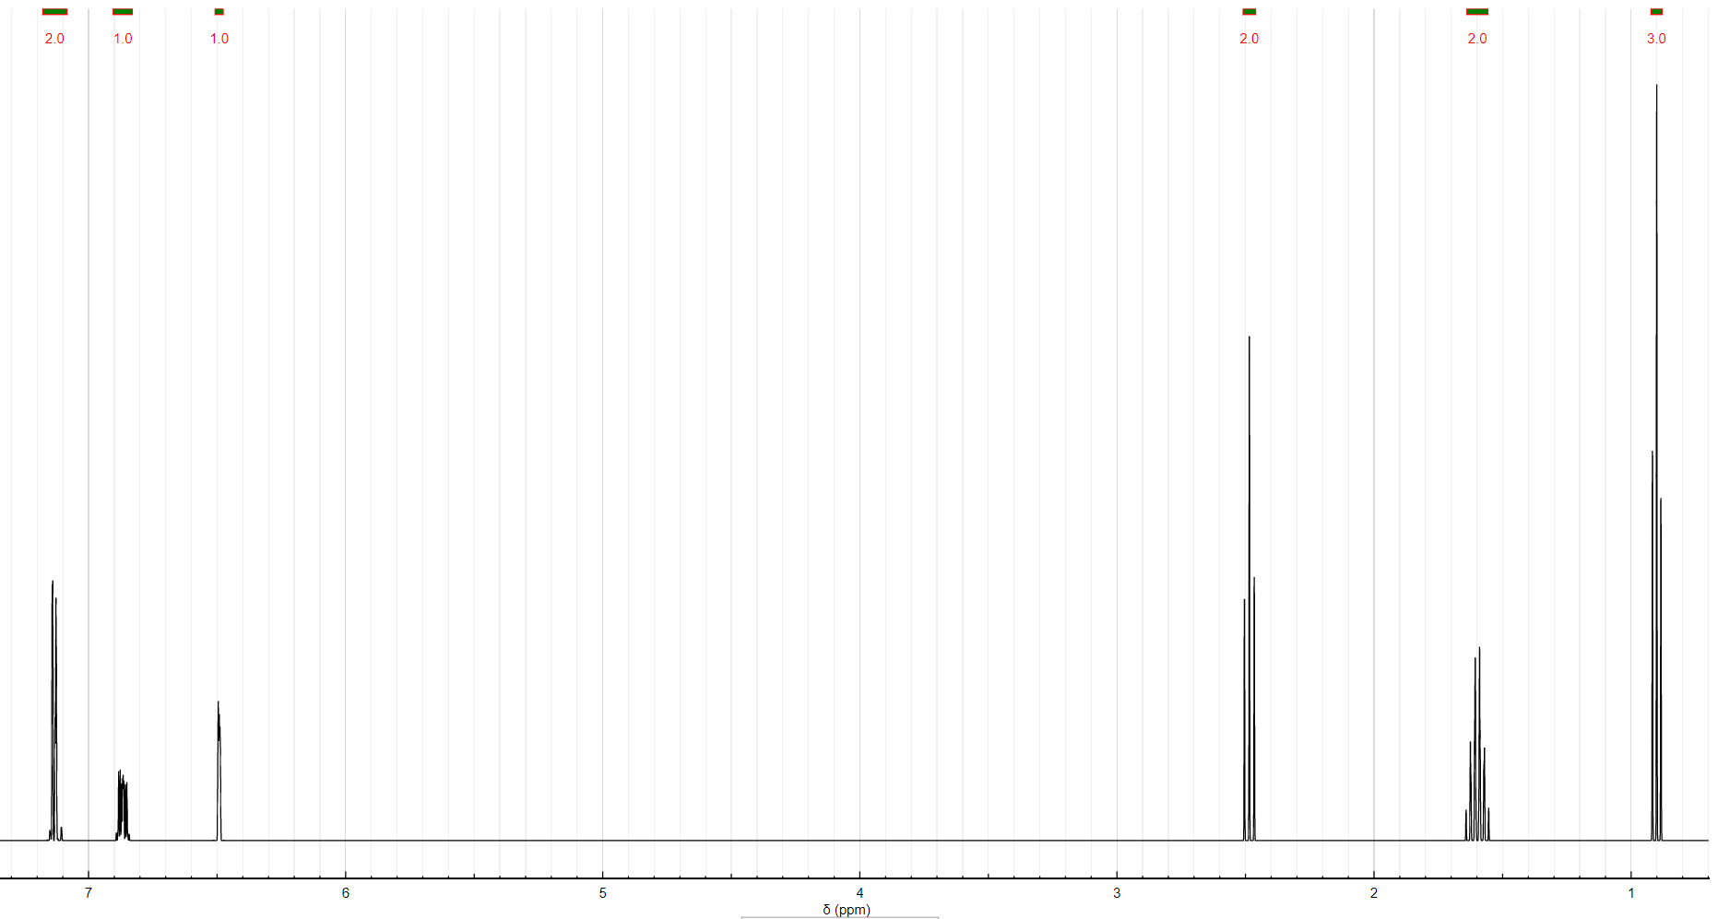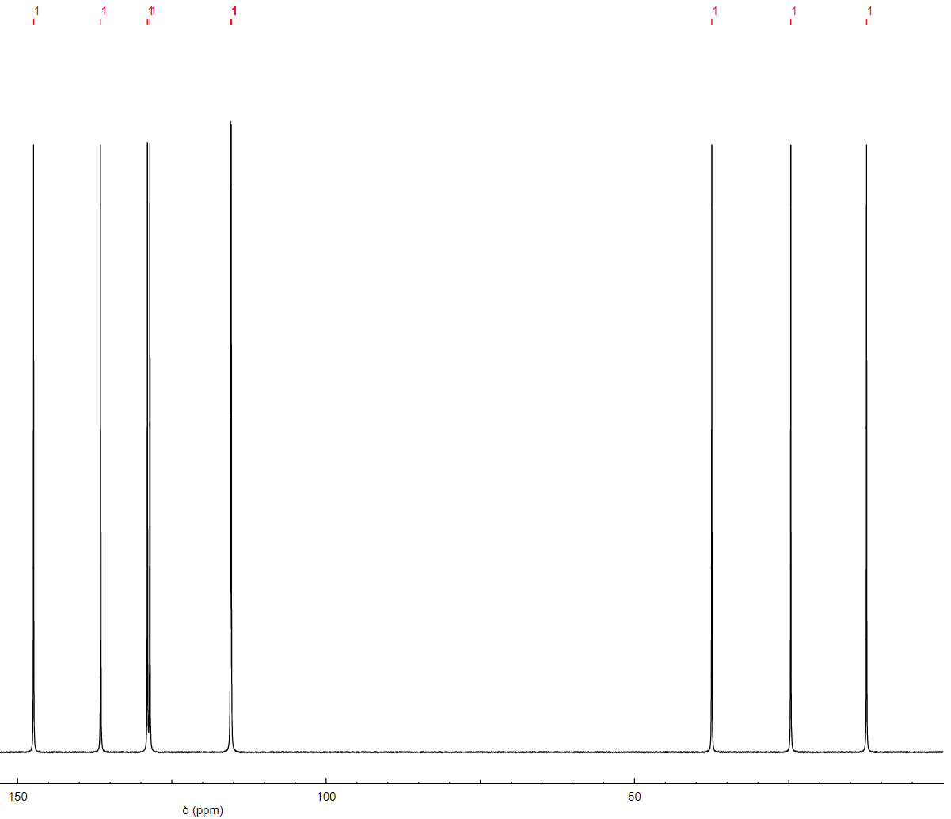

38. C5H12O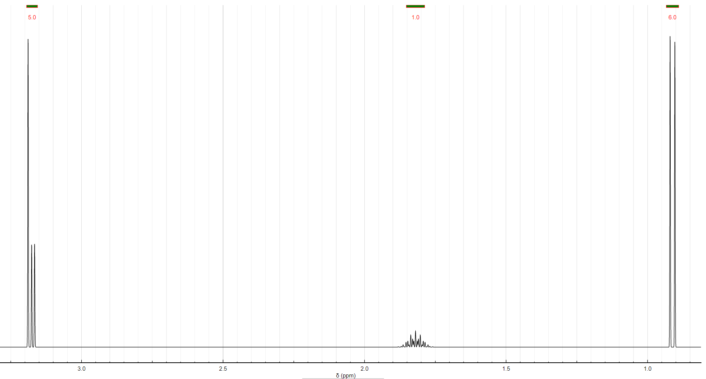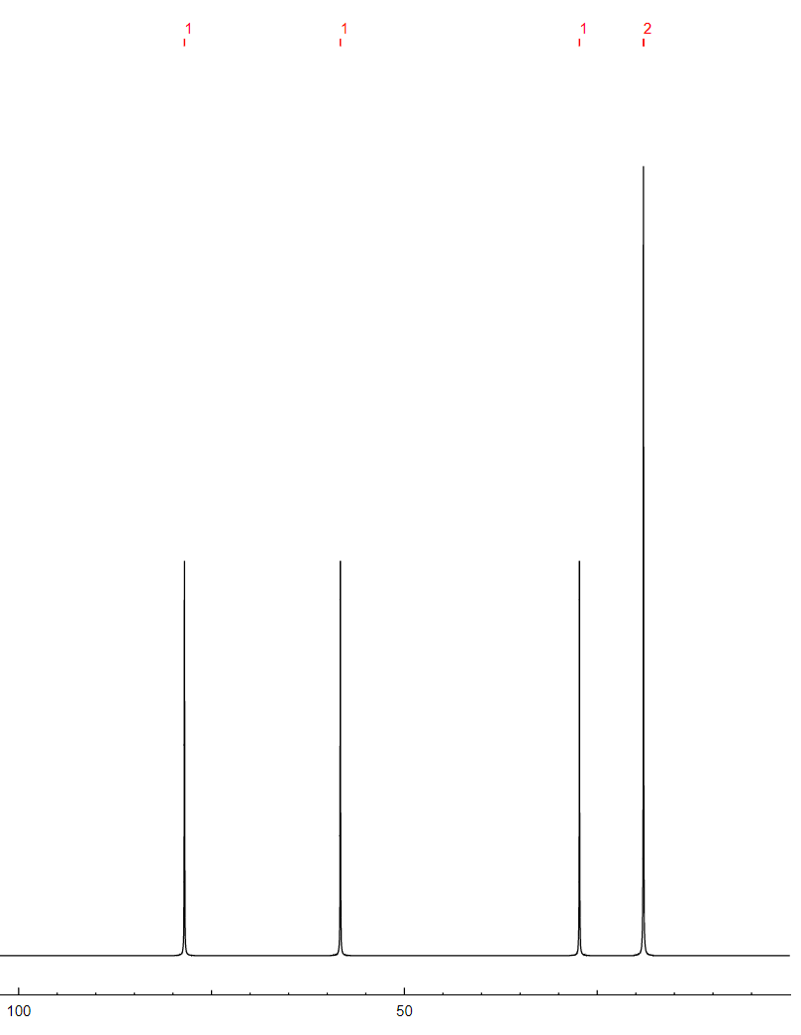

39.C4H7OCl

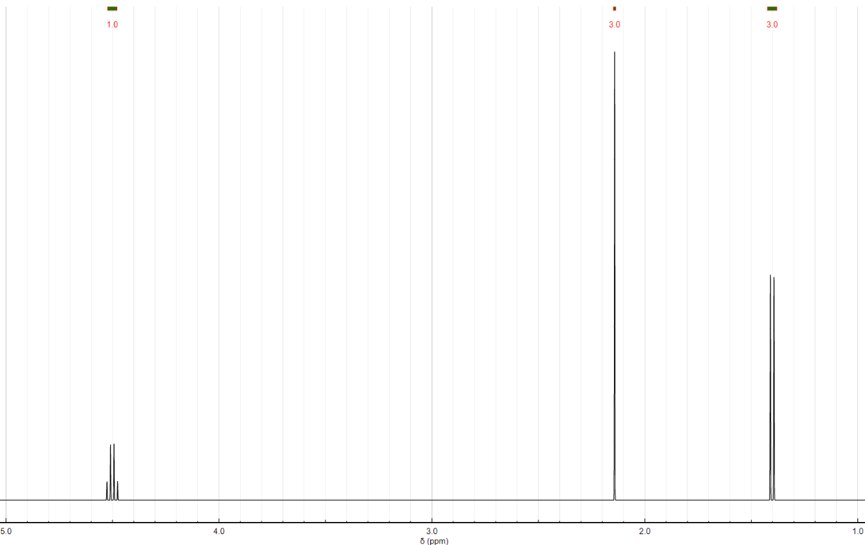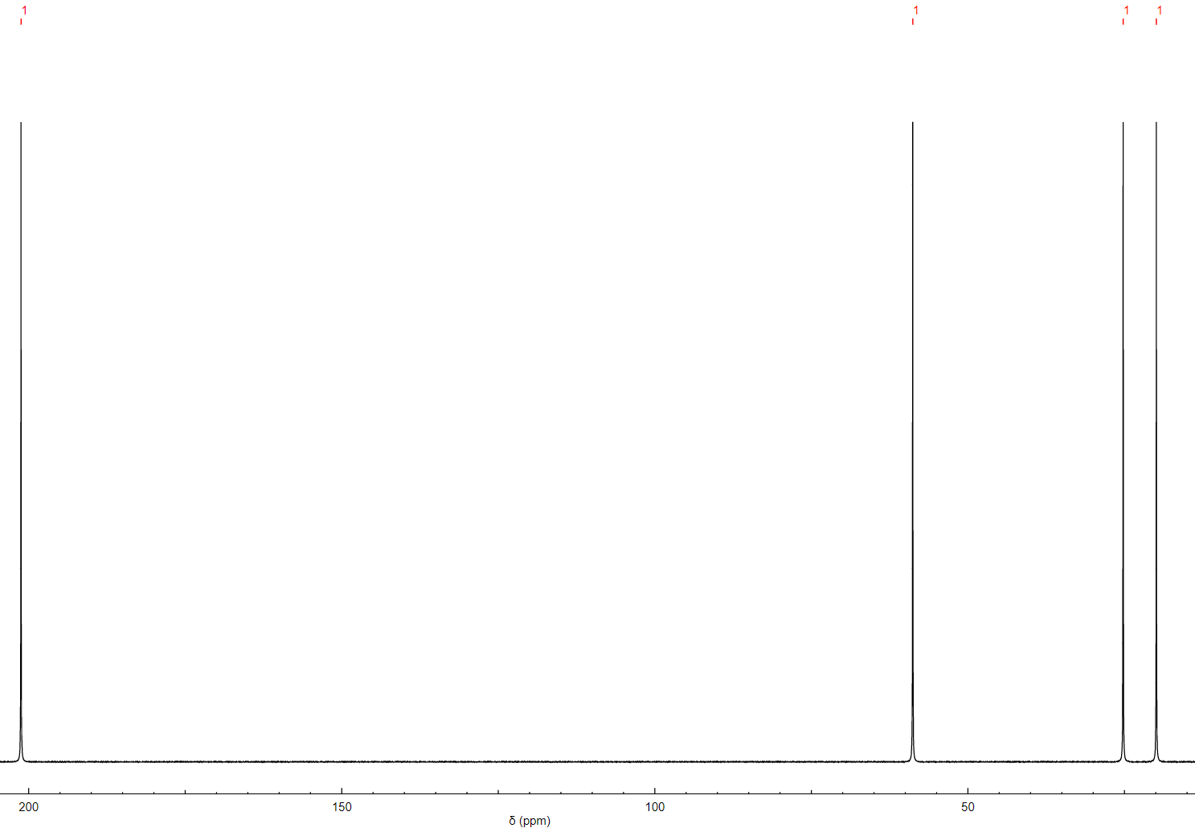

Questions 40-44: Determine the major organic products for the following reactions

40. 

41. 

42. 

43. 

44. 

Questions 45-49: Determine which compound would have a higher lambda max in its UV spectrum and explain your reasoning.

45. 

46. 

47. 

48. 

49. 