Name: ________

Date: ________

Organic Chemistry Practice Exam 3 Answer Key

Questions 1-10: Identify the major organic product for the following reactions

1.  

2.  

3.  

4.  

5.  

6.  

7. 

8.  

9. 

10. 

11. Suppose you are reacting methyl bromide with sodium hydroxide in DMSO. Which of the following changes would cause the rate of the reaction to quadruple: This is an SN2 reaction bc strong nucleophile and polar aprotic solvent and because the alkyl halide is not sterically hindered

a. Doing the reaction in half the original volume of solvent

b. increasing the concentration of methyl bromide by a factor of two

c. increasing the concentration of sodium hydroxide by a factor of two

d. increasing both sodium hydroxide and methyl bromide concentration by a factor of two

e. both a and d

f. none of the above

12. Suppose you are an analytical chemistry intern at a major chemical company and are trying to determine the identity of an impurity in a certain product. The desired product has the following functional groups: ketone, alkyne, alkene, and ether. After doing an IR on the mixture, you find that there is a strange peak at 3300 cm-1 that is very strong and broad. What kind of impurity do you suspect is present in the sample? (give general class of molecule)

This is likely some kind of alcohol impurity because the 3300 cm-1 peak corresponds to the O-H stretching vibration.

13. Explain why the Hoffman elimination reaction results in the Hoffman product exclusively on the premise of its transition state. Compare this transition state to the transition state seen in “normal” elimination reactions.

Hoffman elimination results in the Hoffman product because the ammonium group is a bad leaving group. Because it is a bad leaving group, rather than a positive charge developing on the carbon to which it is attached, a negative charge develops in the transition state. This negative charge prefers less substituted carbons and therefore the Hoffman product results (less substituted alkene).

14. Suppose you wanted to perform an SN1 reaction, would water or ethanol be your preferred solvent? Explain your reasoning on the premise of the reaction mechanism. Hint: do not get caught up in the protic vs aprotic schema, this is a more nuanced question.

First, all SN1 reactions proceed through carbocations. Because this is an obligate intermediate in SN1 reactions, we have to look for the solvent that will support ions the best. It is known that water is a more polar solvent than ethanol and therefore water would be the preferred solvent for SN1 reactions (polar solvents will support ion formation better). This is corroborated by the dielectric constant of water and ethanol (78.4 vs 25.3). Higher dielectric constant = better ion support system.

15. Why do you suspect that secondary alcohols can undergo SN1 reactions much quicker than secondary alkyl halides under acidic conditions?

Secondary alcohols do not form ion pairs when the OH group leaves because under acidic media, the alcohol group gets protonated to a “water” leaving group. In contrast, alkyl halides release a negatively charged halide anion that will be attracted to and form an ion pair with the carbocation, thus preventing as effective SN1 reactions. In short, in the case of alcohols in acid, the leaving group is H2O that will not ionically bond with the carbocation while in the case of alkyl halides, the leaving group is X- that WILL ionically attract the carbocation.

Questions 16-20: Rank each set of compounds in order of increasing nucleophilicity in DMSO

16. NaSCH3, NaNH2, NaOH: NaSCH3, NaOH, NaNH2 because in DMSO, better bases = better nucleophiles.

17. NaOAc, NaNH2, Na3PO4: NaOAc, Na3PO4, NaNH2

18. NaF, NaCl, NaBr: NaBr, NaCl, NaF

19. NaOAc, NaF, NaOCOCF3: NaOCOCF3, NaOAc, NaF

20. NaOCH3, NaI, NaNH2: NaI, NaOCH3, NaNH2

Questions 21-25: Rank each set of compounds in order of increasing reactivity with NaOH in DMSO

21. 



22. 



23. 



24. 



25. 



Questions 26-30: Provide a reasonable synthetic route to produce the compounds indicated using carbon-based compound with less than seven carbons and any necessary reagents. The only functional groups that can be in your starting compounds are halides, alcohols, and ethers. Everything else needs to be made from scratch. If you plan to do a Suzuki reaction then you can use any boron-based compound you want as long as the carbon linker abides by the rules above.

26. 



27. 



28. 



29. 



30. 



Questions 31-35: Determine the compound that is most likely to give the IR spectrum shown based off the answer choices.

31. 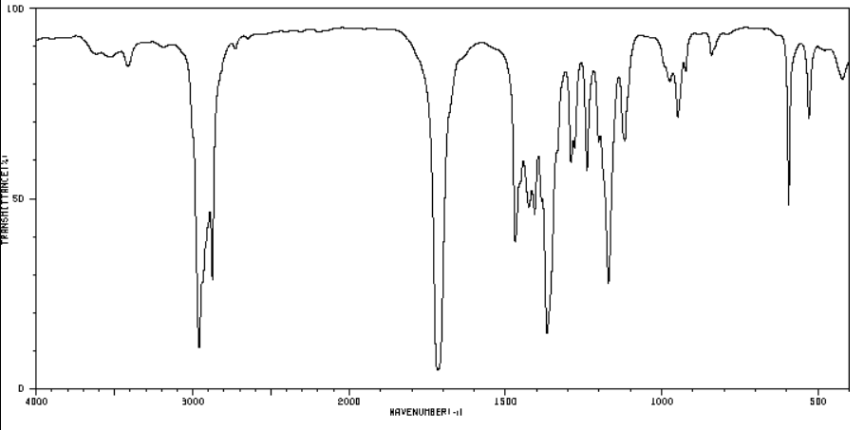

a. 

b. 

c. 

d. 

32. 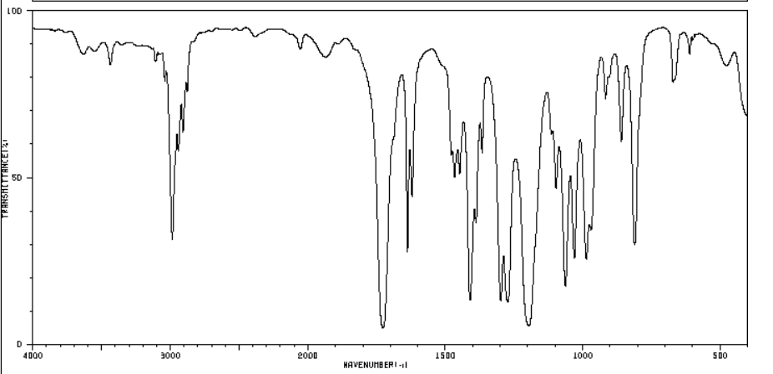

a. 

b. 

c. 

d. 

33. 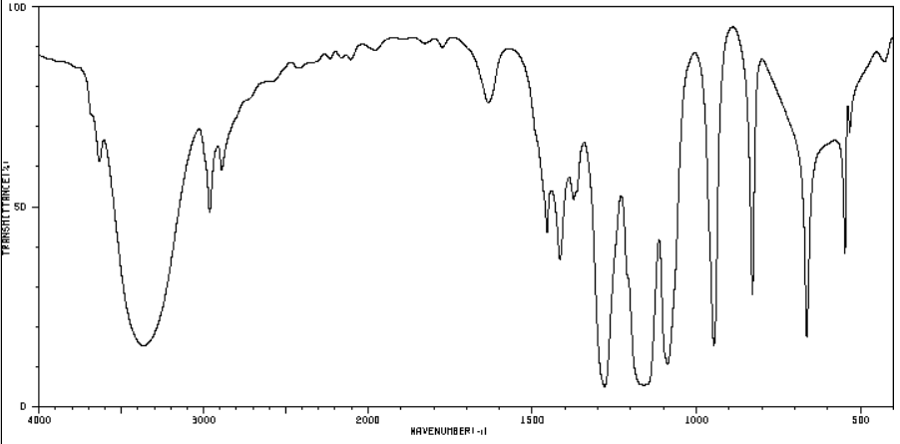

a. 

b. 

c. 

d. 

34. 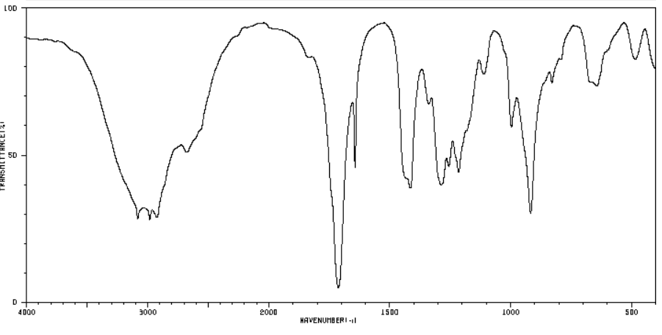

a. 

b. 

c. 

d. 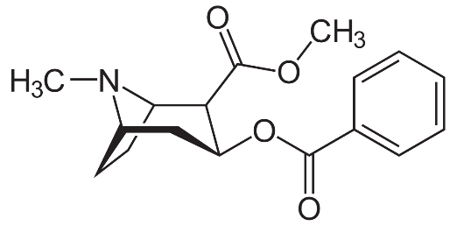

35. 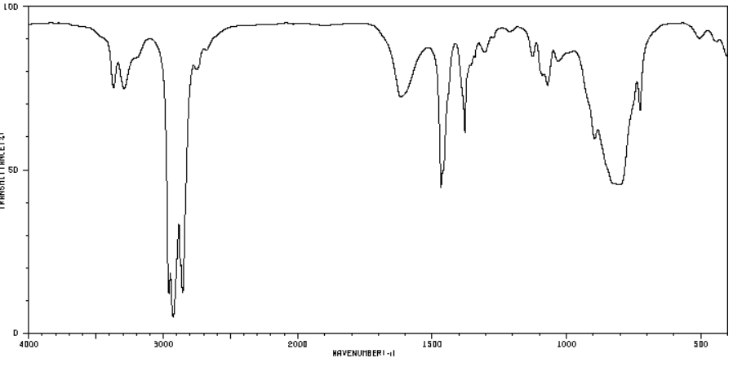

a. 

b. 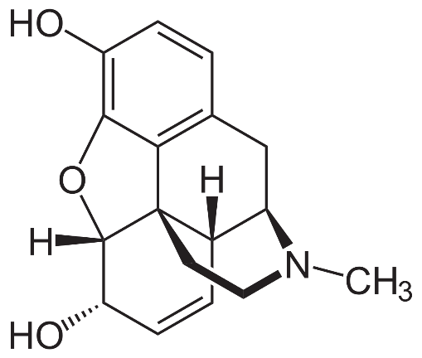

c. 

d. 

Questions 36-39: Determine the compound that is most likely to give the proton and carbon NMR spectrum shown.

36. Molecular formula: C7H16

Proton NMR peaks:

A: 1.378 ppm multiplet

B: 0.834 ppm singlet

C: 0.830 ppm doublet

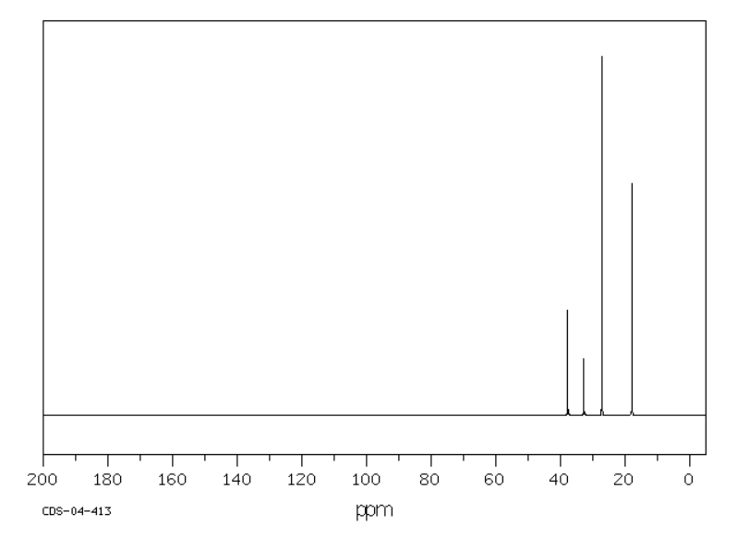

37. molecular formula: C9H13N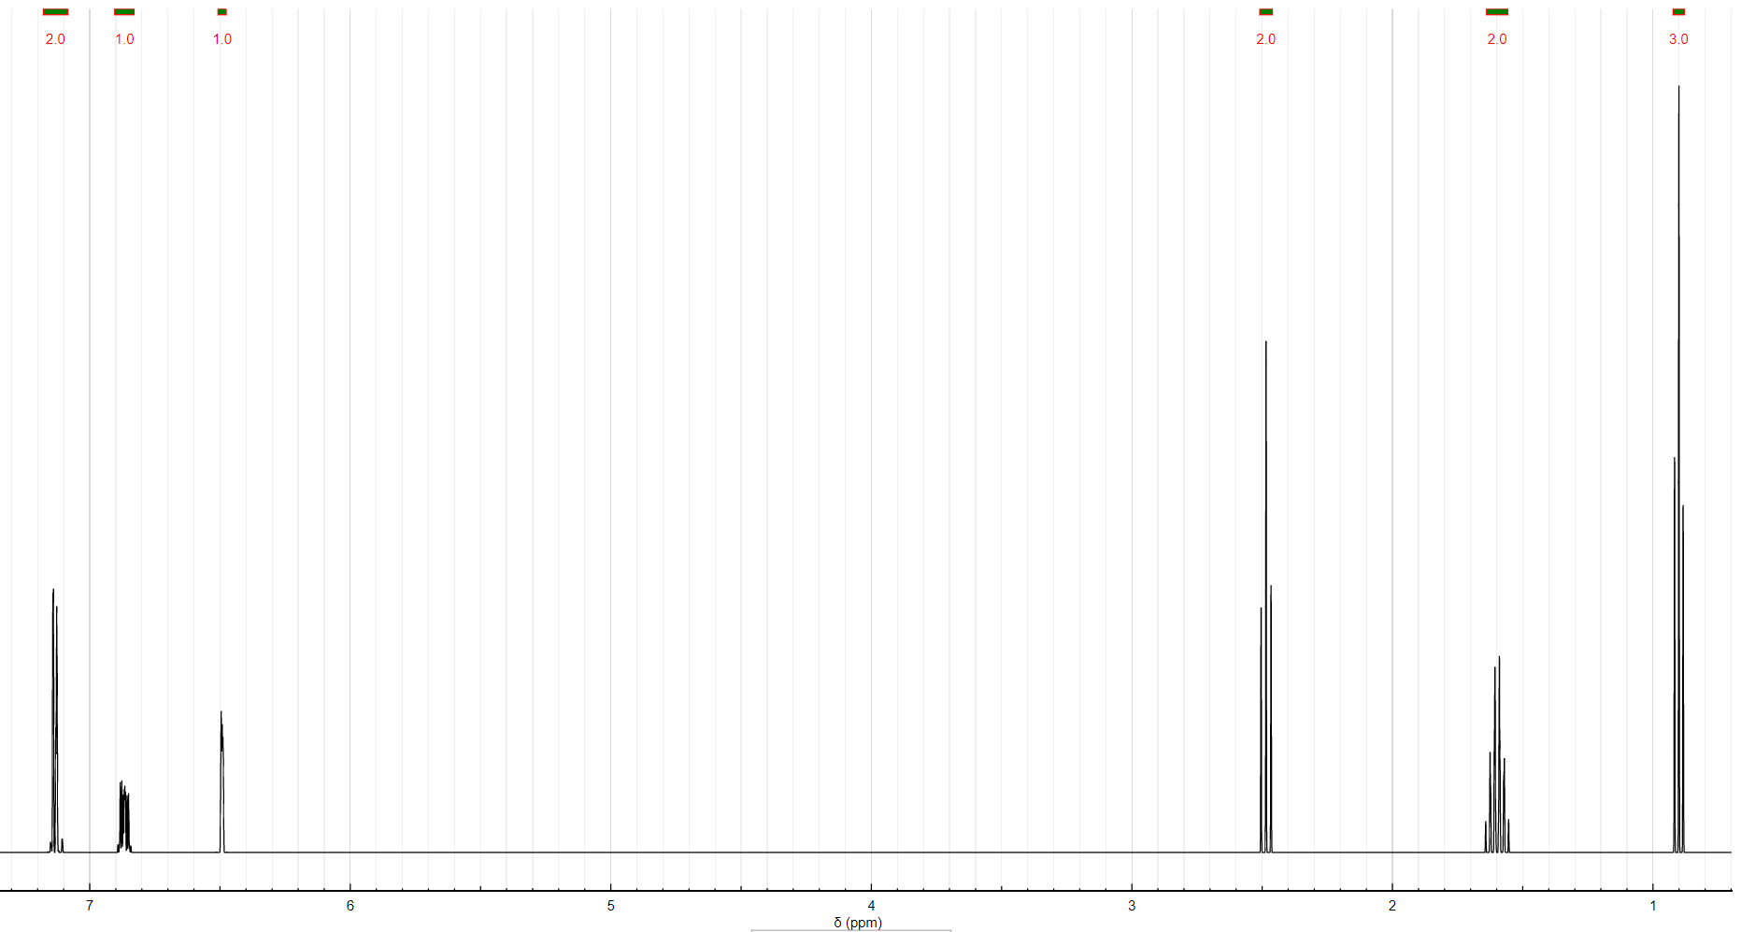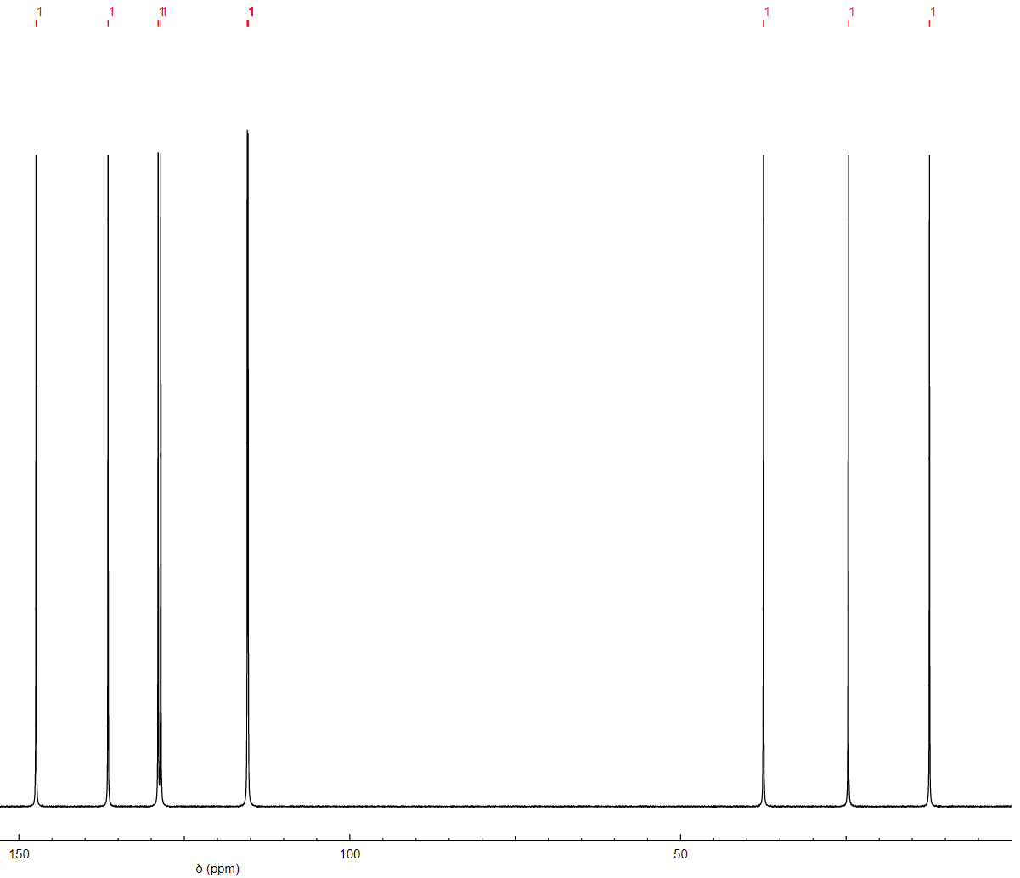



38. C5H12O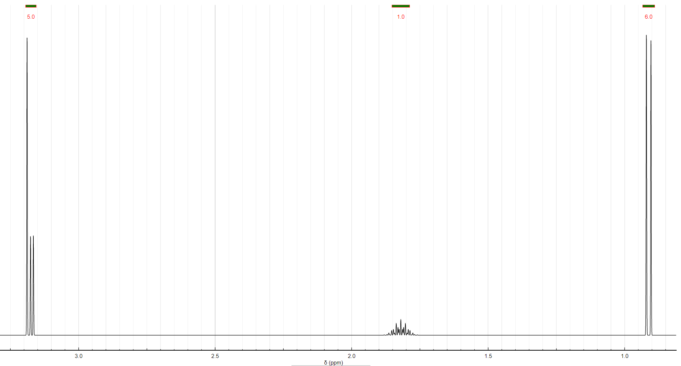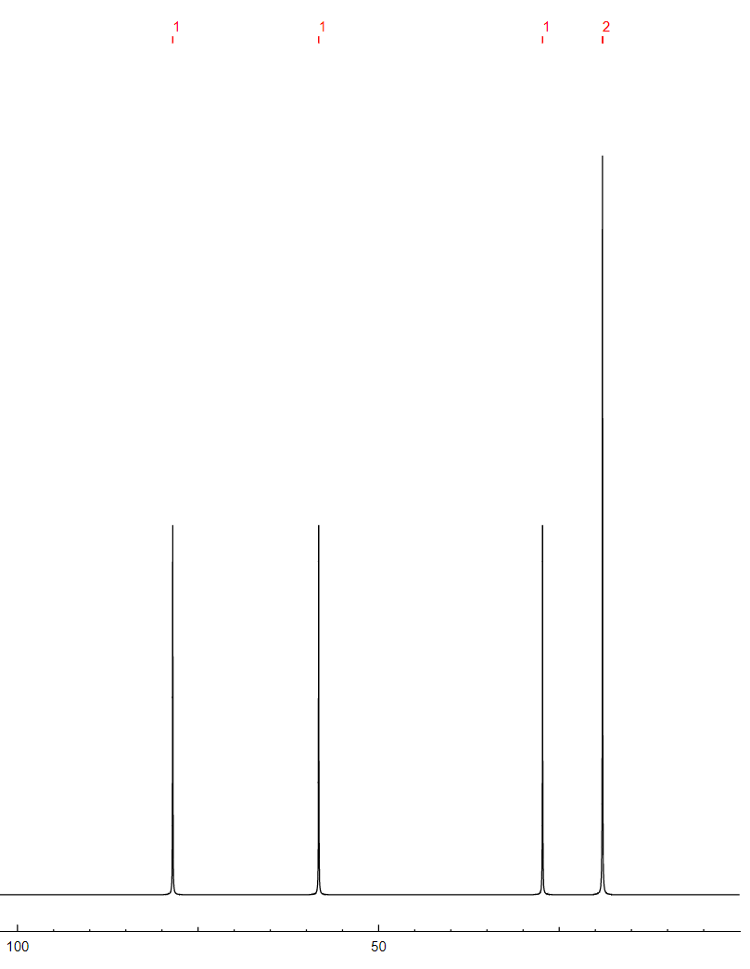

39.C4H7OCl

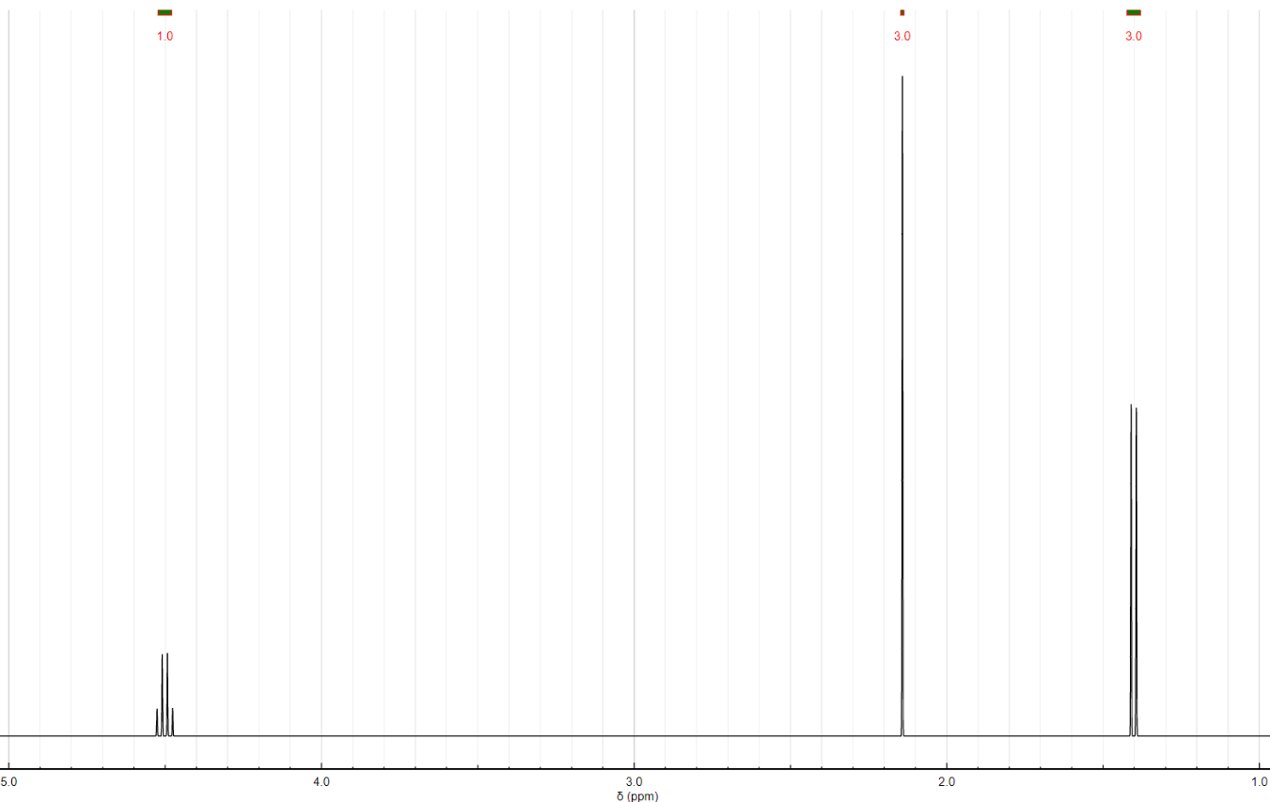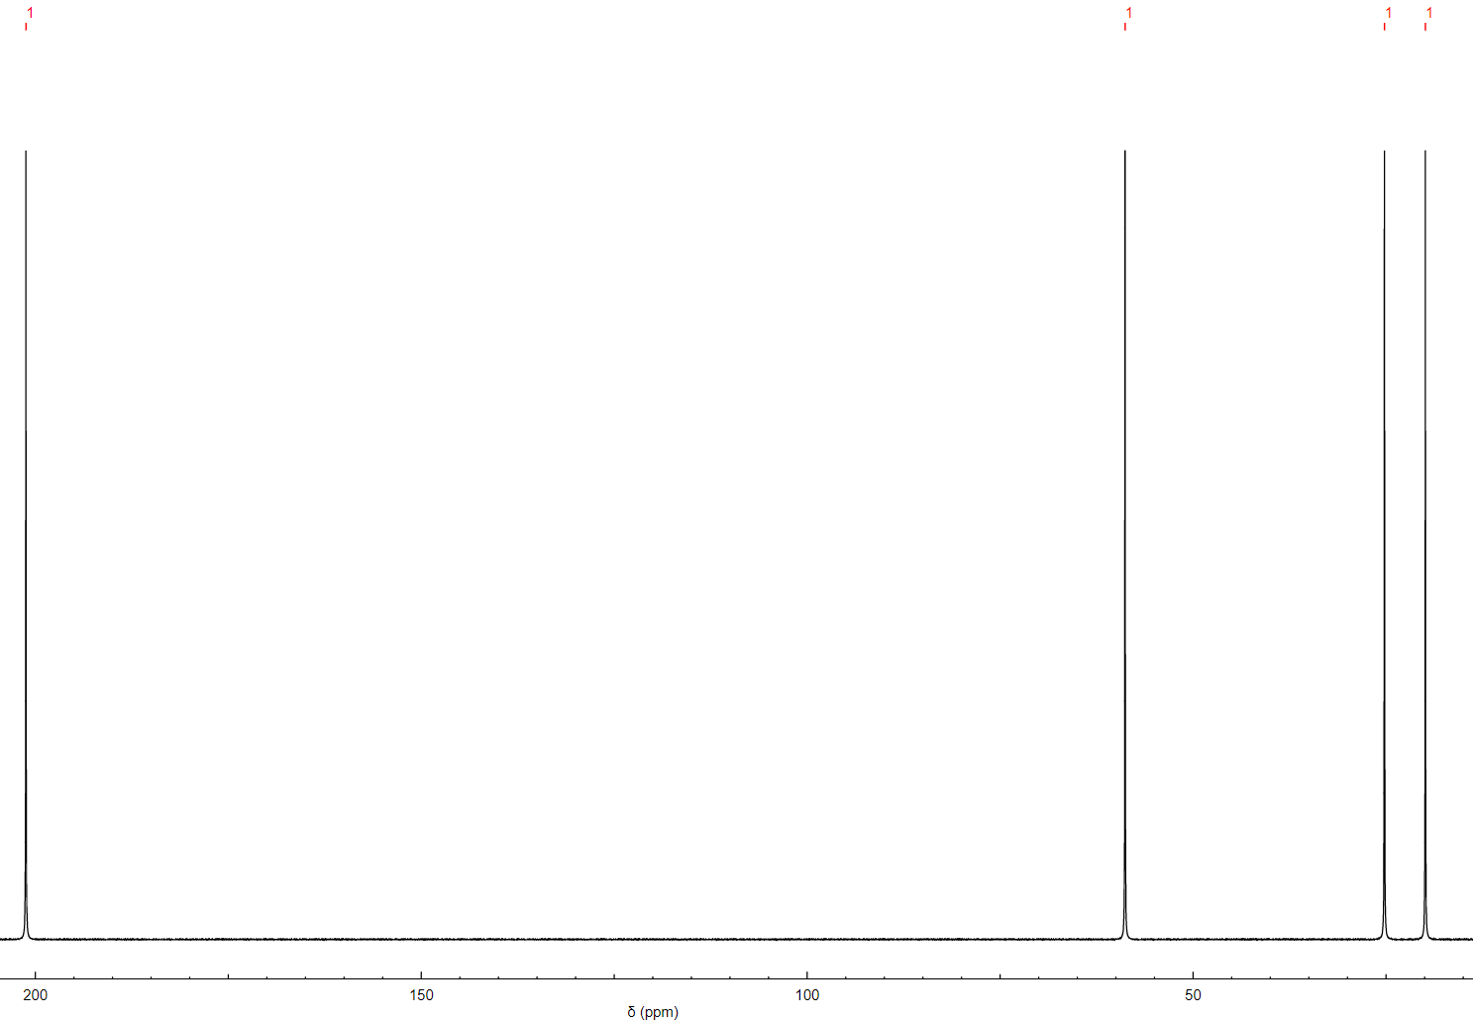



Questions 40-44: Determine the major organic products for the following reactions

40. 

41. 

42. 

43. 

44. 



Questions 45-49: Determine which compound would have a higher lambda max in its UV spectrum and explain your reasoning.

45.  more conjugated

46.  more conjugated with lone pair of nitrogen

47.  more effective conjugation because nitrogen will share its electrons more easily

48.  the molecule on the left isn’t even conjugated

49. More conjugation