Chemistry 145: Foundations of Physical Chemistry

Final Exam, noncumulative

Name:____________________

1. Prove that the energy for a particle in a 1D box is equal to: $E=\frac{h^{2}n^{2}}{8mL^{2}}$ and that the equation for the wavefunction is: $Ψ_{1D}=\sqrt{\frac{2}{L}}sin⁡(\frac{πn}{L}x)$
2. What is the HOMO-LUMO wavelength in nm for 1,3-butadiene given that the average C-C bond length is 1.406 Angstroms? 1,3,5-hexatriene? 1,3,5,7-octatetraene? What do you notice about the HOMO-LUMO wavelength (λmax)? Does this trend make sense from what you know about extensively conjugated organic molecules? Why or why not? What do you expect the wavelength for 1,3,5,7,9-decapentaene to be based off this trend, higher or lower than 1,3,5,7-octatetraene?
3. Consider porphyrin, a common biological molecule found in mammalian blood and a critical component of hemoglobin. Determine its HOMO-LUMO wavelength in nm given that the length of porphyrin is 1000 x 10-12 m for each side (consider it to be a square). What color should porphyrin be based on its HOMO-LUMO absorption? What is its actual color? (Hint: Consider degeneracy! Make sure your energy ladder is correct!).

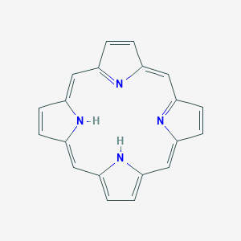

1. What is the ionization energy for Be3+? What about Li2+? Express your answer in terms of kJ.
2. What is the angular momentum in the z direction of an electron in the p orbital of a carbon atom?
3. How many degenerate orbitals are there if the l quantum number equals 5? 7?
4. What is the probability of finding an electron with angular position between π and 3π/2 for a particle on a circular wire? Assume that the particle inhabits the quantum state where n = 2.
5. Consider a 1D box that is divided into 5 segments of equal length. Calculate the probability of finding an electron in between the second and third segments quantum mechanically when the electron in question inhabits the quantum state where n = 1. What is the probability of finding the electron classically? How do these two numbers compare?
6. What is the spring constant associated with the H-Cl bond if the molecule absorbs 450 cm-1 light (assume n = 1 and that the mass of hydrogen is insignificant)?
7. Is the function $f\left(x\right)=e^{x^{2}}$ an eigenfunction of the derivative operator? What about $g\left(x\right)=at about nction of the derivative operator? t H-Cl bond if the molecule ab using the trial wavefunction han 1,3,5,7-octatetraesin(x)$? Are these eigenfunctions of the second derivative operator? How do you know? What are the eigenvalues?
8. Explain in words the meaning of the Schrödinger equation.