Chemistry 145: Foundations of Physical Chemistry

Exam 2

Name:_____________________

SHOW ALL WORK!!!

Good luck

1. Calculate the change in entropy for a gas undergoing reversible isothermal expansion from 10L to 24L.
2. Calculate the change in entropy for an ideal gas being heated from 24 degrees Celsius to 39 degrees Celsius.
3. Calculate the change in entropy for one mole of gas expanding to a constant pressure of 340 mmHg. Assume that the gas is ideal and has an initial temperature and volume of 23 degrees Celsius and 1.43 L.
4. What is the maximum nonexpansion work (for example electrical energy) that can be gained from the perfect combustion of acetylene gas (C2H2)? Assume that the change in entropy for the reaction is -215.5 J/molK. (Hint: Calculate the change in enthalpy and look on the internet).
5. What is the thermodynamic efficiency of a heat engine that has a cold sink at 10 degrees Celsius and a hot source at 284 degrees Celsius?
6. What is the change in entropy for the normal boiling of water? (Hint: Use the internet)
7. What is the change in entropy for the boiling of water at 45 degrees Celsius? (Hint: use the internet and draw a diagram)
8. What is the molar residual entropy for a crystal structure of a molecule that can orient itself 5 different ways? (Hint: if it is a molar quantity, use R)
9. True or False: All spontaneous processes cause a positive ***NET*** change in entropy?
10. Derive the total differential for A, G, H, and U
11. Derive the Clausius Clapeyron equation and explain why the assumptions made are valid
12. Consider the following graphs and identify the phases each line represents as well as the melting, boiling, and subliming conditions on each graph:



1. What is the purpose of Maxwell Relations? In other words, why are they useful?
2. What is the change in Gibbs Free Energy when an ideal gas increases its pressure isothermally from 10 bar to 100 bar?
3. Given the following phase diagram, how many degrees of freedom are present at 90 degrees Celsius and 20 bar pressure?

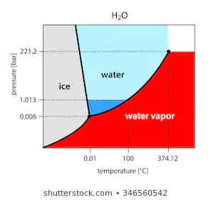

1. Given the following graph, calculate the total volume and density of a mixture of 10 grams water and 30 grams ethanol. 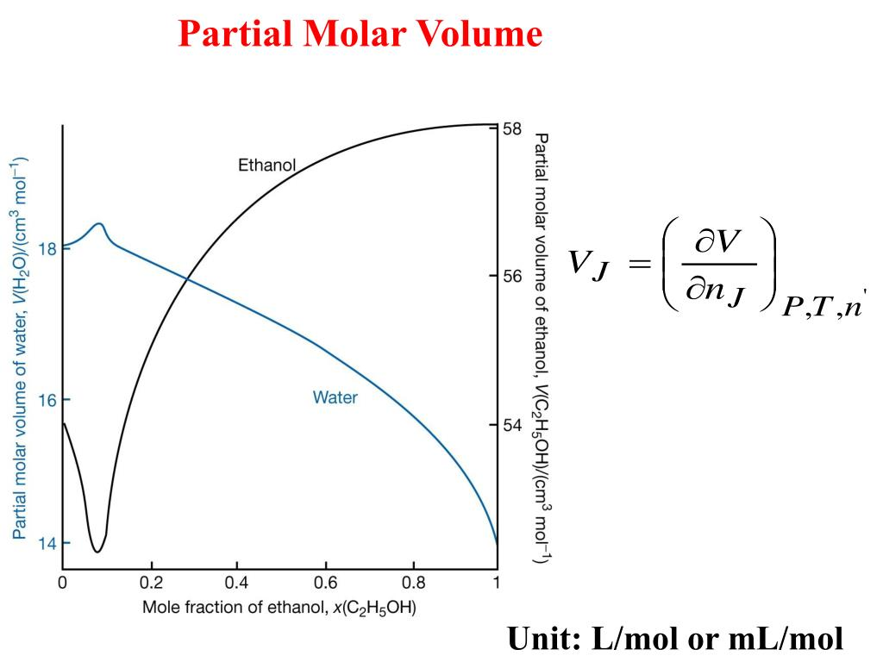
2. Calculate the change in chemical potential if the partial pressure of the solute doubles
3. Calculate the change in entropy and Gibbs free energy when mixing 32 grams of O2 gas with 76.82 grams of N2 gas. What is the change in enthalpy?
4. Calculate the concentration of methane gas dissolved in water if the Henry’s Law constant is 0.0014 mol/kgbar and the pressure of the methane gas above the solution is 0.02138 atm.
5. The normal freezing point of benzene is 5.5 degrees Celsius. If 15.72 grams of pure unknown solid is added to a 230 gram solution of benzene, the new recorded freezing point is 4.22 degrees Celsius. What is the molecular weight of the unknown? The cryoscopic constant for benzene is 5.07 kgK/mol.
6. In order for sufficient oxygen to be transported into the blood from the alveoli of the lungs, a constant osmotic pressure of 150 mmHg must be maintained (this is totally made up), what has to be the concentration of oxygen in the blood if normal body temperature is 37 degrees Celsius?
7. We have a mixture consisting of 32.8 grams benzene (A) and 24.9 grams of toluene (B) at a certain temperature, T, marked on the diagram below. Calculate the number of moles of benzene in the liquid and gas phase at this particular temperature. Calculate the number of moles of toluene in both phases as well.



1. Consider the following reaction and subsequent reaction mechanism:

H2(g) + I2(g) 🡪 2HI(g)



Determine the slow step of the reaction mechanism if the rate law is the following:

$$rate=k\left[I_{2}\right]\left[H_{2}\right]$$

Consider the conditions that would be required to get the rate law to appear that way and determine the sign of delta S of activation.

1. Calculate the activation energy given that the rate constant for a reaction is 1.982 M/s and frequency factor is 18.2 M/s. Assume this reaction occurs at 37 degrees Celsius.
2. Calculate the change in Gibbs free energy of activation given that the reaction rate constant for a particular reaction is 3.295 M-1 s-1 at 22.52 degrees Celsius. Also assume that the frequency factor for the reaction in question is exactly 25.97 M-1s‑1. What does this information tell you about the ease at which this reaction occurs at 22.52 degrees Celsius? What does this information tell you about the transition state relative to the reactants?