General Chemistry ULTIMATE Review Guide
NeighborhoodGeeks
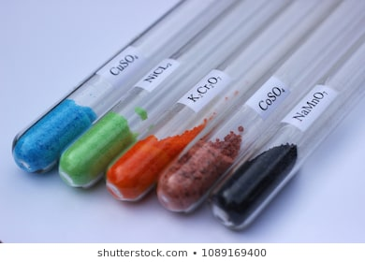
Table of Contents
Chapter 0: Foreword from the Author
Chapter 1: Introduction to Chemistry Terms
Chapter 2: Introduction to Unit Conversion
Chapter 3: Introduction to Atomic and Molecular Structure, types of bonding
Chapter 4: Periodic Trends and Quantum Numbers
Chapter 5: Lewis Dot Structures and Resonance
Chapter 6: Molecular Geometry and Polarity
Chapter 7: Intermolecular Forces and Physical Properties
Chapter 8: Nomenclature and Basic Chemical Reactions
Chapter 9: What the Heck is a Mole? How do we Express Concentration? How do we Set Up a Reaction?
Chapter 10: Gas Laws
Chapter 11: Introduction to Thermodynamics
Chapter 12: What Makes a Reaction Release Heat?
Chapter 13: What Makes a Reaction Spontaneous?
Chapter 14: Chemical Kinetics, How Fast Do Reactions Go?
Chapter 15: Introduction to Redox reactions, LEO says GER
Chapter 16: Introduction to Equilibrium
Chapter 17: Introduction to Electrochemistry, What is a Battery?
Chapter 18: Acid-Base Chemistry and Titrations
Chapter 19: Introduction to Molecular Orbital Theory and Hybridization
Chapter 20: Introduction to Nuclear Chemistry

Chapter 0: Foreword from the Author
When writing this textbook, I am going to approach this subject from an atom’s first perspective because I believe that understanding how atoms operate and their properties are foundational to understanding everything that you will ever learn in your future chemistry courses. I will assume NO prior knowledge of chemistry, so this text is appropriate for both college freshman taking their first and second semesters of general chemistry as well as high school students hoping to better understand the material. Just like in some of my other textbooks I have written, one of the most critical components when learning this material is your mindset. Nobody is born knowing this information, but anyone can learn it, you just have to put in the work. I genuinely believe that anyone who reads this text can understand all of the material in its entirety if enough work is put in. For some of you, this serves as your first taste into the world of chemistry and for others, this is simply revisiting old grounds. Whatever your situation may be, I have confidence that you will understand this material. I offer these pieces of advice for those who wish to understand chemistry:
- Relate every lesson to an everyday experience you have. Bonds can be looked at as springs, dipole moments can be viewed as tug-of-wars, and periodic trends can be viewed as snowmen. Whatever helps you understand the material, USE IT. Analogies to physical objects are indispensable especially for an introductory class such as this.
- Practice as much as you can, try to live this subject and you will reap the rewards.
- Believe in yourself. Your mind and spirit are more powerful than you will ever understand. They are your greatest weapons against confusion; use them.
Just like in my Organic Chemistry textbook, we will introduce some recurring themes in this textbook as well:
- Opposite Charges Attract
- Like Charges Repel
- Minimize Charge and Energy
- Acids React with Bases
- Equilibrium finds the balance
Throughout this textbook, I will be referring to these Guiding Principles of General Chemistry by the acronym AMOLE and will bold-face the parts of the acronym that are applicable in the explanations I provide. Note that many of these diagrams and some of the practice questions provided in this book are not of my own creation, they are taken from other online resources, the credit goes out to the creators of these figures and questions.

Chapter 1: Introduction to Chemistry Terms

Before we get started talking about chemistry, we need to have something of a vocabulary lesson. Before you can act like a chemist, you need to learn to speak like one. We will start our discussion by going over the different states of matter. There are three main states of matter that you should be familiar with from your daily life, those are solid, liquid, and gas. We will relate our discussion to water since you have undoubtedly had some experience with water, otherwise you’d be dead. The solid phase is like ice, it is a rigid phase and has a defined shape and volume. When I say it has a defined shape and volume, I mean that ice will not change its shape to fit its container nor does it change its volume. The liquid phase is like water, it is a more fluid phase and has a defined volume but undefined shape. You have undoubtedly experienced the behavior of liquids before, if you put them in a circular container then it becomes circular, if you put them in a square container then it becomes square. In other words, liquids take the shape of their container. The most fluid state is the gas phase, in this phase, the substance has both undefined shape and undefined volume, this is like water vapor when you cook pasta. In the gas phase, the shape will always match the container that it is in, however, it will also take up the volume of the container as well. This unique behavior of gases makes them incredibly useful for many physical processes, which we will discuss, in detail later in this text.
There are different types of substances that exist in the physical world. All things that take up space are referred to as matter. Matter has many different sub classifications; it is the umbrella term for everything that we can see with our eyes. There are a few different types of matter: pure substances and mixtures. Pure substances are the types of matter that are comprised of only one thing, while mixtures are the types of matter that are comprised of multiple things. We will start by discussing pure substances because it turns out that this category can be further broken down. There are three main classes of pure substances: elements, molecules, and ionic compounds. Elements are exactly what they sound like, they are all of the different types of matter indicated on the periodic table. Elements are pure substances because they are only comprised of a single type of atom. These atoms have a defined structure, which will be discussed in future chapters, but each type of atom has a unique identifier, which is their atomic number. All elements are comprised of many atoms that have the same atomic number. A slab of iron for instance is comprised of many iron atoms, which all have the atomic number 26. Molecules are the types of matter that are comprised of different atoms that are bonded together, an example of a molecule is water, H₂O. Molecules are pure substances because water is comprised of ONLY H₂O, there is only one building block. Molecules are typically built from elements on the right of the periodic table. Ionic compounds are the types of matter that are comprised of charged atoms referred to as ions bonded together, we will discuss the differences between atoms and ions in future chapters, but for right now, know that ions are essentially just the charged versions of atoms. Because opposite charges attract, ionic compounds are always comprised of a negative and a positive ion (AMOLE). An example of an ionic compound that you have seen in real life is NaCl, or table salt. These compounds are pure substances because all salt is comprised of only one thing, NaCl. Ionic compounds generally form by bonding elements from the left and right of the periodic table. We will discuss this more in the future.
Within the world of mixtures, there are three main classifications: homogenous mixtures, heterogenous mixtures, and colloids. Homogenous mixtures are mixtures that appear to look the same throughout despite having several things in them. An example of a homogenous mixture is salt water, in salt water, there is both NaCl and H₂O, however, the mixture looks the same throughout. Heterogenous mixtures are mixtures that DO NOT appear the same throughout. An example of a heterogenous mixture is a peanut butter and jelly sandwich, the sandwich has both peanut butter and jelly in it and those look totally different. The way I remember the difference between these two types of mixtures is by looking at the prefix. Homo means same, hetero means different. But what about colloids? Colloids are a specific type of homogenous mixture that has large particles dispersed throughout the mixture that can be seen with a beam of light.
Practice questions:
Identify each type of substance as a pure substance or mixture and then classify them as specific types of pure substances/mixtures:
- Pure gold necklace
- Italian salad dressing
- Carbon
- Smooth peanut butter
- Chunky peanut butter
- Mixed salad
- Sugar water
- Sugar
- KI
- Ammonia (NH₃)

Answers:
- Pure substance, element (Au)
- Mixture, heterogenous mixture, the mixture does not appear the same throughout
- Pure substance, element (C)
- Mixture, homogenous mixture, the mixture appears the same throughout
- Mixture, heterogenous mixture, the mixture does not appear the same throughout
- Mixture, heterogenous mixture, the mixture does not appear the same throughout
- Mixture, homogenous mixture, the mixture appears the same throughout
- Pure substance, molecule, sugar is C₆H₁₂O₆ (glucose)
- Pure substance, ionic compound
- Pure substance, molecule
In addition to the types of matter, we should also discuss the changes that matter can undergo. That is the study of chemistry after all at its core. There are two different types of changes that substances can undergo, physical and chemical. The key difference between the two of them is that physical changes do not alter the identity of the chemical, while chemical changes do alter the identity of the chemical. An example of a physical change is a phase transition, such as melting or boiling. These are physical changes because we are only changing the state of matter, not the identity of the chemical itself. If we took boiling water as an example, we are simply making liquid water go to gaseous water vapor, we are not making water turn into ammonia (NH₃), therefore the identity stays the same. There are three critical signs that tell you that a chemical change is occurring:
- Color change
- Temperature change
- Light
An example of a chemical change would be cooking a steak. When you cook a steak, it goes from being pinkish/red to nice and brown, therefore this satisfies the color change criteria.
Just as there are physical and chemical changes, there are also physical and chemical properties. A physical property has to do with observation, things like color and shape are physical properties. A chemical property has to do with its ability to change into another chemical, an example of a chemical property is combustibility or flammability. Again, the key difference is that physical properties do not deal with changing the form of matter, but chemical properties do. Within the umbrella of physical properties, there are two different flavors, extensive and intensive properties. Extensive properties are those properties that vary depending on how much material is present, while intensive properties do not. An example of an extensive physical property is mass, the more material present, the greater the mass.

Practice Questions:
Determine if each of the following is a physical or chemical property/change
- Freezing water
- Corrosion of iron
- Acidity
- Density
- Buoyancy
- Boiling point
- Flexibility
- Luminosity (how bright it looks)
- Volume
- Cutting a substance in two
- Combustion
Answers:
- Physical change
- Chemical change
- Chemical property
- Intensive physical property
- Intensive physical property
- Intensive physical property
- Intensive physical property
- Extensive physical property
- Extensive physical property
- Physical change
- Chemical change

Chapter 2: Introduction to Unit Conversion
Converting units is a skill that will help you throughout all future STEM courses that you will take, so I will make sure that you are familiar with how to do it. There are many ways to do unit conversion, however, I believe that the easiest way is referred to as the “factor-label method” or “dimensional analysis.” The concept behind dimensional analysis is that units are like numbers, if you multiply by its reciprocal, they cancel out. For example:
$$4*\frac{1}{4}=1$$
In the same way that:
$$m*\frac{1}{m}=1$$
Therefore, to cancel out and convert units effectively, the unit you want to cancel out needs to be on the denominator of the next fraction. The key to unit conversions is to read it as a sentence, we will do an example, given that we know that there are 100 cm in every one meter:
$$200cm*\frac{1m}{100cm}=2m$$
If I have 200 cm then to convert from cm to meters, I would need to put the cm unit on the denominator of the fraction. The relationship between cm and meters is given as there is 100 cm for every one meter, therefore the fraction is 1/100 because for every 100 cm there is 1 meter. The sentence should therefore read “200 cm is 2 meters because there are 100 cm for every 1 meter.” Here are the unit conversion factors for all metric units:
The “unit” spot has to do with the base unit, things like meters, seconds, grams, etc. are the basic units of measure for length, time, and mass respectively. Therefore a km is 1000 meters as shown by the 1000 underneath the prefix kilo. A cm is 0.01 meter, meaning 1cm = 10⁻² m or 1/100 m. The easiest way to remember this order is with the pneumonic device “King Henry Doesn’t Usually Drink Chocolate Milk” where the first letter of each word corresponds to the first letter of the prefix in the diagram above.

Practice questions:
Convert the following units:
- 100kg to g
- 234 cm to m
- 23 dm to hm
- 23mm to km
- 23 ks to ms

Answers:
- $100kg*\frac{1000g}{1kg}=100*1000 g={10}^{2}*{10}^{3}g={10}^{5}g=100,000 g$
- $234 cm*\frac{1m}{100cm}=2.34m$
- $23dm*\frac{1m}{10dm}*\frac{1hm}{100m}=\frac{23}{1000}hm=0.023 hm$
- $23mm*\frac{1m}{1000mm}*\frac{1km}{1000m}=\frac{23}{{\left(1000\right)}^{2}}km=\frac{23}{{\left({10}^{3}\right)}^{2}}km=\frac{23}{{10}^{6}}km=23*{10}^{-6}km$
- $23ks*\frac{1000s}{1ks}*\frac{1000ms}{1s}=23*1000*1000 ms=23*{10}^{3}*{10}^{3}ms=23*{10}^{6}ms$

This strategy always works as long as the fraction you are multiplying by is true. You can also do this with time for instance:
Question: how many minutes are in a year?
Answer: you can remember the song 525,600 minutes or you can do the math, for our purposes the mathematical way is better, so we will do it this way.
$$1yr*\frac{365days}{1yr}*\frac{24hours}{1day}*\frac{60minutes}{1hour}=525,600 minutes$$
This works because all of the fractions that we are multiplying by are facts, there are 365 days in a year, there are 24 hours in a day, and there are 60 minutes in an hour. This can also be done with more complicated units like speed, which is distance per time interval.
Question: how many km/hr is 60 mi/hr?
Answer: again, you could know that it is about 100 km/hr by being a pro-gamer in Need For Speed, or you can do the math to get an exact answer (there are 1.61 km in one mile).
$$\frac{60mi}{hr}*\frac{1.61km}{1mi}= 96.6\frac{km}{hr}$$Again this worked because the fraction that we multiplied by is a valid statement and the units of miles canceled because they are on opposite sides of fraction (numerator and denominator). See if you can answer these problems:
Practice questions:
Convert the following units
- Convert 15 m/s to mi/hr (1609.34 meters in a mile)
- How many hydrogen atoms are in 3 molecules of water (H₂O)?
- Convert 100 people/m² to people/cm²
- Convert 10 kgm/s² to gm/s²
- How many oxygen atoms are in 5 molecules of glucose (C₆H₁₂O₆)?

Answer:
- $\frac{15m}{s}*\frac{1mi}{1609.34m}*\frac{60s}{1minute}*\frac{60minutes}{1hour}=33.55\frac{mi}{hr}$
- $3molecules H_{2}O*\frac{2H atoms}{1molecule}=6H atoms$
- $\frac{100people}{m^{2}}*\frac{1m}{100cm}*\frac{1m}{100cm}=0.01\frac{people}{cm^{2}}$
- $\frac{10kgm}{s^{2}}*\frac{1000g}{1kg}=10,000 gm/s^{2}$
- $5molecules glucose*\frac{6 Oatoms}{1molecule}=30 O atoms$
Another super important thing for the rest of your STEM courses is being able to calculate significant figures. Significant figures is the system that scientists and engineers use to tell the reader the level of accuracy the method they used had, whether that method was accurate to the tenths place or the thousandths place. First we will learn how to determine the number of significant figures and then we will cover the rules governing how we can figure them out in our own experiment.

Just like how the Pacific Ocean on the map of the US starts on the left hand side, if the decimal point in a number is Present then you start reading from the left. Likewise, if the decimal point is Absent, then you start reading the number from the right, where the Atlantic Ocean is. In either case, you keep reading until you get to a digit that is not 0, you count that as significant and all other numbers after. Here are some examples with the significant figures in red:
- 0.001 (1 significant figure)
- 1.00000 (6 significant figures)
- 100 (1 significant figure)
- 100. (3 significant figures)
- 101 (3 significant figures)
- 1020 (3 significant figures)
- 567.12 (5 significant figures)

Here are some more practice problems for you:
- 25.20
- 25.2
- 17340
- 123.
- 123
- 678000000000
- 450
- 450.00
- 1.01
- 67.820
Answers:
- 25.20
- 25.2
- 17340
- 123.
- 123
- 678000000000
- 450
- 450.00
- 1.01
- 67.820

Now we will cover how to determine which significant figures to keep depending on the operation that you perform on it. The easiest operation is multiplication and division, in this scenario, you round your answer to the lowest number of significant digits in the original two numbers. This harkens back to the old adage, you are only as strong as your weakest link, this applies exactly to measurement accuracy, if one number has 5 significant figures but the other has 2 and you are multiplying them, then the product can only have a maximum of 2 significant figures.
Examples:
- 101.2 * 5 = 506, but rounded it is 500 because it must have 1 significant figure
- 25.3 * 22.9 = 579.37, but rounded it is 579 because it must have 3 significant figures
- 12.7 * 32 = 406.4, but rounded it is 410 because it must have 2 significant figures
Here are some more practice questions for you to try:
- 21.2 * 12.307
- 25.6/12
- 125/6.0
- 125/5.000
- 100*23
Answers:
- 21.2 * 12.307 = 260.9084, but rounded to proper significant figures it is 261
- 25.6/12 = 2.1333, but rounded to proper significant figures it is 2.1
- 125/6.0 = 20.833333, but rounded to the proper significant figures it is 21
- 125/5.000 = 25, but this has too little significant figures, so it must be 25.0 to get 3 sig figs
- 100*23 = 2300, but rounded to the proper significant figures it is 2000.

The more difficult of the operations is addition and subtraction. Here, the lowest digit’s place is taken as the standard, meaning if one number is accurate to the tenths place and the other is accurate to the hundredths place, their sum or difference will be accurate to the worse of the two measurements, in this case the tenths place.
Here are some examples:
- 101 + 25.1 = 126.1, but 101 is only accurate to the ones place so the proper rounded answer is 126
- 101.11 + 12.3 = 123.41, but 12.3 is only accurate to the tenths place so the proper rounded answer is 123.4
- 12+2.3 = 14.3, but 12 is only accurate to the ones place so the proper rounded answer is 14
Here are some practice problems for you to try:
- 1200 + 65.1
- 516 – 1.07
- 236.0000 – 1.17
- 18.2 – 2
- 24.9 – 2.7
Answers:
- 1265.1, but rounded it is 1300
- 514.93, but rounded it is 515
- 234.83, but rounded it is 235
- 16.2, but rounded it is 16
- 22.2

When you are doing your own experiment, when you record measurements from an instrument like a mass balance, the last digit is always the varying digit. You will have the most inaccuracy with that digit and therefore your measurement is only as accurate as that last digit, the number of significant figures is therefore dependent on where that last digit is located. If you are doing an analogue measurement, meaning that you are not using a digital balance, but instead are using a physical measurement using a ruler or graduated cylinder, you have the leisure of approximating one units place after the gradations on the tool. For instance, if you are measuring with a graduated cylinder and the marks are every 0.1 mL, you can approximate the volume to the hundredths place because you can determine how far between the marks you are. In science, we always want to maximize the number of our significant digits. This is because we want our measurements to be as accurate as possible. But wait a second, what exactly is accuracy? Accuracy is how close our answer is to the actual answer. For example, if we do 5 trials of an experiment and we get as our average 12.3 when the actual answer is 523, clearly we are not very accurate. Complementary to accuracy, we have another metric, precision. Precision does not care what the actual value is, it only cares about how close our individual trials were to each other. If we were to take our previous scenario as our example, if our 5 trials gave us 12.3, 12.3, 12.2, 12.2, and 12.3 again, then we would say that our measurements are precise but not accurate. In science the ideal scenario is to have high accuracy AND high precision. Visually, the concept of accuracy and precision can be seen with the following picture of a dartboard:
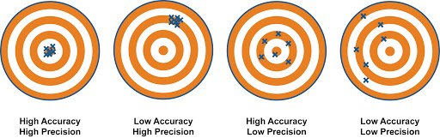

This next paragraph is only if you have not learned scientific notation yet, if you have, please skip to the next chapter. I include this because of the wide variety of backgrounds that some of you reading this come from; this may or may not have been taught to you in high school, but it is necessary to discuss at some point. Scientific notation is mainly used to easily describe very large or very small numbers, numbers that are cumbersome to write out by hand. The underlying principle of scientific notation is that you can write everything as a multiplication by 10 to some power. For example, 1 is 10⁰, 2 is 2*10⁰. For more complicated numbers like 129329, we always want only one number before the decimal when we write it in scientific notation, therefore 129329 in scientific notation would be 1.29329 * 10⁵. An easy way to verify this is by moving the decimal point over to the left 5 times, if that number is the same as the one you are targeting, then you wrote the number correctly. The rules of significant figures works the same here, except we ignore everything after the multiplication operator. For example, 1.29329 * 10⁵ has 6 significant figures because 1.29329 has 6 significant figures.
Here are some example problems for you to do:
- 1230 in scientific notation is?
- 0.242 in scientific notation is?
- 12.87 in scientific notation is?
- 3421 in scientific notation is?
- 0.0000233 in scientific notation is?
- 293063 in scientific notation is?
Answers:
- 1.230 * 10³
- 2.42 * 10⁻¹
- 1.287 * 10¹
- 3.421 * 10³
- 2.33 * 10⁻⁵
- 2.93063 * 10⁵

Chapter 3: Introduction to Atomic and Molecular Structure, types of bonding
Most Chemistry courses will go through the history of atomic structure and how it evolved over time. I personally find this meaningless, however, I will discuss it very briefly for completeness sake. For your benefit in this class, you only have to consider the Bohr model and the very last model I discuss with you, the other models are debunked.
The very first conception of an atom came first in ancient Greece with the philosopher Democritus, who proposed that there was a fundamental, indivisible building block(s) that were used to create matter. The idea of subatomic particles and the elements as we know them today were not a part of Democritus’ theory, but this idea of indivisible building block(s) laid the foundation for atomic theory.
It was not until 1904 with JJ Thompson and the discovery of the electron that a more accurate model was developed. The discovery of the electron was huge because it showed that atoms are comprised of subatomic particles. The electron was the negatively charged component of the atom, however, as we had previously discussed, atoms are electrically neutral, so there had to be a positive charge somewhere in the atomic structure. JJ Thompson’s model is known as the “plum pudding model” and although not accurate, described the atom as taking up space with a distributed positive charge and negatively charged electrons scattered throughout it. It was named the “plum pudding model” because it resembeled the British plum pudding, however, for Americans, it is more reminiscent of the tried and true chocolate chip cookie, where the dough is the positive charge and the chocolate chips are the negatively charged electrons.
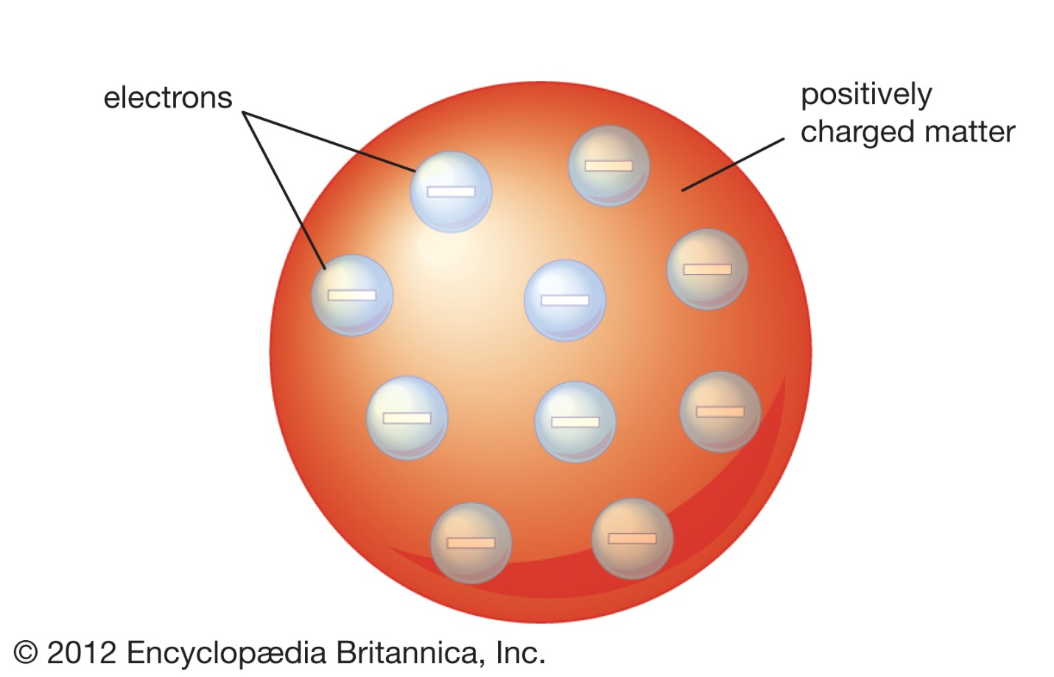

According to the “plum pudding model”, the atom was comprised entirely of space that was either negatively or positively charged.
It was only until Rutherford’s gold foil experiment that the atomic model was further improved upon. This experiment bombarded gold foil with positively charged alpha particles, the majority of which passed through unphased, however, there were some that at the right angle and trajectory bounced back from the gold foil. This told Rutherford that rather than the positive charge being distributed over the entire area of the atom, it was concentrated in a nucleus. If the positive charged were distributed over the entire area, all the positively charged particles would get repelled and bounce back (AMOLE). Rutherford therefore concluded that the atom is comprised of mainly empty space and that the electrons were separated by some distance from the nucleus that held the positive charge.
The model that most people are familiar with from popular culture is the Bohr model, which is shown below:
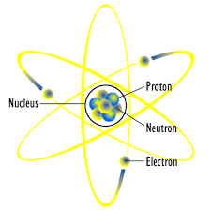

In the Bohr model, electrons orbit the nucleus in specific orbitals as particles. This model was later updated with neutrons being included, neutrons are neutral particles that have about the same mass as protons, but do not contribute to the overall charge. These neutrons act as cushions that prevent the protons from repelling each other and compromising the stability of the nucleus (AMOLE).
The most modern approach to the atom is the electron-cloud model. In the electron cloud model, electrons orbit the nucleus in orbitals, but these orbitals are squishy clouds of electrons, because we now know that electrons do not behave as particles or waves, but can exhibit properties of both depending on the test given. If this seems confusing to you, don’t worry, it confuses everyone including Nobel Laureates, so it is not super necessary to understand the “electron cloud”, but what is important to know is that the atom has a nucleus comprised of protons and neutrons and this nucleus is very dense and is orbited by electrons that have a negative charge. A picture of the electron-cloud model is shown below:
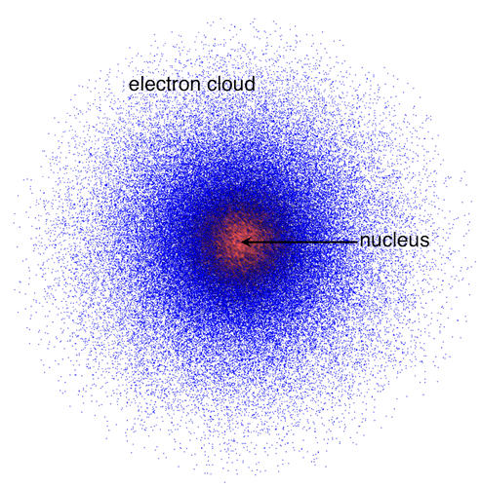

As you can see, unlike in the Bohr model where you can definitively see where the electrons are located, in the cloud model we cannot. All of those blue dots represent the probability of you finding an electron in that location. The most likely position to find an electron is within orbitals in the cloud, which are the darkest blue areas in the above picture. Because the cloud model is admittedly very confusing at first, we will center our discussion around the Bohr model for simplicity.
For most chemical processes, the only electrons that we have to concern ourselves with are the valence electrons. Valence electrons are the electrons that are farthest away from the nucleus. These are the electrons that are involved with bonding and chemical reactions because they are the easiest to move around and use. This should make sense because the farther you are from the nucleus, the weaker your attraction is to the protons (AMOLE). Because attraction decreases with distance, the valence electrons are the most loosely bound electrons in an atom, therefore, if something is going to leave and react, it will be the valence electrons. There are three main types of bonds that can occur between two elements:
- Covalent
- Metallic
- Ionic
Within the umbrella of covalent bonds, there are polar and nonpolar covalent bonds, but we will get to that in a later chapter. For right now, know that there are those three different types of bonds.
First, we will discuss covalent bonds because these are the ones that are of most interest to me as an organic chemist. Covalent bonds are formed by two atoms sharing electrons. If this sharing is mostly equal then that covalent bond is said to be nonpolar, if that sharing is unequal then that covalent bond is said to be polar. An example of a covalent molecule is water, H₂O and the greenhouse gas methane, CH₄. Water has polar covalent bonds and methane has nonpolar covalent bonds. This distinction will be explained in the periodic trends chapter, but it has to do with electronegativity, or the desire for an element to take electrons in a bond. Covalent bonds are typically made from elements that are on the right hand side of the periodic table.
Second, we will discuss metallic bonds. These bonds are made with metals such as iron and nickel. The way these elements combine together is through a “sea of electrons”, where the electrons are shared among a large slab of atoms in one structure. These electrons are loosely bound to each atom in the slab, but together they make for exceptionally strong bonds. Because these electrons in the metallic bonds are loosely bound, they can move around more freely, which explains why metals can be bent into shapes. If you want more specific and advanced information about metallic bonding, you can check out the inorganic chemistry textbook on the site.
Third, we will discuss ionic bonds. These bonds are made between metals and nonmetals. Instead of sharing electrons that we see in covalent and metallic bonding, in ionic bonding, electrons are completely taken from one atom and transferred to another. The metal because it has a lower electronegativity than the nonmetal, will become positively charged and the nonmetal will become negatively charged. The positively charged ion is referred to as the cation and is typically from the left-hand side of the periodic table. The negatively charged ion is referred to as the anion and is typically from the right-hand side of the periodic table.
The periodic table with metals and nonmetals labeled are shown below: 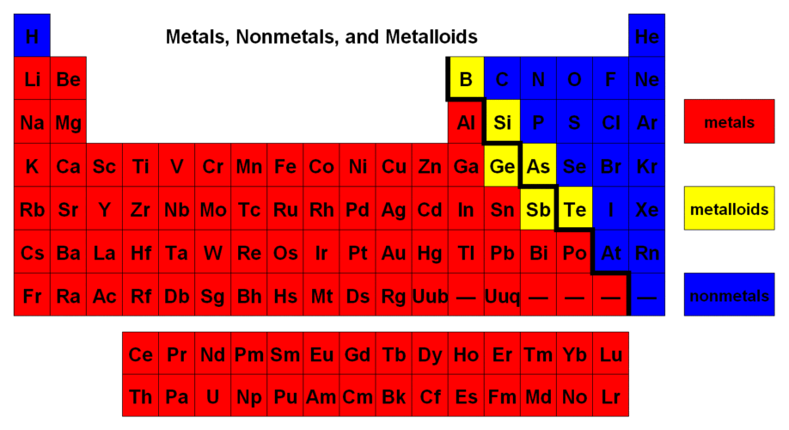
The negatively charged ion is negatively charged because it took an electron from the other element involved in the ionic bond. Ionic bonds are exceptionally strong, stronger than the other types of bonds that we just discussed and this strength is governed by electrostatic attraction. Recall that opposite charges attract, so when one atom takes an electron away from another, they attract each other (AMOLE).

Practice questions:
Predict the type of bonding in the following substances:
- NaCl
- SO₃
- Fe
- AgCl
- NO₂
- CH₃CH₃
- S₈
- KI
- C₆H₁₂O₆
- CO₂
Answers:
- Ionic
- Covalent
- Metallic
- Ionic
- Covalent
- Covalent
- Covalent
- Ionic
- Covalent
- Covalent
If we are to look at the periodic table, there are a few numbers associated with each element. Now that we know the atomic structure, we can dissect what exactly these numbers mean.
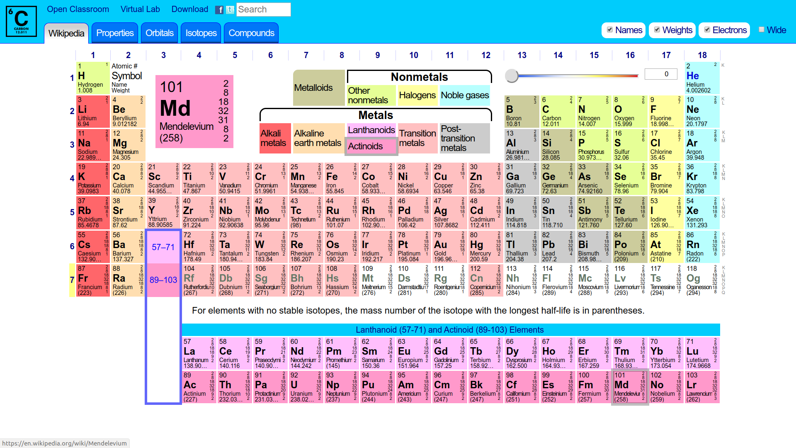

If we look at the zoomed in example above, for the element Md, there is a 101 and 258 above and below the element symbol. The other numbers on the side we can ignore. The number 101 is the atomic number. This number is equal to the number of protons in the atom and because atoms are neutral, it is also equal to the number of electrons in the neutral atom. The atomic number defines the identity of the element because each element has its own unique number of protons. The number below the 101 is the mass number, which is the sum of the protons and neutrons in the element. For the element Md, the mass number is 258, meaning that there are 258-101 = 157 neutrons. For most elements, however, there are different isotopes of the element. These isotopes have the same number of protons, because they are the same element, however, they vary based on their number of neutrons. This introduces the new number, the atomic mass, which is a weighted average of the mass numbers for all the isotopes of the element. For example, Br has an atomic mass of 79.901 amu, it has two different isotopes ⁷⁹Br and ⁸¹Br, these are roughly 50-50 split, with the 79 isotope having 51% abundance. Therefore to calculate atomic mass, we multiply the decimal equivalent of the abundance by the value and add all of these isotope values together:
$$atomic mass=0.51\left(79\right)+0.49\left(81\right)=40.29+39.69≈80$$
The atomic number of an element is ALWAYS less than the atomic mass and the mass number.
Practice questions:
- What is the atomic number of C?
- How many electrons are in Na⁺?
- How many electrons are in Ne?
- How many protons are in Cs?
- How many neutrons are in ¹⁴C?
- How many neutrons are in ⁸¹Br?
- What is the atomic number of Li?
Answers:
- 6
- 10, lost one electron to make it positively charged
- 10, isoelectronic with Na⁺
- 55, same as atomic number
- 14-6 = 8 neutrons
- 81-35 = 46 neutrons
- 3

Chapter 4: Periodic Trends and Quantum Numbers
The periodic table should become your best friend after this chapter. Once you see these trends in the periodic table, you will be able to surmise what kind of behavior certain elements will have and it will be exceptionally useful. There are two different types of groupings in the periodic table, periods and groups. Periods are the different rows of the periodic table (these run horizontally) and groups are the different columns of the periodic table (these run vertically). Elements in the same group have similar chemistry and behave in very similar ways. Sulfur and oxygen are very similar and carbon and silicon are also very similar because they are in the same groups, if you are interested in the similarities and chemistries of the various groups, you can look at the Inorganic Chemistry textbook on the website. The periodic table is comprised of different sections as well and they are shown below:
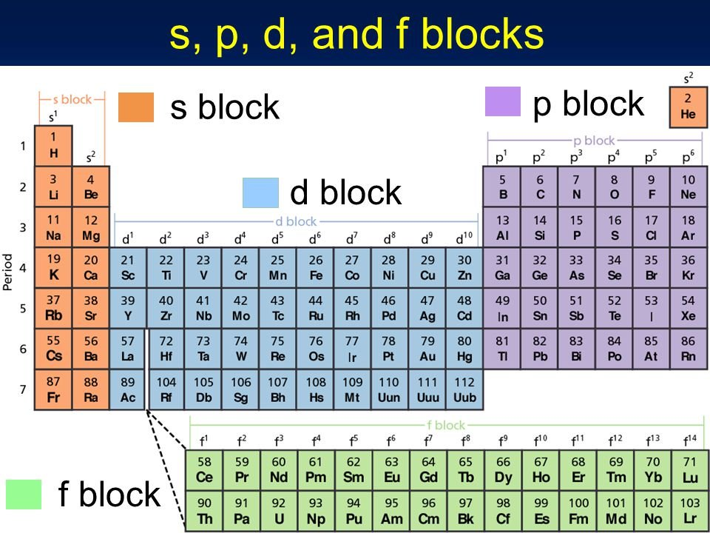

The number of valence electrons increases going from left to right, they increase by one in this direction after skipping the d block. For example, Li has 1 valence electron and B has 3 valence electrons.
Practice questions:
- How many valence electrons does Rb have?
- How many valence electrons does Ga have?
- How many valence electrons does C have?
- How many valence electrons does F have?
- How many valence electrons does I have?
- How many valence electrons does Xe have?
Answers:
- 1
- 4
- 4
- 7
- 7
- 8
First, let’s address the elephant in the room, what in the heck are all of those s,p,d, and f symbols all about? Remember how we said that electrons occupy orbitals? Well those orbitals can either be s, p, d, or f orbitals for all of the known elements. Each subshell in the orbitals can hold 2 electrons and the number of subshells starts with 1 for s and increases by 2. Therefore, p has 3, d has 5, and f has 7 subshells. Before we can get into electron configuration, we must first discuss quantum numbers. Quantum numbers are ways to numerically describe the properties of the electrons in an atom. These numbers describe the general shape that the path these electrons take is, how far they are away from the nucleus, their ‘spin’, etc. There are four quantum numbers and each of these numbers describes a specific electron in the atom. The first of these quantum numbers is the “principal” quantum number. The principal quantum number, often denoted as ‘n’, describes the general energy level the electron takes on, more specifically, it says how far away the electron is from the nucleus. The larger the n quantum number, the farther away that electron is from the nucleus. The second quantum number is the l quantum number and describes the general shape of the orbital, it specifies if the orbital is s,p,d, or f. The third quantum number, m_{l} describes which specific subshell that electron occupies. The last quantum number, m_{s}, describes the ‘spin’ of the electron in question. The spin of an electron is quite misleading, electrons are not balls and they do not rotate about their axis like the name would suggest. Spin is a historical term and it is an inherent property of electrons. Electrons can either be spin up or spin down. Again, the specifics are not super important. What is important is now being able to assign the electron configuration to an element on the periodic table.
The electron configuration is essentially a list of all the electrons in an atom. For example, hydrogen has 1 electron and it is in the first row, therefore its electron configuration is 1s¹. Helium has 2 electrons and it is in the first row, therefore its electron configuration is 1s². We can continue this pattern, lithium’s electron configuration is 1s² 2s¹. This is because each subshell can only contain two electrons, therefore the 1s orbital is full and the next orbital, the 2s orbital, must contain the third electron of lithium. If we wanted to draw out the orbitals and their subshells for H, He, and Li, it would look like the following:

Notice how in Helium’s case, I wrote the arrows pointing in opposite directions. This is because all electrons MUST have unique quantum numbers associated with them, if both electrons in helium pointed up, then they would have the same m_{s} quantum number and that would be forbidden. This principle of opposing spins is known as the Pauli Exclusion Principle. Because the 2s orbital has a higher n quantum number, going from 1 to 2, it is at a higher energy and therefore gets filled last. The principle that we fill lower energies first and then higher energies is known as the Aufbau principle. We can do this pattern continuously for all elements, however, when we get to the d and f block elements, the principal quantum number is 1 less than or 2 less than the row number for d and f orbitals respectively. The only exceptions are if you can get a half-filled or full d orbital by moving an electron from the s orbital. These work because half and completely full orbitals are most stable in energy compared to incomplete orbitals and because the s orbital is always higher in energy than the d orbital according to the principal quantum number. An example of an exception is Cr. Traditionally, the expected electron configuration for Cr would be 1s² 2s² 2p⁶ 3s² 3p⁶ 4s² 3d⁴, however, because the s orbital has a higher energy than the d orbital, the migration of an electron from the 4s orbital to the 3d orbital is energetically favorable and gives two half completed shells. The actual electron configuration for Cr is therefore 1s² 2s² 2p⁶ 3s² 3p⁶ 4s¹ 3d⁵. Here are some practice questions to help you get acquainted with electron configuration and then we will get into the specifics about drawing the orbital diagrams:
- Write the electron configuration for Ca
- Write the electron configuration for Ti
- Write the electron configuration for Zn
- Write the electron configuration for Ag
- Write the electron configuration for C
- Write the electron configuration for O
- Write the electron configuration for P
- Write the electron configuration for Ar
- Write the electron configuration for Bi
- Write the electron configuration for Ga
Answers:
- 1s² 2s² 2p⁶ 3s² 3p⁶ 4s²
- 1s² 2s² 2p⁶ 3s² 3p⁶ 4s² 3d²
- 1s² 2s² 2p⁶ 3s² 3p⁶ 4s² 3d¹⁰
- 1s² 2s² 2p⁶ 3s² 3p⁶ 4s² 3d¹⁰ 4p⁶ 5s¹ 4d¹⁰
- 1s² 2s² 2p²
- 1s² 2s² 2p⁴
- 1s² 2s² 2p⁶ 3s² 3p³
- 1s² 2s² 2p⁶ 3s² 3p⁶
- 1s² 2s² 2p⁶ 3s² 3p⁶ 4s² 3d¹⁰ 4p⁶ 5s² 4d¹⁰ 5p⁶ 6s² 4f¹⁴ 5d¹⁰ 6p³
- 1s² 2s² 2p⁶ 3s² 3p⁶ 4s² 3d¹⁰ 4p¹
An easier way of writing electron notation is by using the nobel gas short cut, to do this, identify the the closest lower atomic number nobel gas and write that in square brackets followed by the normal procedure. For example, the electron configuration for Ca becomes [Ar]4s². Because the orbitals that have the highest principal quantum number are the farthest away from the nucleus, these are also the valence electrons and these are the ones that will get taken away if there is an ionization. For example, the electron configuration for Na⁺ would be [Ne].
There are additional rules governing how to draw orbital diagrams for various atoms, if we take B, C, N, and F as examples, we will see how to draw proper orbital diagrams:
The important thing to note is that when all the subshells are of equal energies, the electrons prefer to spread out. This should make sense because like charges repel (AMOLE). Therefore, the two electrons would prefer to be in different subshells if they can, this principle is referred to as Hunds Rule. This will always work, let’s see if we can do some practice to get used to drawing these orbital diagrams.
Practice questions:
- Draw the orbital diagram for Ne
- Draw the orbital diagram for Mg
- Draw the orbital diagram for Ti
- Draw the orbital diagram for Cr
- Draw the orbital diagram for Ni
- Draw the orbital diagram for Cu
Answers:
You can assign the quantum numbers for each electron in these orbital diagrams. Let’s take the orbital diagram of boron for instance when assigning quantum numbers, we will assign the quantum numbers for those electrons that are colored:
Red electron: n = 1, l = 0, m_{l} = 0, m_{s} = +1/2
Blue electron: n = 2, l = 0, m_{l} = 0, m_{s} = -1/2
Pink electron: n = 2, l = 1, m_{l} = -1, m_{s} = +1/2
The n quantum number corresponds directly to the number proceeding the letter of the orbital, the l quantum number corresponds to the shape of the orbital, the letter after the number, for s orbitals, l = 0, p = 1, d = 2, and f = 3. The m_{l} quantum number refers to the specific subshell that the electron occupies, the subshell in the center is defined as the 0 subshell, the orbitals to the left are negative and the orbitals to the right are positive. The m_{s} quantum number refers to the spin/orientation of the arrow, if the arrow points up then m_{s} is +1/2, if it points down then m_{s} is -1/2.
For practice, assign all of the quantum numbers for each electron in titanium for extra practice.
This chapter is arguably the most important chapter in this textbook because periodic trends appear in every single future chemistry course in some way, shape, or form. Because of this, I include a brief overview of this in most of the other textbooks I have written. There are a few periodic trends that are critical to understand:
- Electronegativity (Anti-Snowman)
- Atomic radius (Snowman)
- Electron affinity (Anti-Snowman)
- Ionization energy (Anti-Snowman)
- Metallic character (Snowman)
- Acidity*
Now onto trends, there are two basic models for them. These are the “Snowman” and “Anti-Snowman” model. Most things follow the “Anti-Snowman” model, in fact only the atomic radius and metallic character trends follow the “Snowman” model. But what the heck are either of these? I will show you:

We will first center our discussion on electronegativity since this and atomic radii are the two most important trends that you will learn in this chapter. First let’s start by defining what electronegativity is. Electronegativity describes how much an atom in a bond wants electrons. The higher the electronegativity, the more the atom wants electrons in its bond. The most electronegative element on the periodic table that reacts with other elements is fluorine. Therefore, the trend is simple, the closer you are to fluorine, the more electronegative you are. This follows a strictly anti-snowman model. This trend can be easily explained using the orbital diagrams for each of the 2p elements, recall from the previous question what they look like:

Notice that the highest energy electrons are those that are in the 2p orbital, this does not change regardless of element. Because of this, without considering the attractive forces of the nucleus, these electrons are all roughly at the same distance from the center. However, what does change between B to F is the number of protons in the nucleus. The number of protons increases from boron to fluorine, while the outermost electrons do not change energy level, therefore there is a more powerful force of attraction for fluorine than boron because there are more protons in fluorine’s nucleus. The effective nuclear charge increases from left to right and because opposite charges attract, the fluorine nucleus REALLY wants that extra electron both because of electrostatic attraction to the nucleus (AMOLE) but also because doing so would complete its 2p orbital. Boron lacks this incentive because it has less protons in its nucleus and because the addition of one electron is not as energetically favorable (it does not form a full 2p orbital). This concept of electronegativity can help explain why some bonds are polar covalent while others are nonpolar covalent. For example, if a bond is formed between an electronegative element and a less electronegative element, then one of the atoms in the bond will want electrons way more and therefore the sharing will be unequal. On the other hand, if a bond is formed between two atoms of around the same electronegativity, then the electrons in that bond have no incentive to go to one atom over the other and therefore the sharing is equal, thus the bond is nonpolar covalent. Electronegativity is typically measured on a scale of 0-4, with 4 being fluorine’s electronegativity.
Practice Questions:
Determine if the following bonds would be ionic, metallic, polar covalent, or nonpolar covalent:
- Cr
- LiF
- CF
- CSi
- CC
- AuCl
- CH
Answers:
- Metallic
- Ionic
- Polar covalent
- Nonpolar covalent
- Nonpolar covalent
- Ionic
- Nonpolar covalent (H has a higher electronegativity than you would expect based off its positioning because its electrons are held very close to the nucleus and because gaining one electron would give it a full 1s orbital)
This concept of electronegativity will be further explored once we cover Lewis Dot Structures and molecular geometry.
The second most important trend for you to understand is the atomic radius trend. This trend should make sense, it follows a snowman model, meaning it increases going down a group and decreases going left to right. This can be explained by again looking at the electrons. If you go down a group, the principal quantum number changes, therefore the outermost electrons are pushed farther away from the nucleus. This is legit how atomic radius is defined, it is the distance from the nucleus to the outermost electron, therefore, going down a group pushes the outermost electrons further away therefore the radius will increase. If you go from left to right, like we said before, the effective nuclear charge increases, causing the atom to shrink. The outermost electrons are more attracted to the nucleus because opposite charges attract (AMOLE), therefore the atom constricts. This is not super important for this course, but it is incredibly useful for the study of organic chemistry because it helps determine bond strength and as you will learn in organic chemistry, weaker bonds will break first. Atomic radius is typically measured in picometers or Angstroms.
Practice questions:
Determine the atom that will have the larger atomic radius:
- C or Si
- Si or F
- Al or C
- Si or N
- Ge or As
- O or F
- Ca or Rb
- Be or Li
Answer:
- Si (it is below)
- Si (it is below and to the left)
- Al (it is below and to the left)
- Si (it is below and to the left)
- Ge (it is to the left)
- O (it is to the left)
- Rb (it is below and to the left)
- Li (it is to the left)

We can now discuss electron affinity. But first, what exactly is electron affinity? Well, put simply, it is exactly how it sounds, it measures how much an atom wants an extra electron put into it. This is different than electronegativity because electronegativity has to do with bonding, while this has to do with adding an electron in the gas state. Electron affinity is the energy released by putting an additional electron to an atom in the gaseous state. Just like electronegativity, this trend follows an Anti-Snowman model and for the same reasons. Electron affinity values are measured in kJ/mol and are strictly negative because the protons in the nucleus attract an electron, therefore, it is favorable to add an electron to an atom (AMOLE). Remember, everything favors negative energy because negative energy means that energy is being minimized, which is inherently good (AMOLE). The rationale for the electron affinity trends are the exact same as the ones for electronegativity. Electron affinity increases from left to right because of increasing effective nuclear charge causing the nucleus to pull incoming electrons closer to it more easily (AMOLE). Electron affinity decreases going down a group because higher principal quantum number means the outermost electrons are farther away from the nucleus, therefore, the force of attraction decreases between the incoming electron and the nucleus of the atom. This trend can have some anomalies depending upon if addition of one extra electron will cause a half-filled or full orbital, these electron affinities will be comparably larger than the surrounding ones because of the stabilizing nature of half-filled and full orbitals. On the other hand, if gaining electrons would cause the formation of a new orbital, then these values will be much lower than expected because one would rather have a full orbital than make a new one.
Practice questions:
Determine which element would have a higher electron affinity:
- Na or Mg
- Si or P
- Al or Si
- B or C
- Cl or S
- O or P
- Se or Cl
- Sn or Sb
Answers:
- Na, Mg already has a full s orbital wouldn’t want to fill in its p orbital
- Si, P has a half-filled p orbital therefore it would not want to lose that by adding an electron, additionally Si would become half-filled if it gained an electron, therefore its EA is higher than expected.
- Si, it is to the right
- C, it is to the right
- Cl, it is to the right and would gain a full octet and full p orbital
- O, it is to the right and up
- Cl, it is to the right and up
- Sn, same rationale as 2

The next periodic trend is ionization energy. While electron affinity was adding an electron to an atom in the gas phase, ionization energy is the removal of an electron from an atom in the gas phase. These values are always positive and measured in kJ/mol. These values are positive because the nucleus attracts electrons to it because opposite charges attract (AMOLE). It therefore takes energy from an external force to forcibly remove an electron from an atom. This trend also follows an Anti-Snowman model for the same reasons as electron affinity and electronegativity. Just as electron affinity, there are some exceptions to the general trend that ionization energy increases from left to right and decreases going down a group. These exceptions occur for the same reasons as for electron affinity, full orbitals and half-filled orbitals are inherently preferred over other incomplete orbitals. If more than one electron is to be removed from an atom, then the ionization energy is referred to as the second, third, or fourth ionization energy depending on if it is the second, third, or fourth electron removed. The second ionization energy is ALWAYS much larger than the first because removing an electron will cause the formation of a positively charged ion and this ion will have a stronger hold over its negatively charged electrons than a neutral atom (AMOLE). The largest increase in ionization energy will be when the atom in question has a noble gas configuration/full octet or half/completely filled orbital. Ultimately, having a full octet or noble gas configuration is the goal for all elements, a full octet is always preferred over a half-filled or completely filled orbital when it can get there.
Practice questions:
- What ionization energy will be larger for Mg, its second ionization energy or third?
- What ionization energy will be larger for Na, its first ionization energy or second?
- What ionization energy will be larger for O, its first or second?
- Which element has a larger ionization energy, O or N?
- Which element has a larger ionization energy, F or O?
- Which element has a larger ionization energy, O or Si?
- Which element has a larger ionization energy, Ne or F?
- Which element has a larger ionization energy, P or S?
Answers:
- Third ionization energy will be MUCH larger because that will break its full octet
- Second ionization energy will be MUCH larger because that will break its full octet
- Second ionization energy will be MUCH larger because that will break its half-filled p orbital
- N because it has a half-filled p orbital without removal, upon removal it no longer has a half-filled orbital, therefore its ionization energy is larger than expected.
- F because it is to the right of O
- O because it is to the right and up of Si
- Ne because it has a full octet, it doesn’t want to lose it by giving up an electron
- P because it has a half-filled p orbital, it doesn’t want to lose that by losing an electron
The least important periodic trend is regarding metallic character. This measures the capacity of an element to act like a metal, meaning it to conduct electricity, be flexible, and lose an electron. This trend follows a snowman model like atomic radius and this trend should make sense. An element like F will absolutely NOT want to lose an electron, however, Na would because then it would get a full octet. It therefore makes sense that metallic character increases from right to left. Metallic character increases going down a group because it is easier to remove an electron that is further away from the nucleus because the electrostatic attraction to the nucleus is smaller (AMOLE). Truthfully, this trend is not very useful and will hardly be tested. I include this trend simply for completeness.

This last trend is an optional trend, I include it mainly to help those of you who will go on to do organic chemistry. The last trend has to do with acidity and it follows a unique model. Acidity increases left to right and down a group. But wait a second, what is acidity? Acidity is the ability for a chemical to give up a hydrogen and become negatively charged. If we consider simple binary acids like HF, H₂O, NH₃, and CH₄, we can see that HF would be the strongest acid of them because giving up its hydrogen would result in the F being negative and because it is the most electronegative element of those being compared, it is the happiest being negatively charged. This is critical because in this way energy is minimized effectively by placing the negative charge on the more electronegative element (AMOLE). That compares compounds within the same period, but what about compounds within the same group? We can then look at the halogens for the best trend, we would compare HF, HCl, HBr, and HI. Though of these atoms F is the most electronegative by far, it produces the weakest acid of the halogens because the H-F bond is very strong due to F’s very small atomic radius. Fluorine forms very strong bonds with other elements because it is small. Small elements form smaller bonds and smaller bonds are strong. Small = strong. Because acidity measures the ability of a compound to give up its hydrogen, if the bond between the element and the hydrogen is stronger, it won’t want to break and therefore it won’t act as an acid as well. This trend can also be rationalized by looking at the anions that form when the hydrogen is given up, for HF it would be F⁻, HCl would be Cl⁻, HBr would be Br⁻, and HI would be I⁻. All of these anions have a negative charge, however, they vary based on size, I is the largest element, therefore, it will form the largest anion. We want to ultimately minimize charge and charge density, or how concentrated the charge is in one area (AMOLE). Because I is the largest element and therefore the largest anion, the negative charge that it has is spread across a much larger area and therefore it more effectively minimizes charge. This was not relevant in the first series because they were relatively the same size due to being in the same period, therefore, in that scenario the driving force was electronegativity. Another trend for acidity is that the more oxygens on oxyacids, the more acidic the compound, for example HClO is less acidic than HClO₄. The reason for this will be explained in future chapters.
Practice questions:
Determine which compound would be the stronger acid
- NH₃, PH₃
- H₂O, H₂S
- H₃PO₄, H₂SO₄
- HClO₄, HCl
- BH₃, HF
- HCl, HI
Answers:
- PH₃, P is below N
- H₂S, S is below O
- H₂SO₄, S is to the right of P
- HClO₄, it has more oxygens than HCl
- HF, F is to the right of B
- HI, I is below
Here are the general trends summarized on one periodic table:

Chapter 5: Lewis Dot Structures and Resonance
We have discussed bonding and the specific types of bonding in the previous chapters, but how can we draw something like H₂O or NH₃? To draw chemical bonds and molecules overall, we use what are called Lewis Dot Structures. These structures allow us to depict what molecules look like in space. We will get more into the specific geometries of these compounds in the next chapter, but suffice it to say that there are rules that govern the shape these molecules take on. First we can start by looking at the Lewis Dot Structures for individual elements and then we will progressively get more and more complex. Recall that the electrons that are involved with bonding are the valence electrons and these electrons are always involved in the orbitals with the highest principal quantum number (s and p orbitals). Therefore, when we write out Lewis Dot Structures, we don’t have to worry about the core electrons, only the valence ones are relevant. Also recall that electrons repel each other and therefore they prefer to spread out rather than pair with each other. Each electrons is drawn as a dot in the Lewis Dot Structure and these dots are centered around the atom of interest. For example, this is the Lewis Dot Structure for all second row elements of the periodic table:

As you can see, the electrons do not pair with each other until the four electrons are already placed. The direction that you move around the atom is not relevant as long as it is consistent. I added the extra electrons clockwise but you can also put it counterclockwise that is also right. There are two different ways to write Lewis Dot Structures, either with dots or with lines, nobody uses dots so I am going to show it to you once and that is it because legit nobody uses dots because it is REALLY ugly by comparison. To make a covalent bond, simply share the dots, we will show H₂ gas as an example shown below:
As you can see, both hydrogens are happy because they now both have a full s orbital. That is the dot notation way, but that way is really gross, the better way is drawing lines like so:
Each line that is drawn from the two atoms represents two electrons that are being shared among the atoms. Hydrogen is special because it can ONLY form one bond, but every other element can have more than one bond. Carbon for example is the most versatile because it can form four bonds and be happy. There is one key rule that governs drawing Lewis Dot Strutures and that is the octet rule. The octet rule states that atoms prefer to have 8 electrons whenever possible. This rule is not without exception like we just saw with hydrogen, but it is a very powerful rule of thumb when starting out, it holds most strongly for second row elements, for elements below the second row it does not apply. The reason why it does not hold for elements below the second row is that third row and beyond elements have access to the d orbital that is far enough away from the nucleus to be involved with bonding. For example, if we wanted to draw H₂O with a Lewis Dot Structure, we would draw it like this:
This works because hydrogen can only have one bond, both of the hydrogens are satisfied because they have a full s orbital and oxygen is happy because it has 8 electrons (2 from each bond and count the dots above the oxygen as well). The electrons that are not involved with bonding but are on an atom in a Lewis Dot Structure are referred to as lone pairs.
There is a systematic way of drawing Lewis Dot Structures such that they are always right:
- Count the number of valence electrons
- Put the least electronegative atom in the middle (this will be referred to as the central atom)
- Draw single bonds to each of the atoms coming off the central atom
- Put lone pairs on those atoms to satisfy their octet
- Put the rest of the electrons on the central atom
- If the central atom is not octet-satisfied, draw double or triple bonds to the atoms bonded to the central atom
For example, we can do the Lewis Dot Structure for CO₂. CO₂ has 4 + 6(2) electrons, 4 come from carbon and then 6 come from the two oxygens, hence we multiply by 2. Therefore CO₂ has 16 electrons at its disposal. Now we continue down the itinerary, because carbon is less electronegative than oxygen, carbon is the central atom and we draw single bonds to it. So far we have this:
That uses up all our electrons, so we can’t put any electrons on the central atom. The carbon is not octet satisfied however, therefore, it needs to have extra electrons in the form of bonds to oxygen. We can therefore put a double bond on each side of the carbon and we get this:
This structure has all 16 electrons in it and all atoms in the structure are octet-satisfied. Therefore this is the best structure we can draw for CO₂. But wait, why couldn’t we put a triple bond on one side and keep one of the single bonds? If we do that then we cause an issue:
The reason why the above structure is an issue is because the oxygens have what are called ‘formal charges’ meaning that they have either an excess or deficiency of electrons relative to their normal elemental form. The way to calculate formal charge is as follows:
$$Formal charge=valence electrons-bonds-lone pair electrons$$
When you count the lone pairs, you count the individual electrons, not just the pair itself. So if we were to assign formal charges to the structure shown above we would get the following for the oxygen with the triple bond:
$$Formal charge=6-3-2=6-5=1$$
Therefore the oxygen with the triple bond has a +1 formal charge. The other oxygen on the other hand has the following formal charge:
$$Formal charge=6-1-6=6-7= -1$$
Therefore, the oxygen with the single bond has a -1 formal charge. Therefore, the proper way to draw the structure above would be this:
Just like in everything else, we want to minimize charge wherever possible (AMOLE), therefore this is not a preferred Lewis Dot Structure because there are charged atoms in it. This speaks to a critical component of drawing Lewis Dot Structures, ALWAYS MINIMIZE CHARGE! Let’s see if you can draw the following molecules using these rules:
- CH₄
- XeF₆
- XeF₄
- NH₃
- H₂S
- N₂
- O₂
- F₂
- SO₃
- H₂SO₄
- HClO₄
- H₃PO₄
Answers:

There should be a pattern that you start to see when you look at C, N, O, and F. Carbon prefers to have four bonds, N prefers to have three bonds and one lone pair, O prefers to have two bonds and two lone pairs, and F prefers to have one bond and three lone pairs. This is referred to as their preferred valence, and elements below them will share this preference if they do not have to expand their octet. Fundamentally, this preference occurs because under these circumstances their formal charge is 0. For carbon, it has four valence electrons to start with, four bonds means in the formula it is
$$Formal charge=valence electrons-bonds-lone pair electrons=4-4=0$$
Therefore carbon will always have a formal charge of 0 if it has four bonds and no lone pairs. This works for N, O, and F as well. And remember, the fundamental reason why is because we want to minimize charge (AMOLE).

Practice:
Prove that the formal charge is 0 for N, O, and F if they have their preferred valence
Answer:
$$Formal charge_{N}=valence electrons-bonds-lone pair electrons=5-3-2=0$$
$$Formal charge_{O}=valence electrons-bonds-lone pair electrons=6-2-4=0$$
$$Formal charge_{F}=valence electrons-bonds-lone pair electrons=7-1-6=0$$

If there is an overall charge of a chemical, for example if it is a polyatomic ion, then that charge will be either added or subtracted from the overall electron count. If the ion is positively charged then the overall electron count will subtract away the positive charge because that means that electrons were removed to make the positive charge. If the ion is negatively charged, then the overall electron count will add to the negative charge because that means that electrons were added to the base structure to make it negatively charged. For example, let’s consider NO₂⁺ and SO₃²⁻ for instance:
NO₂⁺ has 5 + 12 electrons normally, however, an electron must have been removed for it to be positively charged, therefore the actual electron count is 16 rather than 17. SO₃²⁻ has 6 + 6(3) initially, however, an electron must be added for it to be negatively charged, therefore it has 26 electrons rather than the 24. We will first tackle drawing NO₂⁺ and then we will discuss SO₃²⁻.
- The overall electron count for NO₂⁺ is 16 as was previously discussed
- The least electronegative atom in NO₂⁺ is the N, therefore that gets placed in the center
- Single bonds are drawn to the oxygens from the nitrogen like so and their octets are satisfied with lone pairs:
- That uses up all the electrons available, therefore no electrons can be added to the nitrogen central atom
- Oxygen prefers to have two bonds, so put a double bond on either side of the nitrogen to satisfy the valence preference of the oxygens and we get:
- Now we can calculate the formal charge on the nitrogen, because the overall compound is positively charged, it would make sense that the nitrogen be positively charged as well since the oxygens are now neutral.
$$Formal charge=valence electrons-bonds-lone pairs=5-4=1$$
- Therefore, the nitrogen has a +1 formal charge and the official Lewis Dot Structure for NO₂⁺ is:

We can do the same thing for SO₃²⁻:
- The overall electron count is 26
- Sulfur is the least electronegative atom of the two, therefore it gets put in the center
- Put single bonds and satisfy octets of oxygens attached to the sulfur center, yields this structure without indicating formal charges:
- We have only used 24 electrons, therefore there are two left, which can be placed on the sulfur as a lone pair like so:
- We know oxygen prefers to have two bonds and sulfur just needs one extra bond to get its formal charge to 0 so:
- The formal charge on sulfur is 0 because it has 6 valence electrons – 4 bonds – 2 lone pair electrons. The double bonded oxygen has a formal charge of 0 because that is its valence preference, therefore the two oxygens that are single bonded will have the negative formal charge like so:

This formal charge assignment is corroborated by the formula as well:
$$Formal charge_{O}=6-1-6= -1$$

There is something special about SO₃²⁻, however, because there is no reason why the oxygen on the bottom right needs to have the double bond. Indeed, this structure has a resonance form. Now resonance is a super important thing for organic chemistry, and I want to teach it from now so that when you take organic chemistry, you will be more familiar with it. There are a few resonance patterns that are commonly found:
- Double-single-double
- Double-single-lone pair
In the SO₃²⁻ anion, there is the second pattern, double-single-lone pair. I will color code them for you so that you can see:

Because that lone pair is in “conjugation” with the double bond, the double bond with the oxygen can be moved to either of the oxygens in the molecule. This is because both oxygens (the one to the left and the one on the top) have resonance with the double bonded oxygen. There are three distinct resonance forms this anion has:

Practice questions:

Determine if the following anions have resonance:
- CO₃²⁻
- NO₃⁻
- SO₄²⁻
- ClO₄⁻
- PO₄³⁻
- XeF₅²⁻
Answers:
- Yes
- Yes
- Yes

- Yes
- Yes
- No

Chapter 6: Molecular Geometry and Polarity
In the last chapter, we did not concern ourselves with how the molecules arranged themselves specifically, but rather the general concepts of Lewis Dot Structures and resonance. In this chapter, however, we will improve upon our Lewis Dot Structures and give them a more reasonable geometry, one that is valid for real-life molecules. The theory that governs the geometry of most chemicals is known as VSEPR or valence shell electron pair repulsion. The governing principle behind this theory is that electrons are negative and therefore repel each other (AMOLE). Because they repel each other, bonds will orient themselves to minimize the repulsive forces felt by each electron. The end result is that atoms attached to the central atom will arrange themselves to maximize their distance apart from each other. There are six major geometries that you need to be familiar with. In this chapter we will be using AXE notation, where A is the number of central atoms (we will limit our discussion to one), X is the number of atoms attached to said central atom, and E is the number of lone pairs on the central atom. The six major geometries are AX₁₋₆ and these geometries lay the foundation for the molecular shapes that we will discuss after. The following are the major geometries:
To properly interpret these structures, you need to look at the bold-faced lines as bonds that are coming out at you and the dashed lines are bonds that are pointing away from you. The other bonds are neither pointing towards nor away from you, they are simply in the plane of the page.

These base geometries can be altered by the number of lone pairs. The number of X’s and E’s added together will bring you to one of the above base geometries, for each E present in the structure, one of the atoms attached to the central atom is replaced with a lone pair. For example, AX₂E would be bent because one of the X’s in the AX₃ geometry was replaced with a lone pair like so:
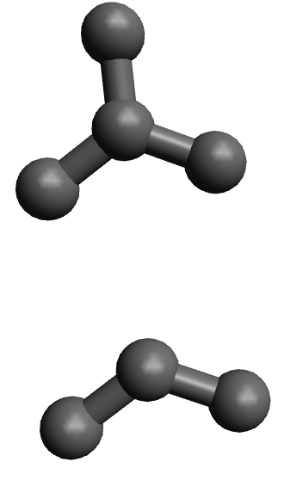

Trigonal planar

Bent
This works for all combinations of X’s and E’s. For base geometries that are lower than AX₅, it does not matter what X you replace with a lone pair. For the AX₅ base geometry, the E’s will replace the equatorial positions or the ones in the triangular portion of the trigonal bipyramidal structure. Like so:
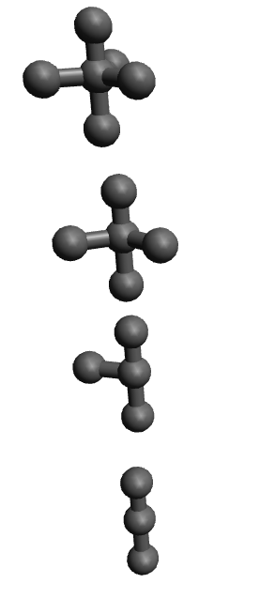

Trigonal Bipyramidal

See-Saw

T-Shaped

Linear

For the AX₆ base geometry, each E replaces the X’s on the top and bottom of the square portion of the octahedral geometry like so:
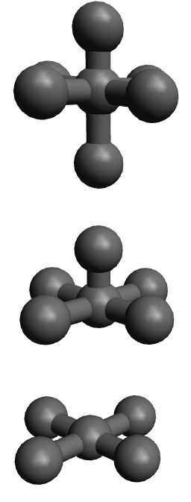

Octahedral

Square pyramidal

Square planar

All of these molecular shapes have specific names associated with them. These names are listed below:
AXE Notation | Base geometry | Molecular shape
AX₆ | AX₆, octahedral | Octahedral
AX₅E | AX₆, octahedral | Square pyramidal
AX₄E₂ | AX₆, octahedral | Square planar
AX₅ | AX₅, trigonal bipyramidal | Trigonal bipyramidal
AX₄E | AX₅, trigonal bipyramidal | See-Saw
AX₃E₂ | AX₅, trigonal bipyramidal | T-Shaped
AX₂E₃ | AX₅, trigonal bipyramidal | Linear
AX₄ | AX₄, tetrahedral | Tetrahedral
AX₃E | AX₄, tetrahedral | Trigonal pyramidal
AX₂E₂ | AX₄, tetrahedral | Bent
AX₃ | AX₃, trigonal planar | Trigonal planar
AX₂E | AX₃, trigonal planar | Bent
AX₂ | AX₂, linear | Linear
AX | AX, linear | Linear

Each geometry has its set of ideal bond angles and each shape has related bond angles. In linear molecules, the bond angle is 180 degrees because both the central atom and the atoms off it are collinear, they are on the same line. In trigonal planar molecules, the bond angle is 120 degrees. This should make sense physically because in a trigonal planar molecule, the atoms off the central atom make up a circle of three equal parts. Because circles have 360 degrees all around, each section must be 120 degrees apart, 3(120) = 360. Tetrahedral molecules prefer to have a bond angle of 109.5 degrees. There is no easy way of visualizing this, so you just need to memorize that as much as I hate to say that. The trigonal bipyramidal molecule has three bond angles, one for the equatorial positions with respect to the other equatorial positions, one for the equatorial positions with respect to the axial positions, and one for the axial positions with respect to each other. The equatorial positions are just trigonal planar so the bond angle there is 120 like before and for the same reason. The bond angle between the equatorial and axial positions is 90 degrees because the equatorial positions are perfectly horizontal and the axial are perfectly vertical and the horizontal and vertical directions are perfectly 90 degrees apart. And finally, the bond angle between the two axial positions is 180 because they are linearly arranged just like the AX and AX₂ case. And finally, the octahedral geometry has three bond angles as well, the same three that the trigonal bipyramidal has. The only difference between the octahedral geometry and the trigonal bipyramidal is that the base is a square rather than a triangle, therefore the bond angle for the equatorial positions change from 120 to 90 degrees. This information is summarized in the table below:

AXE notation | Molecular geometry | Bond angle 1 | Bond angle 2 | Bond angle 3
AX₆ | Octahedral | Equatorial-equatorial = 90 | Equatorial-axial = 90 | Axial-axial = 180
AX₅ | Trigonal bipyramidal | Equatorial-equatorial = 120 | Equatorial-axial = 90 | Axial-axial = 180
AX₄ | Tetrahedral | All angles 109.5 | N/A | N/A
AX₃ | Trigonal planar | All angles 120 | N/A | N/A
AX₂ | Linear | All angles 180 | N/A | N/A
AX | Linear | All angles 180 | N/A | N/A

The molecular shapes have similar bond angles, except the lone pair electrons push the bond angles to be smaller than ideal. This is because like charges repel and the lone pairs represent a more concentrated negative charge than the covalent bonds (AMOLE). Therefore, the bond angles for all of the molecular shapes that are not just base geometries will be less. The specific numbers you are not required to know, these would be covered in the Organic Chemistry textbook.
Practice Questions:
- What is the molecular geometry and molecular shape for NH₃?
- What is the molecular geometry and shape for H₂O?
- What is the molecular geometry and shape for CH₄?
- What is the molecular geometry and shape of SOCl₂?
- What is the molecular geometry and shape of PF₆⁻?
- What is the molecular geometry and shape of HCN?
- What is the molecular geometry and shape of COH₂?
- What is the molecular geometry and shape of PO₄³⁻?
- What is the molecular geometry and shape of POCl₃?
- What is the molecular geometry and shape of XeF₄?
- What is the molecular geometry and shape of PF₅?
- For questions 1-11, what are the specific bond angles?
Answers:
- Tetrahedral, Trigonal pyramidal, AX₃E
- Tetrahedral, Bent, AX₂E₂
- Tetrahedral, Tetrahedral, AX₄
- Tetrahedral, Trigonal pyramidal, AX₃E
- Octahedral, Octahedral, AX₆
- Linear, Linear, AX₂
- Trigonal planar, Trigonal planar, AX₃
- Tetrahedral, Tetrahedral, AX₄
- Tetrahedral, Tetrahedral, AX₄
- Octahedral, Square planar, AX₄E₂
- Trigonal bipyramidal, Trigonal bipyramidal, AX₅
- NH₃: <109.5, H₂O: <109.5, CH₄: 109.5, SOCl₂: < 109.5, PF₆⁻: 90, 90, 180, HCN: 180, COH₂: 120, PO₄³⁻: 109.5, POCl₃: 109.5, XeF₄: 90, PF₅: 120, 90, 180.

Now we will discuss the concept of polarity. Because we can now draw out the proper geometries of all the molecules that we have discussed so far, we can determine if a molecular is polar or not. But what does being polar mean? To be polar, the molecule needs to have a permanent dipole that is somewhat appreciable. There are varying definitions of what constitutes “polarity”, because polarity is not black and white, it is a spectrum. It is not quite accurate to say something is polar, but rather it is better to say that something is MORE polar than something else. In this text, we are going to be using a general definition of polarity which will get you the right answer in most exams because there are certain agreed upon thresholds of polarity. We will make the simplifying assumption that all molecules can be classified as either polar or nonpolar. For a molecule to be polar, there needs to be a net dipole, meaning that all the polar bonds in the molecule need to overall point in one direction. In chemistry, we always draw our dipoles from the less electronegative element to the more electronegative element because as chemists, we are interested in where the electrons are localized. We will first draw the dipole of water and we will discuss why water is polar:
In water, the oxygen is more electronegative than the hydrogens, therefore, each dipole will point from the hydrogen to the oxygen. Because of this and the bent geometry that water has, the molecule is polar because both dipole point up, even though they point in opposite horizontal directions, they point in the same vertical direction, therefore they do not cancel out. I like to view this as a tug of war between the two dipole arrows. Because both dipole arrows point up, there is no opposing force, so it is essentially like playing tug of war with no opponent, you always win. Compare this to a nonpolar molecule like CO₂:
Here, the carbon is less electronegative, therefore both dipole arrows start from the carbon. Because the CO₂ molecule is linear, both dipole arrows cancel each other out, they point in exactly opposite directions and with the same magnitude because the same elements are involved, therefore there is NO net dipole for CO₂ and it is nonpolar. If you can do this analysis for all compounds, then you can determine if a molecule is polar or not.

Practice questions:
- Is NH₃ polar or nonpolar?
- Is CCl₄ polar or nonpolar?
- Is CH₄ polar or nonpolar?
- Is SO₃ polar or nonpolar?
- Is HCN polar or nonpolar?
- Is XeF₆ polar or nonpolar?
- Is XeF₄ polar or nonpolar?
- Is CH₃Cl polar or nonpolar?
- Is CHCl₃ polar or nonpolar?
- Is CH₂O polar or nonpolar?
- Is CH₂O or COF₂ more polar?
- Is NH₃ or NH₂Cl more polar?
Answers:
- Polar, look at dipole arrows, they all point up:
- Nonpolar, all dipoles cancel out, like so:
- Nonpolar, all dipoles cancel out, like so:
- Nonpolar, all dipoles cancel out, like so:
- Polar, look at dipole arrows, they all point to the right:
- Nonpolar, all dipoles cancel out, like so:
- Nonpolar, all dipoles cancel out, like so:
- Polar, look at dipole arrows, C-Cl bond is polar and overrides the C-H bonds
- Polar, same reasons as above
- Polar, look at dipole arrows, they point up:
- CH₂O, COF₂ would partially cancel the dipole pointing up like so:
- NH₃ is more polar because the Cl would cause one of the dipole arrows to cancel like so;

In the next chapter we will discuss the specific implications that being polar or nonpolar has on the molecule’s boiling point and water solubility among other physical properties.

Chapter 7: Intermolecular Forces and Physical Properties

The discussion of intermolecular forces and physical properties of molecules is critically important to a wide variety of subjects. For those of you who are going into the medical field or are thinking of going into drug development, this chapter is especially important to you. This is because the means by which drug molecules interact with their biological target is through intermolecular forces. In fact, a lot of research and development is done to optimize the intermolecular forces to increase binding affinity of a drug molecule for one target over all other possible side reactions to minimize side effects of drugs.

So far, we have only discussed chemical bonds, these bonds occurred within the same molecule, therefore these were INTRAmolecular forces. But there are also forces of attraction and repulsion between one molecule and another. These forces are referred to as INTERmolecular forces. Broadly, there are only four main types of intermolecular forces and one bonding interaction that we had already described, I will describe each of them in order of increasing strength:
- Van Der Waals interactions
- Dipole-dipole interactions
- Hydrogen bonds
- Ion-dipole interactions
- Ionic bonding **
We will discuss each of these in turn and describe their effects on physical properties such as boiling point and solubility in water. Ionic bonding, while truly a bond, rather than a force of attraction, is described here because of its strong impacts in biological systems. This chapter will focus mainly on biological systems and the application this material has on it to help contextualize these forces to solve a real-life problem, otherwise this stuff can get pretty dry and I know that you are super smart so you can do this. At their heart, all intermolecular forces are attractive forces because of the attraction of opposite charges. Therefore, it would stand to reason that polar molecules will have stronger intermolecular forces. This turns out to be true and has drastic implications for protein structure and boiling point.
Van Der Waals interactions are intermolecular forces that every single molecule has by default. These interactions are caused by a temporary dipole created by electron deficiency and excess on the two sides of the molecule because sometimes electrons occupy one portion of the molecule while they are orbiting the molecule slightly more than the other for a split second. This causes one end of the molecule to be negatively charged (the one that has excess electrons) and the other end would be positively charged (the one that has less electrons). Because opposite charges attract, the negatively charged portion of the molecule will be attracted to the positively charged portion of another molecule. Keep in mind, these rarely happen and only exist for a split second, therefore they are EXTREMELY weak interactions.
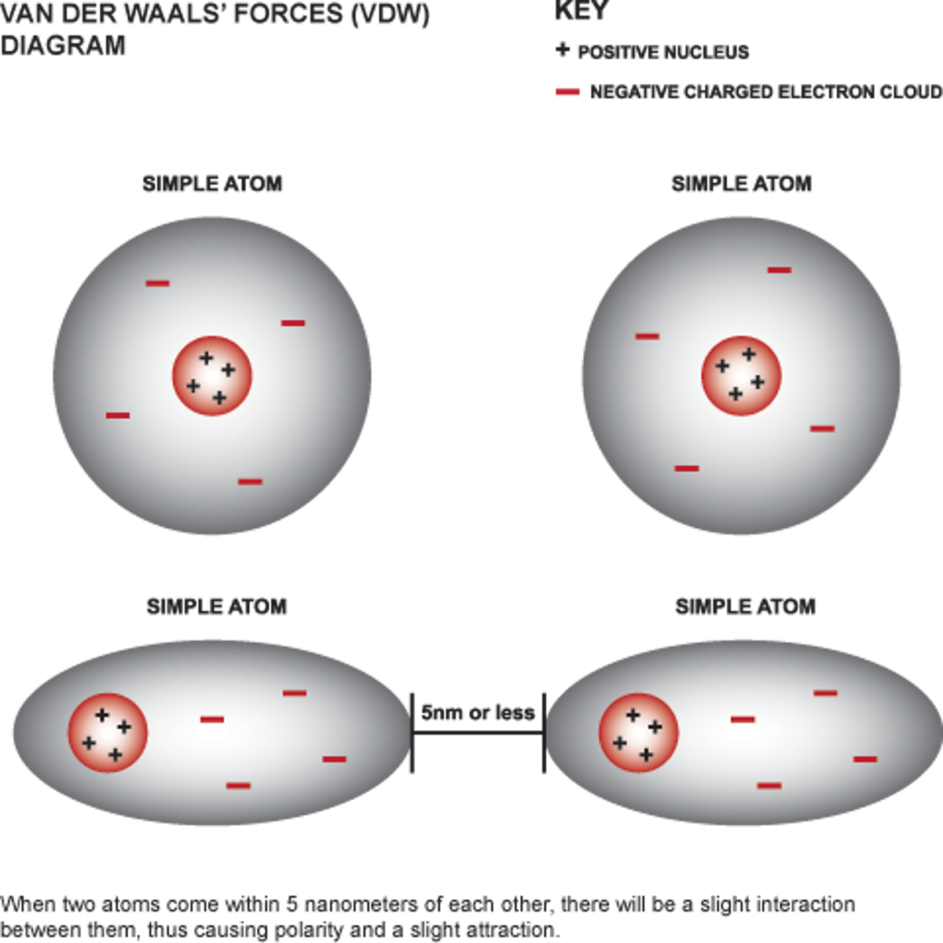

Dipole-dipole interactions occur only within polar molecules. This occurs because in polar molecules, there is ALWAYS a positive and negative end of the molecule. Because in polar molecule there is always a positive and negative end, there will always be an attraction of the negative end of one molecule for the positive end of another (AMOLE). This is much stronger than Van Der Waals interactions for two reasons:
- They will occur for much longer because polar molecules have permanent dipoles rather than temporary ones
- The dipoles in polar molecules are typically larger than those in Van Der Waals interactions, therefore the interactions are stronger. The larger the charge, the larger the attractive force.
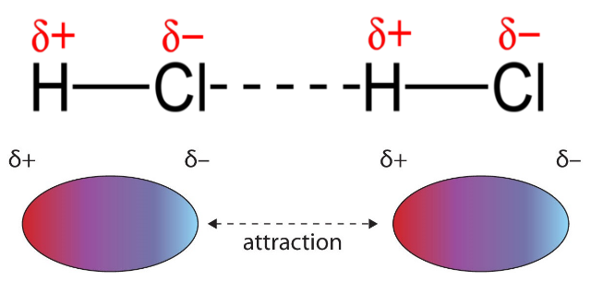
The above diagram shows an example of a dipole-dipole interaction. The little d-looking symbols are called ‘deltas’ and they mean ‘partial’. Notice how the more electronegative of the two atoms, the Cl, has the partial negative charge and it is this side that is attracted to the partial positive atom of the other molecule (AMOLE).
Hydrogen bonds are the strongest type of dipole-dipole interactions. These dipole-dipole interactions occur when a hydrogen is covalently bonded to one of three elements: N,O, or F. These are the elements that must be covalently bonded to the hydrogen because these three elements are the most electronegative elements on the periodic table. The electronegativity of F is 4.00, O is 3.44, and N is 3.04. These elements therefore make the strongest dipole-dipole interactions with hydrogen and makes it so that it acts almost as if it was a bare positive charge, which is the reason why these interactions are the strongest non-ionic interactions. These interactions explain the wide difference in boiling points for H₂S and H₂O and other compounds shown below:
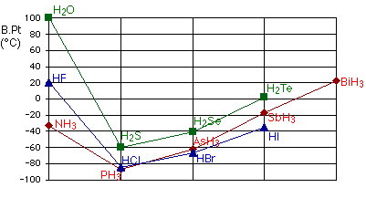

Despite H₂S being able to do dipole-dipole interactions, it cannot do hydrogen bonding and therefore its boiling point is DRASTICALLY different than water (100 degrees Celsius compared to -60 degrees Celsius). Within hydrogen bonding, there are two different types of sites that are available, hydrogen bond acceptors and hydrogen bond donors. The hydrogen bond acceptors are always the electronegative atom covalently bonded to the hydrogen. The number of hydrogen bond acceptor sites on the electronegative atom is equal to the number of lone pairs. The hydrogen bond donors are always the hydrogen covalently bonded to the highly electronegative atom. The above chart shows that it is ideal for there to be two hydrogen bond donors and two hydrogen bond acceptors because H₂O has the highest boiling point. This is the ideal scenario because this allows water to form very complex hydrogen bonding networks like that shown below:
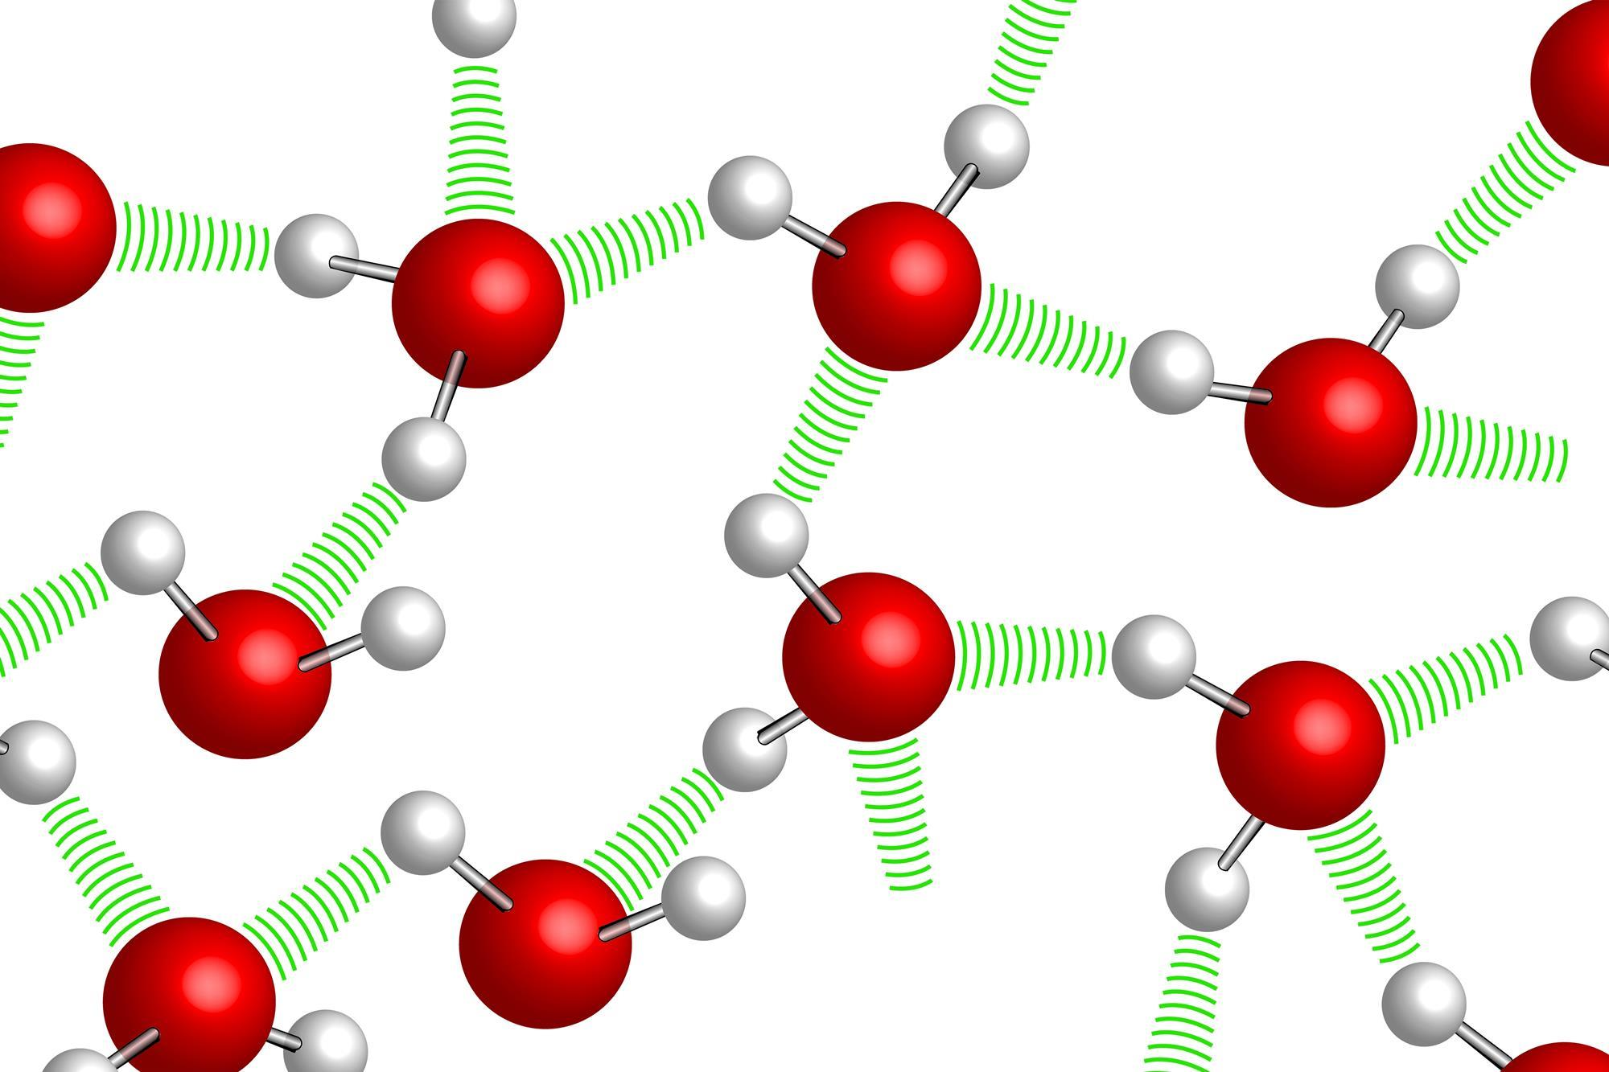

This again, works because the hydrogen is partially positive and the oxygen is partially negative and therefore they will attract each other (AMOLE). Hydrogen bonding, unlike the other interactions that we have discussed so far, is directional, meaning that the orientation of the hydrogen bond donor and acceptor is important and dictates its strength. The ideal hydrogen bond angle is 180 degrees, as shown below:
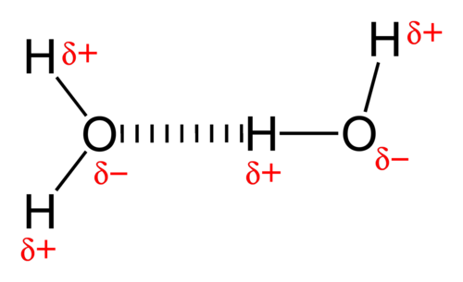
This hydrogen bonding angle maximizes the attractive force felt between the oxygen and the hydrogen and therefore makes a stronger hydrogen bond.

Now we will temporarily leave the world of purely molecular substances and instead discuss molecule-ion interactions. This brings us to discuss ion-dipole interactions. As the name would suggest, these interactions occur when polar molecules interact with ions. Like in every other scenario, opposite charges attract (AMOLE). Therefore, the cations will attract the negative ends of the polar molecules and the anions will attract the positive ends of the polar molecules. The reason why these interactions are stronger than H-bonds and dipole-dipole interactions is because the ions have a full positive or negative charge while molecules only have a partial charge with the H-bonds approaching more of a full charge and therefore are stronger than other dipole-dipole interactions. These most often occur when you dissolve an ionic compound like NaCl in water. The positively charged hydrogens of water will orient themselves towards the Cl⁻ of NaCl and the negatively charged oxygens of water will orient themselves towards the Na⁺ of NaCl. In this way, water can effectively solvate the anions and cations of NaCl and allow it to dissolve in water. This process is shown below:
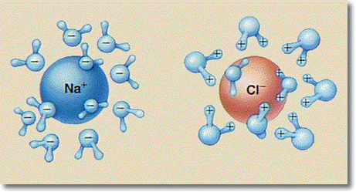

The last interaction that we will discuss is ionic bonds. These ionic bonds are the strongest interaction that we have discussed so far and this is because it involves a full charge interacting with another full charge. The ion-dipole was a full charge interacting with a partial charge, therefore it was weaker. These interactions are very strong and they are critical for proteins folding properly and are typically the most important interactions when a drug molecule first enters the drug target site. The fundamental reason why these interactions work is because of electrostatic attraction between opposite charges. This force of attraction is described quantitatively by Coulomb’s Law as shown below:
$$F_{electrostatic}=k\frac{q_{1}q_{2}}{r^{2}}$$
K is some constant that we will not discuss because we aren’t physicists, the two q’s are the magnitudes of the two charges involved in the interaction, and the r is the distance between the two charges.
Here is a chart that will pull all of this information together:
There are also two trends that you need to be familiar with that are contingent upon you understanding polarity and intermolecular forces:
- Boiling point
- Water solubility
In both scenarios, the more polar the molecule, the higher its boiling point and the higher its water solubility. This is because if you are more polar, then you will generally have stronger intermolecular forces and therefore it will be harder for you to vaporize the compound into the gas phase. To vaporize a compound, you need to first break the intermolecular forces of attraction, therefore the stronger the intermolecular forces, the more thermal energy is required to break those bonds and therefore vaporize the compound. The water solubility is determined by its polarity because of the phrase “like dissolves like”, because water is a polar molecule like we had previously discussed in the last chapter, it prefers to dissolve polar molecules. If you are comparing nonpolar molecules, the one with the larger mass has a higher boiling point, but a worse water solubility. This is because larger molecules are harder to solvate in water, therefore, it will be harder for water to dissolve it. However, the larger mass, the stronger the Van Der Waals forces, therefore the higher the boiling point.
Practice questions:
- What intermolecular forces could CH₃SOCH₃ participate in?
- What intermolecular forces could POCl₃ participate in?
- What intermolecular forces could CHCl₃ participate in?
- What intermolecular forces could CH₂O participate in?
- What intermolecular forces could HCO₂H participate in?
- Identify all relevant intermolecular forces present in the following enzyme’s active site (just worry about the atoms that are explicitly written):
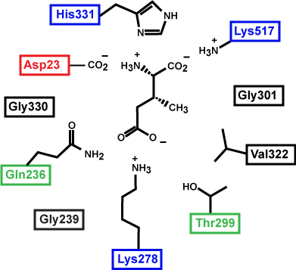
- It is your first day as a medical research scientist and you are attempting to design a drug to target HIV reverse transcriptase to prevent the spread of the HIV virus within the human body, the active site of the enzyme (the part of the enzyme with which the drug interacts) is shown below and your predecessor’s molecule is shown in the active site as well:

  - Identify all intermolecular forces that are keeping your predecessor’s molecule in the active site.
  - Suggest ways to improve its binding affinity

- Cellulose and glycogen are biomolecules that are both polymers of glucose, meaning that they are made of long chains of glucose molecules. Despite them both being polymers of glucose, cellulose is much tougher and stronger than glycogen. Explain this behavior in terms of intermolecular forces.

- The picture below shows the secondary structure of a protein, identify the critical intermolecular forces that are keeping this secondary structure stable:
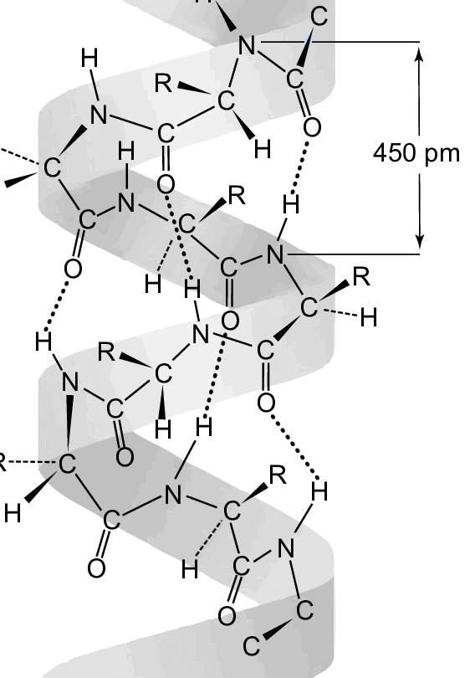
- A drug shows great promise in treating the coronavirus. When it is administered into the blood, it is found that patients with severe acidosis, or acidic blood, respond poorly to this medication while patients with severe alkalosis, or basic blood, respond substantially better than patients with neither condition. Suggest an explanation for this occurrence on the premise of intermolecular forces. (Hint: acidic solution will make negative things neutral and basic solution is the opposite of acidic solution).

- Which compound would have a higher boiling point of the following pairs:

  - CO₂, CH₃SOCH₃
  - H₂S, HF
  - C₂H₆, C₂H₅OH
  - NaCl, HCO₂H
  - XeF₄ vs CH₄
- Which compound would have a better solubility in water of the following pairs:
  - HCO₂H, C₂H₆
  - C₆H₁₂O₆ (glucose), CO₂
  - CH₃OH, CH₃CH₂OH
  - H₂S, HF
  - CH₂Cl₂, CH₂F₂

Answers:
- Dipole-dipole, ion-dipole, and Van Der Waals because CH₃SOCH₃ is polar as shown below:
- Dipole-dipole, ion-dipole, and Van Der Waals because POCl₃ is polar as shown below:
- Dipole-dipole, ion-dipole, and Van Der Waals because CHCl₃ is polar as shown below:
- Dipole-dipole, ion-dipole, and Van Der Waals because CH₂O is polar as shown below:
- Hydrogen bonding, dipole-dipole, ion-dipole, and Van Der Waals because HCO₂H is polar and has an OH bond as shown below:

  - A lot of possible answers here, the key is to change the blue molecule such that it has stronger intermolecular forces, one such response would be something like this:

The reason why changing the Cl’s to O’s makes the dipole-dipole interaction into hydrogen bonding is because O can act as a hydrogen bond acceptor while Cl cannot because it is not one of the special elements that can participate in hydrogen bonding (N,O, and F).

- This was a tricky question admittedly, but it has to do with the orientation of the hydrogen bonds. You had to be able to figure that out because both molecules are polymers of glucose, so there is no difference between them except the orientation of the glucose. Because cellulose is stronger and tougher than glycogen despite being made of the same thing is because cellulose can orient its glucose chain so that it has 180 degree hydrogen bonds which maximizes their strength and makes the material stronger.

- This alpha helical structure (the specific type of secondary structure shown in the picture I gave you) is held together by NH-O hydrogen bonds as shown by the dashed lines. These intermolecular forces are very strong and they can drive the formation of special structures like helixes that otherwise would not exist. We know it has to be hydrogen bonding because the NH portion of the protein acts as a hydrogen bond donor and the O acts as a hydrogen bond acceptor.

- This is not a real situation, but if the situation was true, then it would stand to reason that the acidic blood was causing the loss of a negative charge that was critical for the drug to bind to it. Likely the drug interacted with the coronavirus with some type of ionic bonding or ion-dipole interactions that caused very strong binding and therefore the drug was very potent. The basic solution caused the negative charge of whatever the drug target was to become more pronounced and therefore the drug was able to bind to stronger, strengthening the interaction and making the drug work better.

  - CH₃SOCH₃, it is polar and therefore can do dipole-dipole interactions
  - HF, it can do hydrogen bonding
  - C₂H₅OH, it can do hydrogen bonding and dipole-dipole interactions
  - NaCl, it has ionic bonding which is the strongest force discussed in this chapter
  - XeF₄, both are nonpolar, but XeF₄ is heavier

  - HCO₂H, it is polar and can do hydrogen bonding interactions with water
  - C₆H₁₂O₆ (glucose), it is polar and can do stronger hydrogen bonding interactions with water
  - CH₃OH, it has less carbons which makes it more polar
  - HF, it can do hydrogen bonding interactions and it is more polar because F is more electronegative than S
  - CH₂F₂, it is more polar because F is more electronegative than Cl and therefore will win the dipole tug of war more.

Chapter 8: Nomenclature and Basic Chemical Reactions

So far we have learned to draw chemicals, but not how to name them. In this chapter, we will discuss the nomenclature (system of naming) of chemicals and some basic chemical reactions. It turns out that chemical nomenclature at this level comes in three flavors: ionic compound, molecular, and acid nomenclature. We will start our discussion with ionic nomenclature since this is arguably the simplest.
Recall that ionic compounds occur when a metal bonds with a nonmetal. Therefore, there are a wide variety of compounds that could be formed since there are many metals. To name an ionic compound, simply write the name of the cation as the name of the element followed by the anion’s element name with suffixe –ide. For example NaCl would be named sodium chloride. Sodium because Na is the symbol for the element sodium and chloride because we changed chlorine’s ending from –ine to –ide. The subscripts of ionic substances has to do with the charges of the cation and anion. For example Ag₂O is silver oxide and the reason why there are 2 Ag’s is because Ag has only one stable charge of +1 and oxygen is always -2. The best and easiest way to determine the number of ions in an ionic compound is to do a criss-cross like so:
Some atoms have more than one possible charge that they can carry. These metals are typically in the d-block of the periodic table and some lower p-block elements like Pb. When there is more than one possible charge a cation can take on, indicate the charge in the name by putting the Roman numeral equivalent in parenthesis. For example PbO₂ would be written as lead(IV) oxide because the lead has a +4 charge. But wait, if we did the criss-cross trick with that, we would get lead to have 2 and oxygen to have 4, why then is it PbO₂? The reason why is because we have to reduce the numbers, 2 and 4 are divisible by 2 so we reduce both of them so that Pb has 1 and O has 2. Here are some general charge trends that will be very useful:
- All group 1 elements have +1 charge
- All group 2 elements have +2 charge
- All upper group 3 elements have +3 charge
- Oxygen always has a -2 charge
- Hydrogen always has a +1 charge
- Halogens (the last group before the noble gases) always have -1 charge
These general trends should make sense because if group 1 elements have a +1 charge, they will have a full octet or noble gas configuration. The same is true for the group 2 and 3 element trends. If oxygen has two more electrons and therefore has a -2 charge, it would go from having 6 valence electrons normally to 8 electrons, a full octet, therefore that trend makes sense as well given what we know about the stability of the noble gases. Halogens would also have a noble gas configuration/full octet if they gained an electron and became negatively charged. Remember, we always want to minimize our energy and get to greater stability (AMOLE).
Here is also a list of some common polyatomic ions. Polyatomic ions are ions that are comprised of several elements:
If a polyatomic ion is in the chemical structure and is written more than once, put the group in parenthesis and write the subscript below the parenthesis. For example, ammonium carbonate would be written as (NH₄)₂CO₃. Let’s see if you can give it a go with some mixed practice.
Practice Questions:
- Write the name for CuCl₂
- Write the name for NaF
- Write the name for KI
- Write the name for K₂O
- Write the name for CuO
- Write the name for Cu₂O
- Write the name for TiO₂
- Write sodium hypochlorite
- Write copper(II) acetate
- Write ammonium hydroxide
- Write ammonium phosphate
- Write sodium sulfite
- Write lead(II) phosphate
- Write magnesium hydroxide
- Write calcium chlorate
- Write aluminum acetate

Answers:
- Copper(II) chloride
- Sodium fluoride
- Potassium iodide
- Potassium oxide
- Copper(II) oxide
- Copper(I) oxide
- Titanium(IV) oxide
- NaOCl
- Cu(C₂H₃O₂)₂
- NH₄OH
- (NH₄)₃PO₄
- NaSO₃
- Pb₃(PO₄)₂
- Mg(OH)₂
- Ca(ClO₃)₂
- Al(C₂H₃O₂)₃

Molecular nomenclature has to do with compounds that have nonmetals bonded to each other. This system follows a similar structure to the one above, but with an extra factor. When more than one of an element is present you need to use prefixes to tell how many there are. The most common prefixes are mono, di, tri, tetra, penta, and hexa. For example N₂O₅ would be dinitrogen pentoxide. In the same way that we changed the ending to –ide for the second element listed ion ionic compounds, the same is done here. If the first element listed is only listed once, then mono can be excluded from the name. For example, CO₂ is carbon dioxide, not monocarbon dioxide. Here are some mixed practice for you to do to get used to molecular nomenclature:
Practice questions:
- Write the name for NO₂
- Write the name for P₂O₅
- Write the name for PF₅
- Write the name for XeF₄
- Write the name for XeF₆
- Write the name for CCl₄
- Write the name for BF₃
- Write OCl₂
- Write BrCl₅
- Write KrCl₄
- Write SO₃
- Write ClF₅
- Write RnI₆
- Write NS₂
- Write OF₂
- Write CS₂
Answers:
- Nitrogen dioxide
- Diphosphorus pentoxide
- Phosphorous pentafluoride
- Xenon tetrafluoride
- Xenon hexafluoride
- Carbon tetrachloride
- Boron trifluoride
- Oxygen dichloride
- Bromine pentachloride
- Krypton tetrachloride
- Sulfur trioxide
- Chlorine pentafluoride
- Radon hexaiodide
- Nitrogen disulfide
- Oxygen difluoride
- Carbon disulfide

The last system of nomenclature that we will deal with is acid nomenclature. Acids are compounds that can give away a hydrogen easily. These compounds are critically important to all facets of life and will be discussed in great detail in future chapters. A common feature for all acids that we will discuss in this course is an acidic hydrogen (proton). There are two different kinds of acids that we will encounter in this course, binary acids and oxyacids. The binary acids are things like HCl, HF, etc. These acids are very easy to name, they start with hydro followed by halogen’s name with the ending changed to –ic acid. For example, HCl would be hydrochloric acid. Unlike the other nomenclature systems, the hydro and chloro are not separated by a space, they are one word. For the oxy acids, it is important to determine if the maximum number of oxygens is present in the non-hydrogen part. For N and C, the maximum number of oxygens is 3, for S and P, the maximum number of oxygens is 4. If the maximum number of oxygens is present, the ending is –ic acid, for sulfur and phosphorus the ending is –uric acid and –oric acid to make it sound nicer. For example HNO₃ is nitric acid and H₂SO₄ is sulfuric acid. Notice that in these names, the hydrogens are NOT included in the name. If the number of oxygens is one less than the maximum, then the ending is –ous acid. For example, H₂SO₃ is sulfurous acid. Here are some practice problems for you to do.

Practice questions:
- Name HNO₃
- Name H₂SO₄
- Name HClO₄
- Name HClO₃
- Name HBr
- Name HI
- Name HF
- Name H₂SO₃
- H₃PO₄

Answers:
- Nitric acid
- Sulfuric acid
- Perchloric acid
- Chlorous acid
- Hydrobromic acid
- Hydroiodic acid
- Hydrofluoric acid
- Sulfurous acid
- Phosphoric acid
Here is a comprehensive chart for all the nomenclature rules:

Now we will get to some basic chemical reactions. There are three different types of reactions that we will discuss here:
- Single displacement
- Double displacement
- Combustion
Both of the displacement reactions involve ionic compounds and the last one is special.
In single displacement reactions, a more reactive metal is reacted with an ionic compound and the anion of the ionic compound is moved to the metal like so:
Li + NaCl LiCl + Na
This can also occur with metals that have different charges/oxidation states like so:
Mg + AgNO₃ Mg(NO₃)₂ + Ag
But wait a second, we have come across an issue. On the left side, there is only one NO₃⁻, but on the right, there are two. How is this possible? The short answer is, it isn’t. There is such thing as the law of conservation of mass, which states that in a chemical reaction, the total mass for one element will not change from reactants to product. Meaning that we CANNOT have two NO₃⁻ on the products, but only one on the reactant-side. Because of this, we need to balance the chemical equation like so:
Mg + 2AgNO₃ Mg(NO₃)₂ + Ag
We just balanced the NO₃⁻, but we now have two Ag on the reactant side but only one on the product side, so we need to balance the Ag as well like so:
Mg + 2AgNO₃ Mg(NO₃)₂ + 2Ag
This occurs in all chemical reactions, we always need to balance our elements. The number of an element on one side must equal the number of that element on the other side. Here are the list of reactivities for the various metals that you could see in these reactions:
In a double displacement reaction, two ionic compounds swap anions. This is essentially like the stereotypical high school drama where the two lovers have different dates for prom, but really want to be together, so when the music starts playing they ditch their original dates and dance together. I like to think of single displacement reactions as the “Mr. Steal Yo Girl” reactions, where one of the metals is much more reactive and therefore will attract the anion stronger than the original partner. The double displacement reactions on the other hand are about pairing together the more happy couple. An example of a double displacement reaction is shown below:
Mg(NO₃)₂ + AgCl MgCl₂ + AgNO₃
Keep in mind the charges that the cations have. Mg because it is in the second group will have a +2 charge when it is in an ionic compound. The NO₃⁻ will always have a -1 charge as will the halides, like Cl⁻. But is the above reaction balanced? On the left side, there is only one chlorine, while on the right side there are two, therefore the chlorines must be balances like so:
Mg(NO₃)₂ + 2AgCl MgCl₂ + AgNO₃
But now we have to balance the Ag because there are two on the left side but only one on the right side, therefore the new equation is:
Mg(NO₃)₂ + 2AgCl MgCl₂ + 2AgNO₃
Now we need to figure out if we have properly balanced the equation by counting the elements. We will first start with Mg, there is only one on either side so that is balanced. The NO₃⁻ is balanced as well because there are two on the left side and the right side. The Ag is balanced because there are two on the left side and two on the right side. And finally, the Cl is balanced because there are two on the left and right sides.

The last reaction that we will discuss is combustion reactions. These reactions involve oxygen gas (O₂) and a fuel source. This fuel source is typically a hydrocarbon of some sort. If you have ever gone to the gas station/petrol station for those of you not in the states, you’ve likely seen the “octane” rating of the various types of gasoline you can put into your vehicle. Well octane is C₈H₁₈, it is a hydrocarbon and the reason why your engine runs is that this fuel source (among many other hydrocarbons in gasoline) combusts and generates a lot of heat and energy to power your car and make it go. In all combustion reactions, the products are gaseous CO₂ and H₂O, that is why cars cause environmental degradation. The combustion reactions in the engine release the greenhouse gas CO₂ into the atmosphere. That is why there has been a push in recent years to move towards electric cars because these cars do not produce CO₂ when running; there is no combustion reaction taking place if there is no hydrocarbon fuel source! An example of a combustion reaction is shown below:
C₈H₁₈ + O₂ CO₂ + H₂O
Balancing this reaction is much more difficult than the other reactions that we have seen so far. The reason why is because oxygen appears twice on the product side. But this will not be an issue, we will just deal with the oxygen balancing last and balance all the other elements first because those elements appear only once on either side. We will start with carbon, there are 8 carbon atoms on the left side therefore there must be 8 on the right side like so:
C₈H₁₈ + O₂ 8CO₂ + H₂O
There are 18 hydrogens on the left side, but only two current on the right side. We know for each molecule of H₂O there will be two additional H’s on the right side, therefore 18 = 2(x), were x is the number of water molecules needed to balance the H’s. Solving this algebra equation gives x = 9, therefore we need 9 water molecules to balance the hydrogens properly like so:
C₈H₁₈ + O₂ 8CO₂ + 9H₂O
Now we will balance the oxygens, there are currently two on the left side, but 8(2) + 9 = 25 oxygens on the right side. But wait, 25 doesn’t divide evenly by 2, so what do we do? We have to introduce fractional coefficients for the equation. 25 = 2x, therefore x = 25/2, which is what we will put in front of the O₂ to make sure the O’s are balanced properly like so:
C₈H₁₈ + 25/2 O₂ 8CO₂ + 9H₂O
Generally, though, we don’t like fractional coefficients. There is an easy way to fix this. This is an equation right? Therefore, as long as we do the same operation on both sides the equivalency will persist. The question that we need to ask ourselves now is by what number do we multiply both sides by two cancel the 25/2 fraction so that it is a whole number rather than a fraction. Well 25/2 * 2 = 25. Therefore, we can multiply both sides of the equation by two to get all whole number coefficients like so:
2*(C₈H₁₈ + 25/2 O₂) 2*(8CO₂ + 9H₂O)
This yields the following equation:
2C₈H₁₈ + 25 O₂ 16CO₂ + 18H₂O
This works for any combustion reaction. We can try another one together before I send you off on your own:
C₆H₁₂O₆ + O₂ CO₂ + H₂O
With this reaction, we have oxygens all over the place so we just won’t deal with them until the very end like before. First we will balance the cabons, there are 6 carbons on the left side, but only one on the right side, therefore we need 6 CO₂ molecules to balance the carbons like so:
C₆H₁₂O₆ + O₂ 6CO₂ + H₂O
We now need to balance the hydrogens, there are 12 on the left side, but only two on the right side, therefore we need to balance the number of water molecules. For each water molecule, there are two hydrogens, therefore 12 = 2(x), x = 6. So we need to make the coefficient of water 6 to balance the hydrogens like so:
C₆H₁₂O₆ + O₂ 6CO₂ + 6H₂O
Now we will look to balance the oxygens. On the left side, there are 6 + 2= 8 oxygens, on the right side there are 6(2) + 6 = 18 oxygens, the difference is therefore 10. We cannot alter the coefficient of the hydrocarbon because that would alter the number of carbon and hydrogens which we just balanced, therefore, we can only alter the coefficient of the O₂ gas, luckily 10 is divisible by 2, therefore the coefficient on the oxygen gas must be 5 because 10 = 2(x), x = 5.
C₆H₁₂O₆ + 5O₂ 6CO₂ + 6H₂O
Here is a guide to balancing chemical equations:
There are a couple of extra things that we need to discuss before I give you mixed practice and classification problems. The first thing that we need to discuss is the phases that we write when we do reactions. There are four main phases that we use when writing reactions, solid, liquid, gas, and aqueous denoted as (s), (l), (g), and (aq) respectively. These refer to the state of matter that the chemical is in for solid, liquid, and gas, while the last one refers to something that is dissolved in water. When you want to denote the phase of a chemical, simply write the phase in parenthesis like shown below:
C₆H₁₂O₆(s) + 5O₂(g) 6CO₂(g) + 6H₂O(g)
There a few elements that are always seen as diatomic gases, these are the BrINClHOF elements, or Br, I, N, Cl, H, O, and F. Therefore, oxygen is never seen as bare O, but rather as O₂(g).
The second thing that we need to discuss is solubility. All polar molecules will be soluble in water, so something like glucose will be soluble in water because of its high polarity. However, ionic compounds are NOT all soluble in water because as we had discussed, ionic bonds are the strongest forces, therefore, to break the ionic solid into its cation and anion components requires the breaking of the ionic bond. This can only happen if the ionic bond is sufficiently weak and if the anion and cation are mismatched (we discuss this more in inorganic chemistry if you are interested). For now, I will provide you with solubility rules that you need to know:
- All group one compounds (Alkali metal compounds) are soluble
- All ammonium compounds are soluble
- All nitrate compounds are soluble
- All chlorate compounds are soluble
- All acetate compounds are soluble
- All halide compounds are soluble EXCEPT Ag, Pb, and Hg
- All sulfate compounds are soluble except Sr, Ba, Ag, Pb, Hg, and Ca
- All other compounds are insoluble

There is an acronym for solubility that is helpful, this is CASHNG. Keep in mind, this is NOT my acronym, this is borrowed from another college, but it works really well.
Chlorates
Acetates + ammoniums
Sulfates
Halogens
Nitrates
Group 1A

The sulfates and halogens are the only types of compounds that have exceptions and they share many of the same elements as their exceptions. Sulfates are insoluble when combined with Ca, Ba, Sr, Hg, Ag, and Pb, while halides are insoluble when combined with Hg, Ag, Pb. A way to remember the exceptions is by knowing that Sulfates has the S, therefore it has CBS (like the news station) and HAP as its exceptions. The halides just have HAP as their exceptions because it lacks an S it does not have the CBS tacked on.
The very last thing that we must discuss is the idea of net ionic equations. To write the net ionic equation, you first have to determine the solubility of the ionic compounds involved in the reaction and break them down into their cations and anions. Do this for both sides and cancel out what is seen on both sides, for example, we can consider the following double displacement reaction:
Na₃PO₄ + 3KI K₃PO₄ + 3NaI
All of these ionic compounds(salts) are soluble because they are all group 1 salts, therefore they are all aqueous like so:
Na₃PO₄(aq) + 3KI(aq) K₃PO₄(aq) + 3NaI(aq)
For the Na₃PO₄ salt, when it dissolves in water, there are three sodium cations for every one phosphate anion because the phosphate anion is a -3 charge and that must be countered by the three sodiums that have a +1 charge. Therefore in the general ionic equation there is:
3Na⁺(aq) + PO₄³⁻(aq) + 3K⁺(aq) + 3I⁻(aq) 3K⁺(aq) + PO₄³⁻(aq) + 3Na⁺(aq) + 3I⁻(aq)
There are 3K⁺ because there are three equivalents of KI and for each equivalent there is 1K⁺. The same logic can be applied to NaI. In this case, all ions cancel out because they appear on both sides in equal quantities. When this happens, that means that all the ions are spectator ions. This is not always true, like the situation below:
AgNO₃ + NaCl AgCl + NaNO₃
First we look at the solubility of both sides, on the left side both salts are soluble because nitrate salts are soluble and all group 1 salts are soluble. On the right side though, the AgCl salt is NOT soluble because it is part if the HAP exception for halide salts, the other salt, however, the NaNO₃ salt IS soluble because all group 1 and nitrate salts are soluble. Therefore, the following are the phases:
AgNO₃(aq) + NaCl(aq) AgCl(s) + NaNO₃(aq)
For solid ionic compounds, we cannot separate them into their cation and anion components because they are not dissolved, instead they are ionically bonded together and cannot be separated. Therefore, in the general ionic equation, we simply write AgCl, this yields:
Ag⁺(aq) + NO₃⁻ (aq) + Na⁺ (aq) + Cl⁻ (aq) AgCl (s) + Na⁺ (aq) + NO₃⁻ (aq)
In this general ionic equation, two ions are located on both sides, the Na⁺ and the NO₃⁻, therefore these will cancel out and these will serve as our spectator ions here. Therefore, the net ionic equation is:
Ag⁺(aq) + Cl⁻(aq) AgCl(s)
This should make sense because the only real change we could see if we were doing this is the formation of the AgCl solid. That is the major chemical change. Therefore, to summarize, here are the steps to write a net ionic equation:
- Balance the chemical equation
- Determine the solubility of the ionic compounds on both sides of the equation
- Write all aqueous salts as their cation and anion forms and write all solid salts as their regular ionic compound form because these do not break apart
- Cancel out all ions that appear on both sides of the equation

Practice questions:
- Classify the following reactions and write out the net ionic equations where applicable:
  - 2AgNO₃ + CuCl₂ 2AgCl + Cu(NO₃)₂
  - Li + NaCl LiCl + Na
  - Mg + 2AuNO₃ Mg(NO₃)₂ + 2Au
  - 2NH₄Cl + Pb(NO₃)₂ 2NH₄NO₃ + PbCl₂
  - C₆H₁₂ + 9O₂ 6CO₂ + 6H₂O

- Predict the products for the following reaction and balance the chemical equation, if no reaction occurs, write “No Reaction” and give an explanation:
  - K + LiCl
  - Au + K₂O
  - AlF₃ + LiNO₃
  - ZnCl₂ + (NH₄)₃PO₄
  - Li + CrCl₂
  - C₇H₁₄ + O₂

- Determine if the following salts are soluble or insoluble:
  - Na₃PO₄
  - Pb(NO₃)₂
  - Mg(OH)₂
  - Ca(OH)₂
  - NH₄OH
  - CaCO₃
  - Li₂CO₃
  - Cr(NO₃)₃
  - Cu₃(PO₄)₂
  - Pb(OH)₂
  - Na₂S
  - Na₂O
  - CaS
  - CaO
  - LiClO₄
  - ZnCl₂
  - Zn(OH)₂
  - AgNO₃
  - AgBr
  - AgI
  - AgCl
  - AgF
  - BaSO₄
  - MgSO₄
  - NaOH
  - CoCl₂

Answers:

  - Double displacement, net ionic equation is:
2Ag⁺ (aq) + 2Cl⁻ (aq) 2AgCl(s)
  - Single displacement, net ionic equation is:
Li(s) + Na⁺(aq) Li⁺(aq) + Na(s)
  - Single displacement, net ionic equation is:
Mg(s) + 2Au⁺(aq) Mg²⁺(aq) + 2Au(s)
  - Double displacement, net ionic equation is:
Pb²⁺(aq) + 2Cl⁻(aq) PbCl₂(s)
  - Combustion

  - No reaction, Li is a more reactive metal so it will not give up the Cl
  - No reaction, K is more reactive than Au so it will also not give up the O
  - AlF₃ + 3LiNO₃ Al(NO₃)₃ + 3LiF
  - 3ZnCl₂ + 2(NH₄)₃PO₄ Zn₃(PO₄)₂ + 6NH₄Cl
  - 2Li + CrCl₂ 2LiCl + Cr
  - 2C₇H₁₄ + 21O₂ 14CO₂ + 14H₂O

  - Soluble (all group 1 salts are soluble)
  - Soluble (all nitrate salts are soluble)
  - Insoluble (doesn’t fit into any of the soluble categories)
  - Insoluble (see above)
  - Soluble (all ammonium salts are soluble)
  - Insoluble (doesn’t fit into any of the soluble categories)
  - Soluble (all group 1 salts are soluble)
  - Soluble (all nitrate salts are soluble)
  - Insoluble (doesn’t fit into any of the soluble categories)
  - Insoluble (doesn’t fit into any of the soluble categories)
  - Soluble (all group 1 salts are soluble)
  - Soluble (all group 1 salts are soluble)
  - Insoluble (doesn’t fit into any of the soluble categories)
  - Insoluble (doesn’t fit into any of the soluble categories)
  - Soluble (all group 1 salts are soluble)
  - Soluble (all halide salts are soluble except for HAP)
  - Insoluble (doesn’t fit into any of the soluble categories)
  - Soluble (all nitrate salts are soluble)
  - Insoluble (all halide salts are soluble except for HAP, Ag is A in HAP)
  - Insoluble (all halide salts are soluble except for HAP, Ag is A in HAP)
  - Insoluble (all halide salts are soluble except for HAP, Ag is A in HAP)
  - Insoluble (all halide salts are soluble except for HAP, Ag is A in HAP)
  - Insoluble (all sulfate salts are soluble except for CBS HAP, BA is B is CBS HAP)
  - Soluble (all sulfate salts are soluble except for CBS HAP)
  - Soluble (all group 1 salts are soluble)
  - Soluble (all halide salts are soluble except for HAP)

Chapter 9: What the Heck is a Mole? How do we Express Concentration? How do we Set Up a Reaction?

This is the thing that gets the most people in general chemistry. The dreaded mole. Lucky for you, I will explain moles in terms of something you understand, eggs. The mole is just the chemist’s dozen, it is simply a convenient unit for measuring the amount of a substance. If I said I had a dozen eggs, everyone would know I meant I had 12 eggs. In the same way, if I say I have 1 mole of carbon atoms, everyone knows I mean I have Avogadro’s Number of carbon atoms, which just so happens to equal 12 grams of carbon. The dozen egg container is equivalent to a mole, and each individual egg is equivalent to each individual atom in one mole. It just so happens that 1 mole of an element is equal to its atomic mass in grams. For example, the atomic mass of carbon is 12 amu, or atomic mass units. Therefore, the molar mass of carbon is 12 g/mol. Notice the units there, grams per mole, therefore to get the number of grams of carbon, we just multiply by the number of moles because the mole units would cancel. For example, if I said I had 1.5 moles of carbon, to solve for the mass of carbon, I would simply multiply by the molar mass like so:
$$1.5 mol C*\frac{12g C}{1mol C}=18g C$$
To extend the eggs analogy, if we know that a dozen eggs weighs 12 grams and we have 1.5 dozen eggs, then you would do the same process:
$$1.5 dozen eggs*\frac{12 grams}{1dozen}=18 grams of eggs$$
In the same vein as before, we can determine the number of carbon atoms by multiplying the moles by Avogadro’s number, which is 6.022 x 10²³. Therefore, to get the carbon atoms in our sample of 1.5 moles we do the following:
$$1.5 mol C*\frac{{6.022*10}^{23}atoms of C}{1 mol}=9.033*{10}^{23}atoms of C$$
Again, we can do the same with the eggs, we know that a dozen is equal to 12 eggs, therefore if we have 1.5 dozen eggs, we can get the number of individual eggs like so:
$$1.5 dozen eggs*\frac{12 eggs}{1 dozen}=18 eggs$$
This all comes down to dimensional analysis or unit conversion. All of the above conversions work because all of the fractions we are using to multiply our original number by are valid statements. Just like we know that 1 dozen = 12 eggs, 1 mole = 6.022 x 10²³ atoms. Just like we said that a dozen eggs is 12 grams, we know 1 mole of carbon is 12 grams. All of these conversion factors are known to be true, therefore, they can be used to convert our mole measurement into the thing we want. This works for whatever we want as well, we can do the same analysis for molecules and ionic compounds by simply adding the molar masses of their elements together. For example CH₄, or methane, has a molar mass of 12 + 4(1) = 16 grams/mole. Therefore, if I had 1.5 moles of methane, I could get the mass of methane like so:
$$1.5 moles methane*\frac{16 grams methane}{1 mole methane}=24 grams methane$$
As long as the units cancel out and the fractions are valid statements then you can multiply whatever you want. You can also start with a mass and go to moles, if we suppose that we have 34 grams of water, then we can get the moles of water by dividing by its molar mass like so:
$$34 grams water*\frac{1 mole water}{18 grams water}=1.9 moles water$$
You can also get the volume of a gas because there is a nice conversion factor for moles of gas and volume at Standard Temperature and Pressure or STP. STP is 0 degrees Celsius and 1 atm pressure. At STP, there is 22.4 L/mol of gas. Therefore, if I have 2 moles of H₂ at STP, that is:
$$2mole H_{2}*\frac{22.4 L}{mole H_{2}}=44.8 L$$
To extend the analogy further with the eggs. A dozen eggs takes up some space in the carton, if we know how much one dozen eggs takes up, we know how to convert to volume.

Practice questions:
- Convert the following measurements to moles
  - 230.4 grams of glucose (C₆H₁₂O₆)
  - 120.56 L of H₂ gas at STP
  - From 18 moles of H₂O get moles of H
  - 78.9 grams of NaCl
  - 347.2 grams of NH₃
- Convert the following measurements to grams
  - 1.63 moles of glucose
  - 12.5 L of CH₄ gas at STP
  - From 12 grams of H₂O get grams of O
  - 2.76 moles of NH₄OH
  - 45.22 moles of XeF₄
- Convert the following measurements to L
  - 54.2 grams of H₂ at STP
  - 22.7 grams of CH₄ at STP
  - 1.80 moles of NH₃ at STP
  - 2.34 moles of H₂O at STP
  - 27.4 grams of CS₂ at STP
Answers:

  - 1.28 moles glucose
  - 5.38 moles H₂
  - 36 moles H
  - 1.35 moles NaCl
  - 20.4 moles NH₃

  - 294 grams of glucose
  - 0.558 moles CH₄ = 8.93 grams CH₄
  - 10.7 grams of O
  - 96.7 grams NH₄OH
  - 9373 grams XeF₄

  - 607 L of H₂ gas
  - 31.78 L of CH₄ gas
  - 40.3 L of NH₃ gas
  - 52.4 L of H₂O gas
  - 8.06 L of CS₂ gas

This is an overall summary of how do to these types of unit conversions:

Now we will answer the second question posed by the title of this chapter, what is concentration? Concentration is simply the amount of a substance dissolved in a solvent. Most frequently that solvent is water because it dissolves the most amount of things. Just like the mole concept, I will relate concentration to something that many of you reading this will be familiar with, lemonade. When you make lemonade from a packet, if you add too much of the powder, the lemon taste is too strong right? In other words, the lemonade is too concentrated. The reason why this happens is because there is an overabundance of taste molecules in the drink. How do you usually solve this issue? Typically you put more water in it, to water it down and make it less concentrated. This works because the same number of taste molecules are dispersed in a larger volume of solvent if you add water, therefore the concentration goes down. If we equate one mole to one packet of lemonade powder, we can get a pretty good understanding of how concentration works. The concept of molarity, or M, is that concentration can be reported as the number of moles divided by the volume of the solvent, or substance that does the dissolving. In the same way that we can agree to measure lemonade intensity by number of lemonade powder packets per cup, we can define molarity as the number of moles per liter of solution. It is the exact same concept! In a highly concentrated solution, there are many dissolved molecules or solute molecules per liter of solvent. In a dilute solution, there are fewer solute molecules per liter of solvent. These two cases are shown below, with each yellow circle representing one mole of solute molecules or lemonade powder packet:
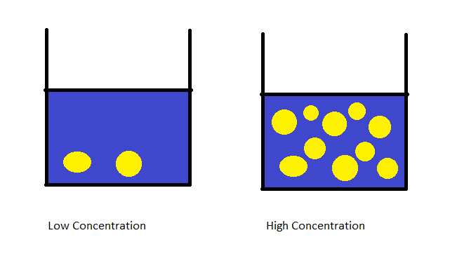
The glass of water on the left would have a 2M concentration because it has 2 moles dissolved in 1L, while the glass on the right would have 10M concentration because it has 10 moles dissolved in 1L. Likewise, the glass of lemonade would taste WAYYY stronger on the right than it would on the left because there are simply more taste molecules per volume there. Therefore, molarity is a convenient way for chemists to discuss concentrations because it uses moles which as we previously discussed is like the chemist’s dozen.
$$Molarity=\frac{\left(moles of solute\right)}{liters of solvent}$$
The above diagram showed how to manipulate concentration by varying the moles of solute, but we can also vary concentration by manipulating the amount of solvent like so:
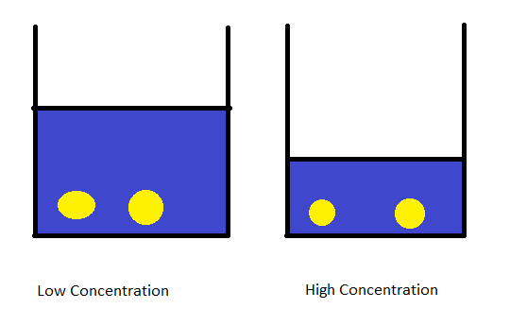
The glass on the left has more water in it, therefore the drink is more watered down and less concentrated. Both glasses have the same number of lemonade packets in it aka moles of solute particles, but they vary on the amount of solvent present. The glass on the left has more solvent, therefore the denominator in the concentration equation is larger than the one on the right, hence its concentration is lower.
This brings us to one of the most useful equations we have discussed so far:
$$C_{1}V{}_{1}=C_{2}V_{2}$$
This works because when you add or take away water, you are not changing the number of dissolved particles, the number of lemonade packets stays the same among the two glasses above, the only thing that changes is the volume of solvent/water. Concentration times volume always equals amount of dissolved substance, in the case of molarity it is number of moles of solute, in the case of the lemonade, it is the number of lemonade packets. Because that amount always stays constant regardless of solvent level, the above equation holds true. The equation simply reiterates the fact that the number of solute molecules stays the same regardless of dilution.

Practice Questions:
- How many molecules of NaCl are in a 2L, 1M solution?
- How many moles of glucose are in 5L of a 20 mM solution?
- To what volume does a 1L, 2M solution NaCl have to be diluted to become 1M?
- To what volume does a 1L, 500 mM solution of lactose have to be diluted to become 10 mM?
- How many molecules of NH₃ are there in a 3L, 0.2M solution?
- How many moles of PO₄³⁻ are there in a 1L, 0.2M Na₃PO₄ solution? How many moles of Na⁺? Assume complete dissociation into their ions.
Answer:
- 1.20 x 10²⁴
- 0.1 moles of glucose
- 2L
- 50L
- 3.61 x 10²³
- 0.2 moles of PO₄³⁻, but 0.6 moles of Na⁺ because there are 3 moles of Na⁺ for every one mole of PO₄³⁻
Now we will answer the last question of this chapter, how to set up a reaction. Now this question is not about the actual physical set up of a reaction, but instead will discuss a very important concept, called stoichiometry. This concept of stoichiometry relates the balanced chemical equation with moles so that we can accurately predict the amount of product we will get at the end of a reaction. Put simply, we will relate the moles of starting material with the moles of product using the coefficients in the balanced chemical equation and from the moles of product we can get grams with the molar mass. We will first look at a simple double displacement reaction:
MgO + 2NaCl Na₂O + MgCl₂
If we suppose that we start with 10 grams of each reactant, we can determine how much product we get by relating the molar mass. To start, we need to determine the limiting reagent. To do this, we simply need to convert the grams of starting material to moles and then divide the moles by the coefficients in the equation. This is done to take into consideration how many moles we need for each turn of the reaction. Suppose that we have an equal amount of moles of each starting material, but one of them requires two equivalents to do one turn of the reaction, clearly that reagent is limiting. Let’s do that for this reaction:
$$10grams MgO*\frac{1moleMgO}{40.3grams MgO}=0.25 mole MgO$$
$$10grams NaCl*\frac{1moleNaCl}{58.44grams NaCl}= 0.17 mole NaCl$$
We can then divide these moles by the coefficients in the chemical equation like so:
$$0.25 mole MgO*\frac{1reaction}{1mole MgO}=0.25 reaction$$
$$0.17 mole NaCl*\frac{1reaction}{2mole NaCl}=0.086 reaction$$
Therefore it is clear to see that the NaCl is the limiting reagent here. Because of this, we will only consider the moles of NaCl when calculating the number of moles of products that we get from this reaction. If we wanted to calculate the mass of MgCl₂ we can relate it through the chemical equation like so:
$$0.17 mole NaCl*\frac{1mole MgCl_{2}}{2mole NaCl}*\frac{95.211g MgCl_{2}}{1mole MgCl_{2}}=8.1 grams MgCl_{2}$$
Likewise, if we wanted to calculate the mass of Na₂O then we could do the following:
$$0.17 mole NaCl*\frac{1mole Na_{2}O}{2mole NaCl}*\frac{61.98 g Na_{2}O}{1mole Na_{2}O}=5.3 grams Na_{2}O$$
This can be done for any reaction and can also be used to determine the identity of an unknown substance through combustion analysis. This type of analysis can give what is called the empirical formula. The empirical formula is the molecular formula divided by the greatest common factor, for example C₆H₁₂ would be empirically written as CH₂ because both subscripts can be divided by 6. We will do an example of combustion analysis here and explain why we do the things we do for combustion analysis. Imagine that you burn an unknown hydrocarbon that is only comprised of carbon and hydrogen and this hydrocarbon is reacted with excess oxygen to release 23.118 grams of CO₂ and 4.729 grams of H₂O, determine the empirical formula for the hydrocarbon.
The first thing we do is we convert the grams of each product, CO₂ and H₂O to moles. We do this because we ultimately want to find the moles of C and moles of H. This can be done by relating the number of moles of the molecule with the number of C’s and H’s in the molecular formula. This gives us the following:
$$23.118 grams CO_{2}*\frac{1mole CO_{2}}{44.011g CO_{2}}*\frac{1moleC}{1moleCO_{2}}=0.52528 moles C$$
$$4.729 grams H_{2}O*\frac{1moleH_{2}O}{18.02gH_{2}O}*\frac{2molesH}{1moleH_{2}O}=0.5252 moles H$$
We can then divide each number by the smallest number of moles to get a relationship. Here we get that the number of carbons to the number of hydrogens is in a 1:1 ratio. We divide the by smallest number of moles because we want to see how many of the other element there is for every mole of the smallest one so that we can establish the empirical formula. From the empirical formula, we can calculate the molecular formula if we know the molar mass of the compound. Assume that analysis of the unknown hydrocarbon shows a molar mass of 78.11 grams/mole. To determine the molecular formula, we simply divide the molar mass of the empirical formula by the molar mass of the actual compound to find the multiple that we must multiply our empirical formula by to get the molecular formula. In this case, the empirical formula was CH, which has a molar mass of 13 grams/mole, 78/13 is 6, therefore, we must multiply the subscripts of both C and H by 6 to get the molecular formula from the empirical one. The molecular formula is therefore C₆H₆. The reason why this works is because by dividing, you are answering the question, how many of the empirical formula units are found in the actual compound. Remember, that the empirical formula is found by dividing the subscripts by the greatest common factor. By dividing the empirical and molecular formula molar masses, we are essentially determining that greatest common factor and therefore working backwards. There are times when the division does not work out nicely, in this case, you may get a decimal answer like C_{2.5}H₃, if that happens simply multiply by 2 to get whole numbers.
When you do a reaction, you will ultimately weigh out the amount of product that you get from the reaction. When you do this, it is best to calculate a percent yield to determine how well you performed the reaction. To do this, you simply plug into the following formula:
$$percent yield=\frac{experimental yield}{theoretical yield}*100$$
The experimental yield is the one that you measured with the balance and the theoretical yield is the one that you calculated using stoichiometry.

Practice questions:
- Determine the percent yield of the following reactions:
  - 2NaCl + Pb(NO₃)₂ 2NaNO₃ + PbCl₂, start with 10 grams of each and gets 8 grams of PbCl₂
  - MgS + PbCl₂ MgCl₂ + PbS, start with 10 grams of each and get 5 grams of PbS
- Determine the empirical formula and molecular formulas for each of the following combustion reactions given the information:
  - An unknown hydrocarbon of molecular weight 72 grams/mole is reacted with excess oxygen in a combustion reaction that yields 38.2 grams of CO₂ and 18.8 grams of H₂O.
  - An unknown hydrocarbon of molecular weight 272 grams/mole is reacted with excess oxygen in a combustion reaction that yields 33.1 grams CO₂ and 10.8 grams H₂O.
Answers:

  - 95.3%
  - 58.1%

  - Empirical formula: C₅H₁₂, molecular formula: C₅H₁₂
  - Empirical formula: C₅H₈, molecular formula C₂₀H₃₂

Chapter 10: Gas Laws

Now we will start to discuss more of the physical processes that chemicals can undergo and some of the relationships that chemists have found. The first thing that we will discuss is the gas laws. These gas laws describe the relationship between three physical quantities: temperature, pressure, and volume. We can think of the gas phase as free molecules moving extremely fast and bouncing off the walls of their container. The force that the gas molecules exert on their container is measured as the pressure of the gas, the more force applied to the walls of the container, the greater the pressure of the gas. Volume is simply how much space these gas molecules take up, and temperature is simply the average kinetic energy of the gas molecules. Kinetic energy is the energy associated with motion, the faster the gas molecules move, the larger their kinetic energy. There are three basic gas laws that you must be familiar with before we go into the more advanced properties of gases, these are the Gay-Lussac’s Law, Boyle’s Law, and Charles Law. We will discuss each of these equations in turn, ALL GAS LAWS YOU MUST CONVERT THE TEMPERATURE TO KELVIN, DO NOT PLUG IN CELSIUS EVER.
Kelvin and Celsius are related by the following formula:
$$K=273.15+C$$
The Gay-Lussac’s Law describes the relationship between pressure and temperature. Without me telling you what this law says, we can use our intuition to figure it out. If the gas is being heated up, the molecules in the container are moving faster, therefore the pressure would do what? Well if the molecules in the container move faster, then they would hit the walls of the container with more force, because they hit the walls with more force, we would suspect that the pressure of the gas would also increase. In other words, as temperature increases, so too does pressure. This is represented mathematically with the following equation:
$$\frac{P_{1}}{T_{1}}=\frac{P_{2}}{T_{2}}$$
This equation relates the temperatures and pressures at two different situations if the volume does not change. The units of pressure and temperature do not matter, all that matters is that they are consistent with each other. There are a couple of different common units of pressure that you should be familiar with, these are Pa, kPa, bar, atm, and torr. The following are the conversion factors for each of these pressure units:
1 atm = 101325 Pa = 101.325 kPa = 1.01325 bar = 760 torr
Practice questions:
- What is the pressure of N₂ gas at 40 degrees Celsius if at 20 degrees Celsius it exerts a pressure of 101325 Pa?
- What is the temperature of H₂ gas at 1 bar pressure if at 13 degrees Celsius the pressure is 0.2 bar?
- What is the pressure of N₂ gas at 22 degrees Celsius if at 36 degrees Celsius it exerts a pressure of 101325 Pa?
- What is the temperature of H₂ gas at 120 torr pressure if at 13 degrees Celsius the pressure is 0.02 bar?
Answers:
- $\frac{P_{1}}{T_{1}}=\frac{P_{2}}{T_{2}}, solve for P_{2}$
$$P_{2}=\frac{P_{1}T_{2}}{T_{1}}, substitute in known values$$
$$P_{2}=\frac{\left(101325Pa\right)\left(273.15+40\right)K}{(273.15+20)K}=108238 Pa$$
- $\frac{P_{1}}{T_{1}}=\frac{P_{2}}{T_{2}}, solve for T_{2}$
$$\frac{P_{1}T_{2}}{T_{1}}=P_{2}$$
$$P_{1}T_{2}=P_{2}T_{1}$$
$$T_{2}=\frac{P_{2}T_{1}}{P_{1}}, substitute in known values$$
$$T_{2}=\frac{\left(1bar\right)\left(273.15+13\right)K}{0.2bar}=1431 bar$$
- $\frac{P_{1}}{T_{1}}=\frac{P_{2}}{T_{2}}, solve for P_{2}$
$$P_{2}=\frac{P_{1}T_{2}}{T_{1}}, substitute in known values$$
$$P_{2}=\frac{101325Pa\left(273.15+22\right)K}{\left(273.15+36\right)K}=93787 atm$$
- $\frac{P_{1}}{T_{1}}=\frac{P_{2}}{T_{2}}, solve for T_{2}$
$$P_{1}is in bar but we need it in torr, so we must convert$$
$$P_{1}=0.02bar*\frac{760torr}{1.01325bar}=15 torr$$
$$T_{2}=\frac{P_{2}T_{1}}{P_{1}}, substitute in known values$$
$$T_{2}=\frac{120torr\left(273.15+13\right)K}{15torr}=2289K$$
The second gas law that you must know for this course is Boyle’s Law. Boyle’s Law relates pressure and volume, just like before, without having to look at the equation we can determine what this law will state in words. If we decrease the volume of a container and press the gas into a smaller container, what do you think would happen to the pressure? Well like we said before, pressure is the force that the gas molecules exert on the container, therefore, if we force them into a smaller container, they will want to break free even more, so the force the exert on the container will be larger. Because the force on the container is larger, the pressure is larger. In other words, if volume decreases, pressure increases and vice versa. This relationship is shown below:
$$P_{1}V_{1}=P_{2}V_{2}$$
This equation relates pressure and volume if temperature does not change. Just as before, the units of these variables does not matter as long as they are consistent with each other. Here are some practice questions using this equation.
Practice Questions:
For all of the below questions, assume that temperature is held constant
- A gas is contained at pressure P and volume V, what would happen to the pressure if the volume is halved?
- Nitrogen gas is stored at constant pressure 720 torr and volume of 427 mL, what is the final pressure if this gas is expanded to a final volume of 1L?
- Hydrogen gas is stored at constant pressure 896 kPa and volume 23 L, what is the final volume if the gas exerts a final pressure of 1.2 bar?
- A gas is contained at pressure P and volume V, what would happen to the volume if the pressure is doubled?

Answers:
- We have to translate this question into math, if the final volume is half the original volume that means that $V_{2}=\frac{1}{2}V_{1}$, they are asking us to solve for the final pressure, therefore we must solve for P₂ in Boyle’s Law like so:

$$P_{1}V_{1}=P_{2}V_{2}, solve for P_{2}$$
$$P_{2}=\frac{P_{1}V_{1}}{V_{2}}, substitute in known values$$
$$P_{2}=\frac{PV_{1}}{\frac{1}{2}V_{1}}, V_{1}^{'}s cancel$$
$$P_{2}=\frac{P}{\frac{1}{2}}=2P$$
- They are asking to solve for final pressure, therefore, we must solve for P₂ in Boyle’s Law.
$$P_{2}=\frac{P_{1}V_{1}}{V_{2}}, substitute in known values after converting L to mL$$
$$P_{2}=\frac{720torr\left(427mL\right)}{1000mL}=307 torr$$

- They are asking for final volume and they gave us mismatching pressure units, therefore, we must convert the kPa to bar like so:
$$P_{1}=896kPa*\frac{1.01325bar}{101.325kPa}=8.96 bar$$
Because they ask for final volume, we must solve for V₂ in Boyle’s Law like so:
$$P_{1}V_{1}=P_{2}V_{2}, solve for V_{2}$$
$$V_{2}=\frac{P_{1}V_{1}}{P_{2}}, substitute known values$$
$$V_{2}=\frac{8.96bar\left(23L\right)}{1.2bar}=172L$$

- Just like the first problem, we need to translate the problem into math. They told us that the final pressure is double what the initial pressure is, therefore: $P_{2}=2P_{1}$. They asked us to find the final volume, therefore we must solve for V₂ in the Boyle’s Law equation like so:

$$V_{2}=\frac{P_{1}V_{1}}{P_{2}}, substitute known values$$
$$V_{2}=\frac{P_{1}V_{1}}{2P_{1}}, P_{1}^{'}s cancel$$
$$V_{2}=\frac{V_{1}}{2}$$
Therefore, if the pressure doubles, the volume needs to be halved.

The last basic gas law that we must discuss is Charles’ Law, which relates volume and temperature. We will do the same analysis that we have done with the other gas laws to see if we can get to the general conclusion of this mathematical formula. If the temperature of the gas increases, that means that the average kinetic energy of the gas molecules increased as well. This means that the gas molecules will move faster and faster as the temperature increases. Because of this, they will push against the container walls harder and force the container to expand. In other words, as pressure increases, so too does volume. This is expressed mathematically like so:
$$\frac{V_{1}}{T_{1}}=\frac{V_{2}}{T_{2}}$$
Notice that if two quantities move in the same direction, in other words, if one increases so does the other, these quantities are divided in the equation (Gay-Lussac’s Law and Charles’ Law), while if they move in opposing directions, they are multiplied (Boyle’s Law). Charles’ Law works only if pressure is held constant. The variable in all of these equations that is held constant is not in the equation. Here are some practice questions for you to use Charles’ Law in.
Practice Questions:
- If a gas is held at constant volume V and temperature T, what is the final volume if temperature is doubled?
- If a gas is held at constant volume V and temperature T, what is the final temperature if volume is halved?
- A sample of methane gas is held at 40 degrees Celsius in a 2.3L container, what is the final temperature if this gas is allowed to expand to a volume of 10L?
- A sample of water vapor is held at 110 degrees Celsius in a 600 mL container, what is the final volume if this gas is heated to a temperature of 200 degrees Celsius?
Answers:
- We have to translate this question into math, they said the final temperature is double the original temperature, therefore: $T_{2}=2T_{1}$, they asked for the final volume, therefore we must solve for V₂ in Charles’ Law like so:
$$\frac{V_{1}}{T_{1}}=\frac{V_{2}}{T_{2}}, solve for V_{2}$$
$$V_{2}=\frac{V_{1}T_{2}}{T_{1}}, substitute known values$$
$$V_{2}=\frac{V_{1}2T_{1}}{T_{1}}, T_{1}^{'}s cancel$$
$$V_{2}=2V_{1}$$
In other words, if the temperature is doubled, the volume is also doubled.

- Same thing as before, we need to translate the problem into a math equation. They said that the final volume was half the initial volume, therefore: $V_{2}=\frac{1}{2}V_{1}$. They want us to solve for the final temperature, therefore, we must solve for T₂ in Charles’ Law like so:
$$\frac{V_{1}}{T_{1}}=\frac{V_{2}}{T_{2}}, solve for T_{2}$$
$$\frac{V_{1}T_{2}}{T_{1}}=V_{2}$$
$$T_{2}=\frac{V_{2}T_{1}}{V_{1}}, substitute in known values$$
$$T_{2}=\frac{\frac{1}{2}V_{1}\left(T_{1}\right)}{V_{1}}, V_{1}^{'}s cancel$$
$$T_{2}=\frac{1}{2}T_{1}$$
In other words, if the volume is halved, so too is the temperature.
- We have to solve for T₂ because the question asks us to find the final temperature, therefore:$$T_{2}=\frac{V_{2}T_{1}}{V_{1}}, substitute in known values$$
$$T_{2}=\frac{10L\left(273.15+40\right)K}{2.3L}=1362K$$

- They are asking for the final volume, therefore solve for V₂ like so:$$V_{2}=\frac{V_{1}T_{2}}{T_{1}}, substitute known values$$
$$V_{2}=\frac{600mL\left(273.15+110\right)K}{(273.15+200)K}=486mL$$
But what if none of the variables of P, T, and V are held constant, what do we do then? In that scenario, we have to use the combined gas law, which is, like it sounds, a combination of all three gas laws into one equation like so:

$$\frac{P_{1}V_{1}}{T_{1}}=\frac{P_{2}V_{2}}{T_{2}}$$

You can use this equation the same as you would the other equations. Here are some practice problems using the combined gas law.

Practice questions:
- A gas is held at constant temperature T, pressure P, and volume V, what is the final volume if temperature is doubled and all other values are held constant?
- A gas is held at constant temperature T, pressure P, and volume V, what is the final volume if temperature and pressure are doubled?
- A sample of CH₄ gas is held at 20 degrees Celsius and 1.2 bar in a 2L container, what is the final pressure if the sample of gas is heated to 50 degrees Celsius and the gas was moved to a smaller container of 1.5L?
Answers:
- We have to translate this question into an equation. Because we know the final temperature is twice the initial temperature, $T_{2}=2T_{1}$ and we are asked for the final volume of V₂, we have to solve for V₂ in the combined gas law and then plug in the known values like so:
$$\frac{P_{1}V_{1}}{T_{1}}=\frac{P_{2}V_{2}}{T_{2}}, solve for V_{2}$$
$$T_{2}*\frac{P_{1}V_{1}}{T_{1}}=P_{2}V_{2}$$
$$V_{2}=\frac{P_{1}V_{1}T_{2}}{T_{1}P_{2}}, substitute known values$$
$$V_{2}=\frac{P_{1}V_{1}2T_{1}}{T_{1}P_{1}}, T_{1} and P_{1}cancel$$
$$V_{2}=2V_{1}$$
$$Volume is doubled$$
- We have to translate this question into an equation. Because we know the final temperature is twice the initial temperature, $T_{2}=2T_{1}$ and because we know the final pressure is twice the initial pressure, $P_{2}=2P_{1}$, we just need to solve for V₂ in the equation like so:
$$\frac{P_{1}V_{1}}{T_{1}}=\frac{P_{2}V_{2}}{T_{2}}, solve for V_{2}$$
$$V_{2}=\frac{P_{1}V_{1}T_{2}}{T_{1}P_{2}}, substitute known values$$
$$V_{2}=\frac{P_{1}V_{1}2T_{1}}{T_{1}2P_{1}}, T_{1}and P_{1}cancel out and the 2's$$
$$V_{2}=V_{1}$$
$$No change in volume$$
- The question is asking for final pressure, therefore, we must solve for P₂ in the combined gas law like so:
$$\frac{P_{1}V_{1}}{T_{1}}=\frac{P_{2}V_{2}}{T_{2}}, solve for P_{2}$$
$$\frac{P_{1}V_{1}T_{2}}{T_{1}}=P_{2}V_{2}$$
$$\frac{P_{1}V_{1}T_{2}}{T_{1}V_{2}}=P_{2}$$
$$P_{2}=\frac{1.2bar\left(2L\right)\left(273.15+50\right)K}{\left(273.15+20\right)K\left(1.5L\right)}=1.76 bar$$

The absolute last thing we will discuss for gas laws is the ideal gas law. The ideal gas law describes, as one would probably guess, ideal gases. But what exactly is an ideal gas? An ideal gas is a gas that has the following properties:
- Its particles are so small that they essentially take up no volume
- There are no attractive forces between particles
- All collisions between particles are perfectly elastic (conserve energy and momentum)
This is a purely theoretical concept, all gases do not behave perfectly ideally, but they behave sufficiently ideally so this equation finds a lot of use. But first, I would like to pose a question, under what conditions would a gas behave more ideally, high temperature and low pressure or low temperature and high pressure? Well to answer this, we have to remember what makes an ideal gas, specifically, we should turn our attention to the attractive forces between particles. If a gas has a lot of thermal energy, i.e. it is at a high temperature, then it has enough energy to break the forces of attraction that hold molecules together (remember the intermolecular forces chapter). Because of this, under high temperature conditions, gases do not experience the intermolecular forces of attraction to any appreciable extent. Additionally, if the gas is under a high pressure, then the particles will collide more often and will tend towards imperfect collisions, thus the third condition is not satisfied either. Therefore, gases behave most ideally under high temperature and low pressure conditions. The ideal gas law is a simple equation and many students (myself included) simply refer to it as pivnert because of how it reads if said aloud:
$$PV=nRT$$
The only two variables in this equation with which you are not familiar from the other equations is the n and R variables. Lucky for you, these are relatively simple because R is a constant and n is simply the number of moles of gas. The R constant can have many different units depending on the units of P and V, here are some of the R constants values for some of the common units:
- R = 8.314 J/mol K
- R = 0.0821 L atm/mol K
- R = 8.314 kPa L/mol K

But wait, the R constant is in units of K, what the heck are those? K stands for Kelvin and it is the absolute unit of temperature. Kelvin and Celsius are related by the following formula:
$$K=273.15+C$$
Here are some practice problems for you to use the ideal gas law for.
Practice Questions:
- Calculate the number of moles in a sample of CH₄ gas that exerts a pressure of 1 atm in a 2L container at 23 degrees C.
- Calculate the number of grams of CH₄ gas in the situation above
- Calculate the volume that a sample of 234 grams of N₂ gas would take up at 30 degrees Celsius and 125.3 kPa of pressure.
- Calculate the temperature that a sample of 127 grams of O₂ gas would have if it took up a volume of 15.32L and exerted a pressure of 1 atm.
Answers:
- Solve for n, $n=\frac{PV}{RT}=\frac{1atm\left(2L\right)}{\frac{0.0821Latm}{molK}*\left(273.15+23\right)K}=0.082 moles of CH_{4}$
- Now that we have moles, we can convert to grams by multiplying by the molar mass like so: $0.082 mole CH_{4}*\frac{18gramsCH_{4}}{1mole CH_{4}}=1.5 grams CH_{4}$
- Have to convert the grams of N₂ gas to moles by dividing by molar mass like so:
$$234 grams N_{2}*\frac{1mole{ N}_{2}}{28grams N_{2}}=8.36 moles N_{2}$$
Now that we have moles of N₂, we can plug into PVNRT to solve for what we want, V like so:
$$V=\frac{nRT}{P}=\frac{8.36mole\left(\frac{8.314kPaL}{molK}\right)\left(273.15+30\right)K}{125.3kPa}=168L$$

- Same thing here, we have to convert to moles of O₂ by dividing by the molar mass like so:
$$127 grams O_{2}*\frac{1mole}{32grams}=3.97 moles O_{2}$$
Now that we have moles, we can plug into PVNRT to solve for T, which is what we want:
$$T=\frac{PV}{nR}=\frac{1atm\left(15.32L\right)}{3.97mole\left(0.0821\frac{Latm}{molK}\right)}=47.0K$$

The absolute last thing that we should discuss is the ideal conditions to dissolve a gas. Now believe it or not, you already know the ideal conditions to dissolve a gas in water. Think of your favorite soda, have you wondered what makes it fizzy? The reason why the soda is fizzy is because it has dissolved CO₂ in it, that’s why it is super easy to burp when you drink it and why it feels different than regular drinks. What else do you notice about the pressure of the soda can when you open it versus when it is unopened? The soda can is much more stiff and tense before you open the can, in other words, it is under high pressure. Likewise, we don’t drink soda warm because it doesn’t taste as good and it isn’t as fizzy. In other words, we typically drink soda cold, or under low temperature. Therefore, to maximize the amount of CO₂ dissolved in the soda, we drink it when it is highly pressured and when it is cold.

Chapter 11: Introduction to Thermodynamics

Now we start our discussion of thermodynamics, which is the study of the flow of heat and energy. Thermodynamics for right now will strictly be concerned with phase transitions, heating things up or cooling things down, and work. We will get to the specifics in later chapters. But first, some preliminary definitions.
Heat is the transfer of energy in the form of the random motion of particles. To heat something up means to give the particles in that system more random energy, typically in the form of kinetic energy. Therefore, typically, when heat is applied to a system, the temperature will increase because that energy that is being transferred is being put into speeding up the molecules. Think of temperature as the speedometer of molecules (if they have the same mass) and heat as the accelerator, the more you press on the accelerator, the higher your temperature.
Work is the transfer of energy in the form of uniform motion of particles. Typically, in the context of Chemistry, this work is done in the form of an expansion of a gas. Therefore, the work that we are interested in as chemists is expansion work, or PΔV work. We will discuss the mathematics later.
Phase changes are the process by which the state of matter of a substance changes into another. This is done by breaking or reforming forces of attraction (Intermolecular forces) so that a substance becomes more or less ordered. During this process, the heat supplied to the system is not being used to change the temperature, but instead is being used to break these intermolecular forces because doing so requires energy. In other words, when you boil water to make pasta, the temperature of that water is ALWAYS 100 degrees Celsius because the heat supplied by the flame is being used to break the hydrogen bonds holding the water molecules in the liquid phase.

Now we will discuss the mathematical equations that describe the terms that we just introduced. First we will start by addressing the way to calculate the heat supplied to a system. Now when I say system, I just mean whatever we are working with, that could be a beaker or a test tube of whatever we are interested in. Heat is again the amount of energy transferred in the form of random motion, therefore, its units are Joules because Joules is the basic unit of energy. Now when heat is applied to a system and its temperature changes, some substances will increase their temperature easier than others. The tendency for a substance to want to change its temperature is referred to as its heat capacity, often denoted as C. The larger a substances heat capacity, the more energy is required to change its temperature. Heat capacity is typically measured in J/K and if the mass is taken into account by dividing the heat capacity by the mass, then we get the specific heat capacity, or c. This is typically what students are most familiar with when they first learn this material because it is often said in Earth Science that water has a very high specific heat. This means water requires a lot of energy to heat it up relative to other substances. This is the reason why coastal regions are typically more moderately temperate compared to inland regions because the coastal regions have the water to regulate the temperature and prevent it from getting too hot or too cold. Water having a high specific heat should make sense because it has those strong hydrogen bonds that prevent the water from moving very much in the first place, therefore, a lot of energy is required to make those molecules move faster aka increase temperature. The easiest way to calculate heat (q) is the following equation:
$$q=mc∆T$$
I know a lot of you reading this may be premed, so if you view the triangle as an A, heat, or q is equal to MCAT. The m in the equation is the mass of the substance being heated or cooled, the c is the specific heat capacity, and the $∆T$ is the change in temperature. Whenever you see that triangle or delta, that can be read as “change in”. When a system is heating up or cooling down, the heat gained by the system is equal to the heat lost by the surroundings because the surroundings is supplying that thermal energy.
$$q_{system}= -q_{surroundings}$$
Here are some practice questions for you to try out to see if you know how to use this.
Practice Questions:
- What is the heat required to increase the temperature of 100. grams of water from 20 degrees C to 50 degrees C if the specific heat of water is 4.182 kJ/kgC?
- What is the heat required to increase the temperature of 234.2 grams of ammonia from 35 degrees C to 78 degrees C if the specific heat of ammonia is 2.20 kJ/kgC?
- What is the heat required to increase the temperature of 788.1 grams of benzene from 0 degrees C to 25 degrees C if the specific heat of benzene is 1.10 kJ/kgC?
- What is the specific heat of 120 grams of hot metal if its initial temperature is 80 degrees C and its finial temperature is 45 degrees C when placed into 400 grams of water at 20 degrees C?
- Provide an explanation for why the specific heat of water is higher than ammonia and benzene (C₆H₆).

Answers:
- Convert the mass measurement into kg by dividing by 1000 like so:
$$100. grams H_{2}O*\frac{1kg}{1000grams}=0.100 kg H_{2}O$$
$$q=\left(4.182\frac{kJ}{kgC}\right)*0.100 kg*\left(50-20\right)C=12.5kJ$$
- Convert the mass measurement into kg by dividing by 1000 like so:
$$234.2 grams NH_{3}*\frac{1kg}{1000grams}=0.2342 kg NH_{3}$$
$$q=\left(2.20\frac{kJ}{kgC}\right)*0.2342kg*\left(78-35\right)C=22.2 kJ$$
- Convert the mass measurement to kg by dividing by 1000 like so:

$$788.1 grams C_{6}H_{6}*\frac{1kg}{1000grams}=0.7881 kg C_{6}H_{6}$$
$$q=\left(1.10\frac{kJ}{kgC}\right)*0.7881 kg*\left(25-0\right)C=21.7 kJ$$
- This is the trickiest problem that I assigned. The key to know is that the final temperature for the metal and the final temperature for the water are the same. If they weren’t then the hot one would heat up the cold one and the process would not be finished. The other important relationship to know is that $$q_{system}= -q_{surroundings}$$
If we define our metal cube as our system and the water as the surroundings we get:
$$q_{metal}={-q}_{H_{2}O}$$
The only heat that we can calculate so far is the heat gained by water because we know its specific heat from problem 1. Therefore, we will calculate the heat gained by water by using the typical q=MCAT formula like so:
$$q_{H_{2}O}=\left(4.182\frac{kJ}{kgC}\right)*0.400 kg H_{2}O*\left(45-20\right)C=41.82 kJ$$
This is simply the inverse of the heat lost by the metal cube, therefore:
$$q_{metal}= -q_{H_{2}O}= -41.82 kJ$$
We can now relate this number to the MCAT formula and solve for c:
$$q_{metal}=cm∆T, solve for c$$
$$c=\frac{q_{metal}}{m∆T}= -\frac{41.82kJ}{0.120 kg*\left(45-80\right)C}=9.96\frac{kJ}{kgC}$$
- Water has the strongest hydrogen bonds, OH---O, NH₃ or ammonia has weaker hydrogen bonds NH---N, and benzene has no hydrogen bonding and can only do Van Der Waals forces so it has the lowest specific heat.

The second concept that we introduced in the beginning was the concept of work. Work is the energy from uniform motion of particles. Like we discussed previously, the most common form of work that we are interested in here is expansion work. The specifics about how this formula is derived can be saved for a later time, this is not a physics course, this is a chemistry course, so all we care about is how to use it:
$$w= -P∆V$$
For this formula, the pressure that is in the equation is the pressure of the gas inside the system. Just like heat, work is also a form of energy, therefore its units are also Joules, or a Nm. Here are some problems for you to try out by yourself using this formula.
Practice questions:
- How much work is done by compressing a gas at a constant pressure of 540 Pa if its volume changed from 10m³ to 2m³?
- How much work is done by expanding a gas at a constant pressure of 1234 Pa if its volume changed from 18.2 m³ to 25.7 m³?
Answer:
- $w= -P∆V= -540\frac{N}{m^{2}}*\left(2-10\right)m^{3}= -540\frac{N}{m^{2}}*\left(-8\right)m^{3}=4320 J$
- $w=-P∆V=-1234\frac{N}{m^{2}}*\left(25.7-18.2\right)m^{3}=-1234\frac{N}{m^{2}}*\left(7.5\right)m^{3}=-9255 J$
Notice that when a gas expands the work done is negative and when a gas contracts the work done is positive. This is the sign convention that chemists use, the physicists of the world would disagree, but screw them, its fine. The way I think of this is that if you are allowing the gas to expand, the gas is pushing against its container, therefore the gas is expending/losing energy, hence the work is negative because the gas LOST energy. The opposite would be true if you contracted a gas. For a gas to contract, an external force needs to push against it and make it contract, in this way, work is being done ON the system and therefore the gas is GAINING energy, hence the energy is positive.

The last thing that we will cover in this chapter is phase changes. When a substance changes its phase, the heat supplied to it is changing its potential energy, rather than its kinetic energy. The reason this happens is because the heat is being used to break the intermolecular forces of the substance, thereby freeing up the molecules and giving them more potential energy to do work. This can be seen with heating curves, which plots the temperature of a substance with the heat supplied to it after various phase changes occurs. An example of a heating curve is shown below:
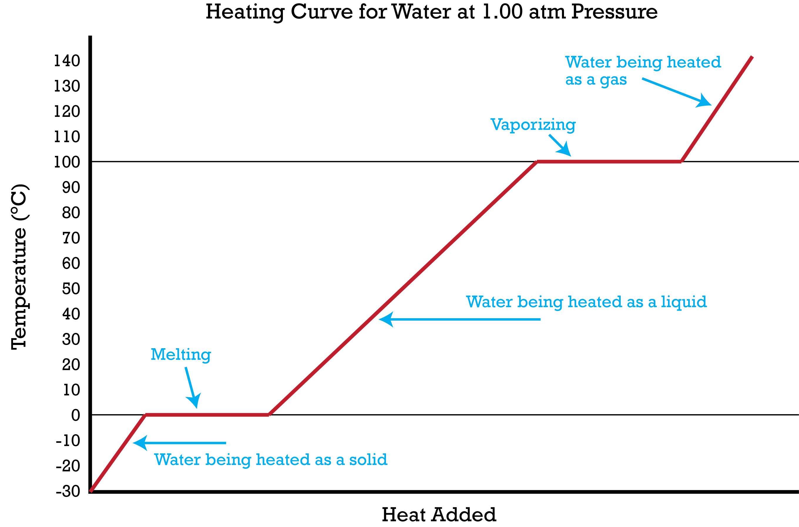
As you can see in the diagram, heat is still being supplied to the water as it is melting and vaporizing, however, the temperature remains constant for the reasons we mentioned above. The way you can measure the amount of heat added to the water as it is melting and vaporizing is given by the heat of fusion and the heat of vaporization for melting and vaporizing respectively.
$$q_{melting}=∆H_{fusion}$$
$$q_{vaporization}=∆H_{vaporization}$$
What the heck is that H thing? That question will be answered in the next chapter, but suffice it to say that the H, or enthalpy, is essentially the energy of a system at constant pressure, which is typically how we operate in chemistry. The heat of fusion and heat of vaporization are essentially the energy stored in the intermolecular forces that are being broken when melted and vaporized. But what about freezing and condensing? Just take the negative of those values:
$$q_{melting}= -q_{freezing}$$
$$q_{vaporization}=-q_{condensing}$$
Remember, we only use these formulas during phase changes because if we used the other formula (q= MCAT) we would erroneously conclude that no heat is being supplied because the change in temperature is 0 during a phase change. To tackle heating and cooling curve problems, use the MCAT formula on increasing portions of the diagram and the heat of fusion and vaporization for the flatlines like so:

The very last thing that we will discuss is phase diagrams, which say how the phase of a substance changes with different temperatures and pressures. An example of a phase diagram is shown below for water:
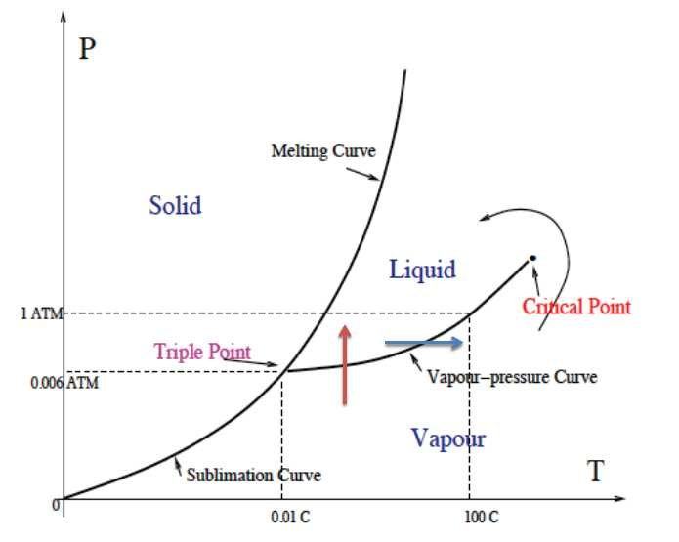
The phase diagrams show the phases that exist at certain temperature and pressure values, there are four critical points in any phase diagram:
- Triple point
- Critical point
- Normal melting point
- Normal boiling point
The triple point is the temperature and pressure value at which ALL three phases (solid, liquid, and gas) exist harmoniously and there is no preference for one over the others. The critical point is the point at which the distinction between liquid and gas phases is removed and one cannot distinguish between a liquid and a gas. The normal melting and boiling points are the temperatures at which a substance goes from a solid to a liquid or a liquid to a gas at 1 atm. Normal phase transitions are always measured at 1 atm pressure.

Chapter 12: What Makes a Reaction Release Heat?

In this chapter, we will introduce the concept of enthalpy, or H and how it can be used to figure out if a reaction will release heat or absorb heat. Enthalpy is essentially the energy stored in a system when the system is at constant pressure. Since most chemical reactions occur at constant pressure, this quantity turns out to be rather useful. There turn out to be two different types of reactions that can occur, exothermic and endothermic. Exothermic reactions are those reactions that will release heat to the surroundings, these reactions will feel hot to the touch. Endothermic reactions are those reactions that will absorb heat from the surroundings, these reactions will feel cold to the touch (think of ice packs). I like to think of it this way, EXothermic reactions have heat energy EXit, while ENdothermic reactions have heat energy ENter the system. There are many ways to calculate enthalpy and we will discuss some applications of enthalpy as it relates to ionic solids.

The first way to calculate enthalpy is through evaluating bond energies. Bond energies are the amount of energy required to break a bond. Because we always want to go towards maximum stability, favorable reactions will form strong bonds and break weak ones (AMOLE). If a reaction is favorable, that means that it minimizes energy, therefore, the energy change or change in enthalpy in the system will be NEGATIVE. Expressed mathematically this is:
$$∆H_{rxn}=BE_{reactants}-BE_{products}$$
This should make sense because if ΔH is negative then that means that the bond energies of the products are greater than the bond energies of reactants, i.e. the bonds formed are stronger than the bonds that broke. Bond energies are always on a per-bond scale, therefore, we must multiply whatever value each bond has by the number of bonds to get the energy of that molecule. This turns out to be exceptionally tedious for most reactions, but we will do two examples just so you have experience seeing how to use this. Consider the following reaction:
CH₄ + Cl₂ CH₃Cl + HCl
BE_{C-H} = 413 kJ/mol
BE_{Cl-Cl} = 242.6 kJ/mol
BE_{C-Cl} = 346 kJ/mol
BE_{H-Cl} = 432 kJ/mol
To calculate this change in enthalpy, we must plug into the formula

$$∆H_{rxn}=\left(4\left(413\frac{kJ}{mol}\right)+1*242.6\frac{kJ}{mol}\right)-$$
$$\left(3\left(413\frac{kJ}{mol}\right)+1*\frac{346kJ}{mol}+1*432\frac{kJ}{mol}\right)$$
$$∆H= -122.4\frac{kJ}{mol}$$
Therefore, this reaction is exothermic because the change in enthalpy is negative. This reaction would release heat energy and increase the temperature of the surroundings.
2H₂O 2H₂ + O₂ ΔH_{rxn} = ??
BE_{O-H} = 467 kJ/mol
BE_{H-H} = 432 kJ/mol
BE_{O-O} = 146 kJ/mol
BE_{O=O} = 495 kJ/mol
This question is a bit tricky because you have to draw the Lewis Dot Structures for the oxygen gas, otherwise you would erroneously pick 146 kJ/mol as your bond energy. Remember that oxygen prefers to have two bonds and two lone pairs whenever possible to maintain a neutral formal charge (AMOLE). Therefore, oxygen gas will have a double bond between the two oxygens, NOT a single bond. The other tricky part about this question is that now we have coefficients in front of the reactants and products. This means that for each turn of the reaction, we need to consume two water molecules and we produce two hydrogen gas molecules. Meaning that we cannot simply say two O-H bonds are broken and one H-H bond is forming because there are two water molecules, hence four O-H bonds broken and there are two hydrogen gas molecules, hence two H-H bonds forming. Now our enthalpy equation looks like so:
$$∆H_{rxn}=BE_{reactants}-BE_{products}$$
$$∆H_{rxn}=\left(4\left(467\frac{kJ}{mol}\right)\right)-\left(2\left(432\frac{kJ}{mol}\right)+495\frac{kJ}{mol}\right)=509\frac{kJ}{mol}$$
The change in enthalpy for this reaction is positive, therefore the reaction is ENDOTHERMIC. This reaction requires energy from the surroundings to occur. This makes sense because we don’t randomly see our water bottle turning into hydrogen gas and oxygen gas, the reason why is because there is such a huge enthalpy barrier to get that reaction started that the heat from your hands to the water is not nearly enough to get the reaction going. In other words, because the bonds formed are weaker than the bonds broken, the reaction requires energy to get started.

This concept of needing energy to start a reaction is critical for all chemical reactions, including exothermic ones because all reactions have an activation energy. The activation energy is the minimum energy threshold to start a reaction. It just so happens that exothermic reactions are super favorable so these reactions tend to have lower activation energies. The way chemists describe reactions is through a reaction coordinate diagram, which shows the energy of the system over the course of a reaction. An example of a reaction coordinate diagram is shown below:
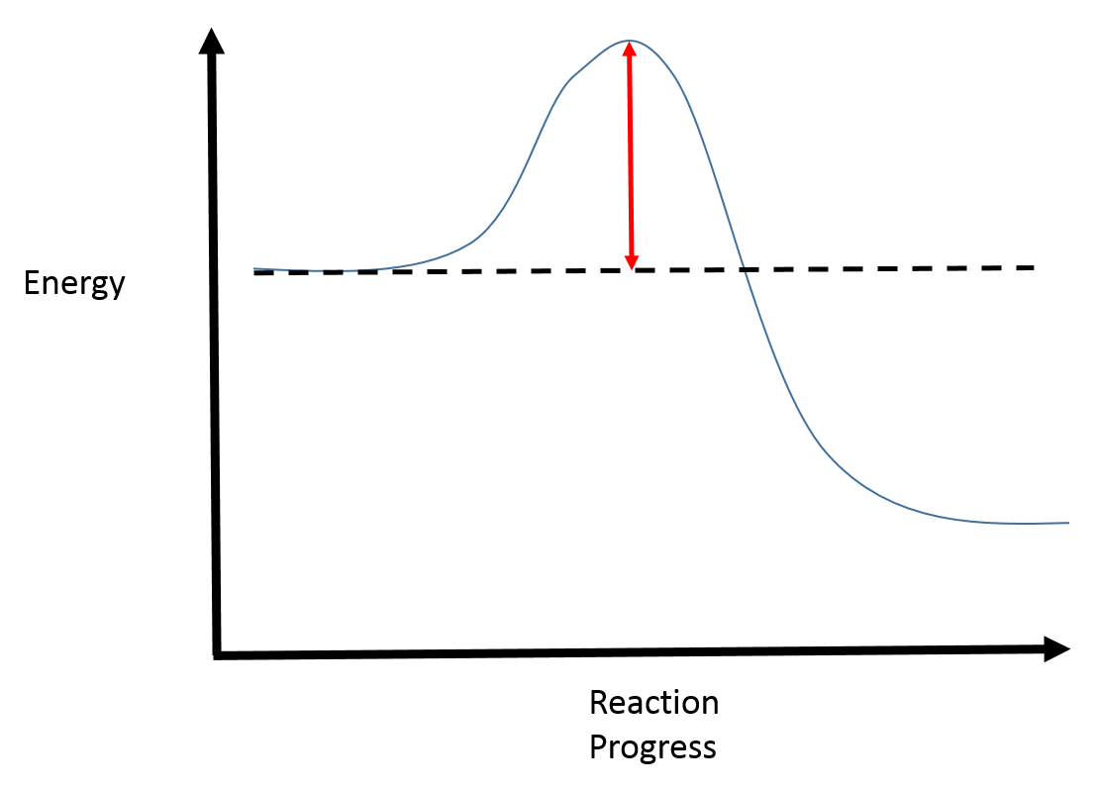
The red arrow is the activation energy and at the very top of the activation energy is the transition state, notice that after the activation energy has been supplied, the overall energy decreases and that the energy of the products is less than the energy of the reactants (right side is lower than left side). This means that the reaction indicated by this free energy diagram is an EXOTHERMIC reaction. But what would an endothermic reaction look like in a reaction coordinate diagram? That is simple, it would just look like the mirror image of that like so:
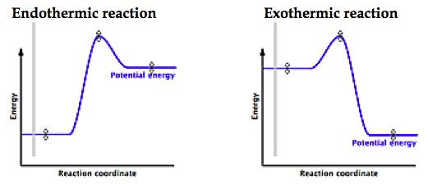
The overall change in enthalpy or energy is the difference between the reactant’s energy and the product’s energy. This is because enthalpy is a state function. State functions are quantities that only care about start and end points, they DO NOT care about how you get there. To a state function, being born and dying in the same room would be the same as never being born at all, in both scenarios, the change in position is 0 (sorry to get graphic). In other words, state functions are path independent. This is NOT true for heat and work because heat and work depend on how you change temperature or volume respectively. Enthalpy does not care and this turns out to be a very useful property that we will discuss at the end of the chapter in more detail. For now, here are some practice questions regarding reaction coordinate diagrams since these are fairly common questions to see in a typical introductory course.

Practice questions:
- Identify which of the following reactions are exo or endothermic and explain why, label the activation energy and change in enthalpy:
- Identify how many transition states each of the following reactions has:
- Identify how many intermediates each of the following reactions has:

The second way to calculate changes in enthalpy is by using enthalpy of formation. The enthalpy of formation is the change in enthalpy associated with making one mole of substance from its elements in their reference state. The reference state for an element is the state that the element is most frequently found in at room temperature, so for oxygen it would be O₂ (g) and for iron it would be Fe(s). The enthalpy of formation equation for water would be as follows:
H₂ + ½ O₂ H₂O ΔH_{rxn} = ΔH_{formation H2O}
This is because we must make exactly one mole of product and the elements that comprise water are hydrogen and oxygen which are both diatomic gases in their reference state. This is the ONLY exception to the rule that we do not want fractional coefficients in our chemical equations. To use these enthalpies of formation is relatively simple, simply plug into the equation below:
$$∆H_{rxn}= ∆H_{formation of products}-∆H_{formation of reactants}$$
Notice that the order of subtraction is flipped for this equation relative to the first one we used. This should make sense because if a reaction is exothermic (ΔH_{rxn} is negative), meaning it releases energy, the energy of the products (ΔH_{products}) should be less than the energy of the reactants (ΔH_{reactants}), therefore, the order of subtraction should reflect that. Just as before, we will do two questions using this equation and then I will give you practice problems for you to use this equation yourself. Before beginning an example, it is important to know that the enthalpy of formation for elements in their reference state is defined to be 0, meaning that H_{2(g)}’s enthalpy of formation is 0 as is O₂(g) and Fe(s). Consider the following reaction:
C₂H₆(g)+ O₂(g) CO₂(g)+ H₂O(g) ΔH_{rxn} = ??
ΔH_{formation, C2H6} = -83.8 kJ/mol
ΔH_{formation, CO2} = -393.5 kJ/mol
ΔH_{formation, H2O} = -241.82 kJ/mol
First we have to balance the reaction like so:
2C₂H₆(g)+ 7 O₂(g) 4CO₂(g)+ 6H₂O(g)
Now that we have balanced this, we can substitute what we know into the equation and multiply by the coefficients in the chemical equation:
$$∆H_{rxn}=\left(4\left(-393.5\frac{kJ}{mol}\right)+6\left(-241.82\frac{kJ}{mol}\right)\right)-\left(2\left(-83.8\frac{kJ}{mol}\right)\right)= -2857\frac{kJ}{mol}$$
This reaction is a combustion reaction, so you may also hear the term enthalpy of combustion used to describe this enthalpy of reaction. Now we will do the second example, consider the following chemical reaction:
CH₄(g) + Br₂(g) CH₃Br(g) + HBr(g) ΔH_{rxn} = ??
ΔH_{formation CH4} = -74.87 kJ/mol
ΔH_{formation CH3Br} = -35.1 kJ/mol
ΔH_{formation HBr} = -35.66 kJ/mol

Just like before, we will plug into the equation like so:
$$∆H_{rxn}=\left(-35.1\frac{kJ}{mol}+ -35.66\frac{kJ}{mol}\right)-\left(-74.87\frac{kJ}{mol}\right)=4.11\frac{kJ}{mol}$$
As you can see, this way of determining the enthalpy of reaction is far simpler than the bond energy way, therefore, this will typically be your typical means of calculating enthalpies of reaction. Here are some practice questions for you to try by yourself.
Practice Questions:
- Calculate the enthalpy of reaction for the following unbalanced chemical transformation, indicate if the given reaction is exothermic or endothermic:
NO(g) + O₂(g) NO₂ (g)
ΔH_{formation, NO} = 90.25 kJ/mol
ΔH_{formation, NO2} = 33.18 kJ/mol
- Calculate the enthalpy of reaction for the following unbalanced chemical transformation, indicate if the given reaction is exothermic or endothermic:
C₂H₂(g) + O₂(g) CO₂(g) + H₂O(g)
ΔH_{formation, C2H2} = 224 kJ/mol
ΔH_{formation, CO2} = -393.5 kJ/mol
ΔH_{formation, H2O} = -241.8 kJ/mol
- Calculate the enthalpy of reaction for the following unbalanced chemical transformation, indicate if the given reaction is exothermic or endothermic:
CO₂(g)+ H₂O(g) H₂CO₃(g)
ΔH_{formation, CO2} = -393.5 kJ/mol
ΔH_{formation, H2O} = -241.8 kJ/mol
ΔH_{formation, H2CO3} = -275.2 kJ/mol
Answers:
- First balance the chemical reaction like so:
2NO(g) + O₂(g) 2NO₂(g)
Now plug into the formula using the information that you know keeping in mind to multiply by the coefficient in the chemical equation:
$$∆H_{rxn}=\left(2\left(33.18\frac{kJ}{mol}\right)\right)-\left(2\left(90.25\frac{kJ}{mol}\right)\right)= -114.1\frac{kJ}{mol}$$
$$because ∆H_{rxn}<0, the reaction is exothermic$$

- First balance the chemical reaction like so:
2C₂H₂(g) + 5O₂(g) 4CO₂(g) + 2H₂O(g)
Now plug into the formula like so:
$$∆H_{rxn}=\left(4\left(-393.5\frac{kJ}{mol}\right)+2\left(-241.8\frac{kJ}{mol}\right)\right)-\left(2\left(224\frac{kJ}{mol}\right)\right)=-2510\frac{kJ}{mol}$$
$$because the enthalpy is less than 0, the reaction is exothermic$$

- First check to see if the equation is balanced, it is because the number of atoms of each element is the same on either side, therefore, we do not have to do any balancing. Now we can just plug into the equation like so:
$$∆H_{rxn}=\left(-275.2\frac{kJ}{mol}\right)-\left(-393.5\frac{kJ}{mol}+ -241.8\frac{kJ}{mol}\right)=360.1\frac{kJ}{mol}$$
$$because the enthalpy is greater than 0, the reaction is endothermic$$

The very last thing that we will discuss with regards to enthalpy is its unique property of being a state function. The fact that enthalpy is a state function allows us to calculate the lattice energy of a given ionic compound. The lattice energy is the energy that holds the ionic compound together in its solid state. As one would imagine, the lattice energy will be greater for ionic compounds that are bound more tightly together, specifically those ionic compounds that have cations and anions with greater charge. The law that states that enthalpy can be treated as a state function is Hess’ Law. If we look at the diagram below we can see visually what Hess’ Law states: 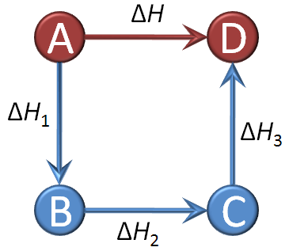
If we want to calculate the change in enthalpy of A going to D, we simply have to add up the enthalpy changes of A B, B C, and C D. The reason why this works is because in both scenarios, we start with A and end with D. In other words, our starting and ending positions are the same. This is all enthalpy cares about because it is a state function and therefore only cares about where we start and where we end. Therefore in the diagram, $∆H=∆H_{1}+ ∆H_{2}+∆H_{3}$. In the same way that that is true, we can calculate the lattice energy by starting with the elemental forms of the ions in the ionic compound and bringing them together to form the ionic salt. We will do an example together and then I will give you one practice problem to do on your own. We will calculate the lattice energy of MgO given the following information:
$$∆H_{formation MgO}= -601.7\frac{kJ}{mol}$$
$$∆H_{sublimation Mg}=146\frac{kJ}{mol}$$
$$∆H_{IE1+IE2 Mg }=2187\frac{kJ}{mol}$$
$$BE_{O=O}=249\frac{kJ}{mol}$$
$$∆H_{EA1+EA2 O}=703\frac{kJ}{mol}$$
First we will start out by drawing a diagram detailing all the steps like so:
For us to calculate the enthalpy at each step, we need to ionize the Mg and O in the gas phase because ionization energy and electron affinity are both measured in the gas phase. The oxygen is already in the gas phase so that is nice, all we need to do there is break up the oxygen gas into elemental oxygen, but Mg needs to sublimate, or transition directly into the gas phase from solid. Then once they are in the gas phase, we need to ionize them, Mg has a 2+ charge and therefore we need the enthalpy changes for both the first and second ionization energy (to make it Mg⁺ and Mg²⁺ respectively). The same goes for oxygen, oxygen has a -2 charge in the salt, therefore, two electrons needed to be added (EA₁ and EA₂ combined to put the first and second electron respectively). Then the energy released when the two ions form the salt is the lattice energy, which is what we want to solve for. We can relate this to the enthalpy of formation because they both start and stop with the same substances.
The formation equation for MgO is as follows:
Mg(s) + ½ O₂(g) MgO (s) ΔH_{formation MgO} = -601.7 kJ/mol
In both cycles, we start with Mg(s) and ½ O₂(g) and we end with MgO, therefore we can equate the two of them because enthalpy is a state function.
$$∆H_{formation, MgO}= ∆H_{sub}+BE_{O=O}+∆H_{IE1+IE2 Mg }+∆H_{EA1+EA2 O}+LE$$
We can then isolate the lattice energy term (LE) to give us an expression for LE in terms of the constants that we know like so:
$$LE=∆H_{formation, MgO}-\left(∆H_{sub}+BE_{O=O}+∆H_{IE1+IE2 Mg }+∆H_{EA1+EA2 O}\right)$$
Substituting in the values that we know yields:
$$LE= -601.7\frac{kJ}{mol}-\left(146\frac{kJ}{mol}+249\frac{kJ}{mol}+2187\frac{kJ}{mol}-703\frac{kJ}{ml}\right)=-2480\frac{kJ}{mol}$$
This can be done for any of the ionic salts that we have discussed so far. Here is a practice problem for you do to on your own.
Practice Question:
- Calculate the lattice energy for NaCl given the following information:
Na(s) + ½ Cl₂(g) NaCl(s) ΔH_{formation NaCl} = -411.0 kJ/mol
Na(s) Na(g) ΔH_{sublimation} = 108 kJ/mol
Na(g) Na⁺(g) ΔH_{ionization energy 1} = 496 kJ/mol
½ Cl₂(g) Cl(g) ΔH_{Cl-Cl} = 242.6 kJ/mol
Cl(g) Cl⁻¹(g) ΔH_{EA} = -349 kJ/mol

Answer:
- First, we construct a diagram like so:

Then we write the equality like so: $$∆H_{formation, NaCl}= ∆H_{sub}+BE_{Cl-Cl}+∆H_{IE1 Na }+∆H_{EA1 Cl}+Lattice Energy$$
We want to solve for the lattice energy for NaCl, therefore we must isolate Lattice Energy in the above equation:
$$Lattice Energy= ∆H_{formation, NaCl}-(∆H_{sublimation}+BE_{Cl-Cl}+∆H_{IE1 Na}+∆H_{EA1 Cl})$$
Now that we isolated our desired unknown, we can simply plug in what we know like so:
$$Lattice Energy= -411.0\frac{kJ}{mol}-\left(108\frac{kJ}{mol}+242.6\frac{kJ}{mol}+496\frac{kJ}{mol}-349\frac{kJ}{mol}\right)$$
Lattice Energy = -909 kJ/mol

We can also discuss relative lattice energies, ionic compounds that have higher charged cations and anions and those ionic compounds that have smaller cations and anions will have a larger lattice energy because opposite charges attract (AMOLE) and because the force of attraction has to do with the distance sparateing the two charges, Coulomb’s law. For example as we just saw MgO has a much larger lattice energy than NaCl and this has to do with the fact that Mg²⁺ and O²⁻ are both highly charged. Here are some practice questions asking about relative lattice energies.
Practice Questions:
- Which has a greater lattice energy: AgCl or BeO?
- Which has a greater lattice energy: NaCl or NaI?
- Which has a greater lattice energy: MgO or MgS?
- Which has a greater lattice energy: MgCl₂ or NaCl?
Answers:
- BeO because Be²⁺ is smaller than Ag⁺ and because Be²⁺ and O²⁻ have larger charges than Ag⁺ and Cl⁻.
- NaCl because Cl⁻ is smaller than I⁻.
- MgO because O²⁻ is smaller than S²⁻.
- MgCl₂ because Mg²⁺ is more highly charged than Na⁺.

Chapter 13: What Makes a Reaction Spontaneous?
This chapter we introduce two key terms for thermodynamics, entropy and Gibbs free energy. First we will start by introducing entropy since that is a concept that you are required to know before we discuss Gibbs free energy.
Entropy is the reason why my desk constantly gets messy. Put simply, entropy is the term in thermodynamics that represents disorder in a chemical system. Disorder is not necessarily a bad thing, it just means things are spread out and not in any particular order, just ask me, I know where things are on my desk despite it looking like a hurricane it. Just like it takes me energy to reorganize my desk after my mother complains about it, it also takes energy to reorganize chemical systems. Therefore, it is favorable if there is a net gain in entropy, meaning that the change in entropy, denoted as ΔS is favorable if it is positive because the change is always final state minus initial state. In other words, entropy increases if one goes from a more ordered to a more disordered state. This is sometimes the driving force for phase changes because the entropy of a substance substantially increases when it goes from solid to a liquid to a gas. Gas has the most entropy associated with it because there is no order in the movement or placement of particles in a gas, while the solid phase has the least entropy associated with it because in a solid all molecules are arranged very specifically. A reaction is generally favored through entropy when there is a net gain in disorder, most commonly found in the formation of more gas particles. For example, the following reaction is entropy favored:
2C₈H₁₈(g) + 25 O₂(g) 16 CO₂ (g) + 18 H₂O (g)
This is because there are more gas particles on the right than there are on the left:
Product side: 16 + 18 = 34 gas particles
Reactant side: 2 + 25 = 27 gas particles

Just like enthalpy, there are entropies of formation too and these are calculated the same way to find the change in entropy of a reaction:
$$∆S{}_{rxn}= ∆S{}_{formation product }-∆S_{formation reactant}$$
Unlike enthalpy, however, entropy is measured typically in J/molK rather than kJ/mol. Therefore, when comparing these two quantities, you need to convert J to kJ ALWAYS. You will get the answer wrong if you do not do this! Another different between enthalpy and entropy is that entropy reactions are favored if the change is positive, while enthalpy favors negative changes. This is because all reactions will strive towards maximizing disorder if possible and will strive towards minimization of energy (AMOLE). Enthalpy measures energy and entropy measures disorder, that is why there is a fundamental disagreement on sign preference.

The second term that we must introduce for your background in general chemistry is the Gibbs Free Energy term. Like we had just discussed, enthalpy and entropy have two distinct preferences and they both will determine if the reaction is spontaneous. Therefore, for most reactions, there needs to be a delicate balance between entropy and enthalpy, to combine them and get the best of both worlds, we typically look at Gibbs free energy, or G. Gibbs free energy is the amount of energy a reaction can be used to produce nonexpansion work, so things like electrical energy, etc. The following formula is how you calculate $∆G$:
$$∆G= ∆H-T∆S$$
The negative sign is there to account for the opposite sign preference for entropy, just like enthalpy, Gibbs free energy also prefers to be negative. In other words, if a reaction’s change in Gibbs free energy is negative, that reaction is said to be spontaneous. Likewise, if a reaction’s change in Gibbs free energy is positive, that reaction is said to be nonspontaneous and it needs to be pushed to get it to start. In essence, Gibbs free energy is the ultimate determining factor about whether a reaction will occur at a given temperature or not! This makes it incredibly useful for determining which reactions are worth trying in a lab because if the change in G is negative, that reaction will proceed with minimal push, however, if it is positive, you need to really push it to get it to go.
Practice questions:
- Under what conditions is a reaction favorable if its change in enthalpy(ΔH) is negative but change in entropy (ΔS) is positive?
- Under what conditions is a reaction favorable if its change in enthalpy(ΔH) is positive but its change in entropy(ΔS) is negative?
- Under what conditions is a reaction favorable if its change in enthalpy(ΔH) is negative and its change in entropy(ΔS) is negative?
- Under what conditions is a reaction favorable if its change in enthalpy(ΔH) is positive and so is its change in entropy(ΔS)?

Answer:
- For a reaction to be favorable, the change in Gibbs free energy has to be negative, when we look at the equation to calculate the change in Gibbs free energy we see that:
$$∆G=∆H-T∆S$$
If the change in enthalpy is negative and the change in entropy is positive, then regardless of what T is, the reaction will always be favorable. This is because a negative – a negative will ALWAYS be a negative (remember T is in K whenever we are discussing thermodynamics so it cannot be negative. In other words, T is strictly positive in all of these formulas).

- Apply the same logic as before, look at the Gibbs free energy equation and evaluate signs:
$$∆G=∆H-T∆S$$

Therefore, the change in Gibbs free energy = (+) – (+)(-), the negatives cancel so it is just (+) + (+), which is strictly positive. Therefore, this reaction will never be spontaneous regardless of temperature because the change in Gibbs free energy is always positive.

- Same as before:
$$∆G=∆H-T∆S=\left(-\right)-\left(+\right)\left(-\right)=\left(-\right)+(+)$$
This change in Gibbs energy will only be negative if the entropy term is very small. Since entropy does not change much with temperature, we can only make it small if we make T very small. In other words, when a reaction is enthalpy favored but entropy disfavored, it will be spontaneous (favorable) when temperature is low.

- Same as before:

$$∆G=∆H-T∆S=\left(+\right)-\left(+\right)\left(+\right)=\left(+\right)-(+)$$
This change in Gibbs energy will only be overall negative if the entropy is very large an the enthalpy term is small by comparison. Just like before, because entropy does not change much with temperature, we must make the temperature really high in order to compensate for the smaller units of the entropy term (remember that entlapy is kJ and entropy is J). In other words, when a reaction is entropy favored but enthalpy disfavored, it will be spontaneous (favorable) when the temperature is high to blow up the entropy term.

A critical distinction to make is that although a reaction is thermodynamically favorable (the change in Gibbs free energy is negative), that does not mean that the reaction will occur quickly. A stereotypical example of this is the conversion of diamond to graphite. Graphite is slightly more thermodynamically stable than diamond, yet we do not see wedding rings quickly turning into pencil lead. Because of this, we say that thermodynamic factors and kinetic factors are completely independent. Something can be favorable but slow and unfavorable but fast under the right conditions. We will discuss the kinetic factors that govern a reaction in the next chapter.

Chapter 14: Chemical Kinetics, How Fast Do Reactions Go?

All chemical reactions occur through several steps and in order for a reaction to occur, there needs to be an effective collision of two or more molecules. An effective collision requires two things:
- Proper speed
- Proper orientation
It’s like having sex, to be good at it, you need to learn the right speed and orient yourself properly for maximum effect. In other words, most of you are the result of an effective collision. The equation that governs the rate of a reaction is referred to as a rate law and this rate law has the general formula:
$$rate=k{\left[reactant_{1}\right]}^{n}{\left[reactant_{2}\right]}^{n_{2}}….$$
The k in the rate equation is known as the rate constant and the larger the rate constant, the faster the reaction will occur. We will get to how you determine the exponents for the reactants once we discuss reaction mechanisms.
Each reaction must go through a certain amount of steps to go from reactants to products and each of these steps are referred to as elementary steps. The sequence of all the elementary steps of a reaction is referred to as the reaction mechanism. To explain a reaction mechanism, we can start by looking at a stereotypical reaction. Consider the following:
A + B C
- A + 2B AB₂ + D
- AB₂ + D C + B
Each of the above steps is an elementary step, the slowest of these steps is called the rate-determining step or the rate-limiting step. As the name would suggest, the rate-determining step is the one that defines the rate law. This should make sense because a reaction is only as fast as its slowest step (a chain is only as strong as its weakest link). Because of this, we have two options for our rate equation, we could either make the first step our rate-determining step or the second step. The only way to determine this for sure is if I told you what the rate law is or you do an experiment to figure it out. If I told you the rate law for this reaction is:
$$rate=k\left[A\right]{\left[B\right]}^{2}$$
Then the rate-determining step HAS to be the first step because the coefficients in the rate-determining elementary step are also the exponents in the rate equation. If we look at the first step, the rate is determined by A and B, but B is more impactful for the rate due to its 2 coefficient, therefore it gets a 2 exponent in the rate law. Also notice that if we cross out what is seen on the left and right hand sides, we get the overall chemical reaction:
- A + 2B AB₂ + D
- AB₂ + D C + B
A+B C
This should always work for a reaction mechanism to be valid, we cannot make things that are not included in the overall chemical reaction. That doesn’t make sense, because we made D and AB₂ in the first step, those need to be used up in the second step because they are not seen in the overall chemical reaction, only A, B and C are.
We said that we can determine the exponents of each reactant by experiment, but how do we do that? The way that we can determine the exponent, or order, of each reactant is by varying the concentration. The rate law states that the rate of reaction equals some constant, k, multiplied by the concentration of reactants raised to some power, or order. For example, we could determine the order of A and B in the rate law from the reaction above by keeping one concentration constant and increasing or decreasing the other while monitoring the rate. The rate can be monitored in two ways depending on which is easier, rate can be measured as the loss of reactant (A or B) or the gain of product (C). The way that you go about doing this is purely down to convenience, if one of your products is fluorescent then you would likely monitor the formation of product because you can easily detect fluorescence. If the opposite was true and the reactants were fluorescent and the product was not, then I would monitor the disappearance of reactant. The data shown below can be used to determine the order of each reactant on the rate of reaction:
[A] (M) | [B] (M) | Rate of reaction (M/s)
0.01 | 0.01 | 10
0.01 | 0.02 | 40
0.02 | 0.01 | 20

The initial rate when both of the reactants were of equal concentrations was 10 M/s, when the concentration of B was doubled, the rate quadrupled, indicating that the reaction was second order with respect to B because 2² is 4. Similarly, when the concentration of A was doubled while B was held constant, the reaction rate doubled, meaning that A is linearly related to reaction rate, indicating the reaction is first order with respect to A because 2¹ is 2. This would give us the overall reaction rate law as:
$$rate=k\left[A\right]{\left[B\right]}^{2}$$
This reaction would therefore be first order with respect to A, second order with respect to B and third order overall because 1+2 = 3. Now let’s see if we can put this to practice with some example questions for you to try on your own.

Practice Questions:
- Based on the following data, what is a reasonable rate law for the chemical reaction?
[A] (M) | [B] (M) | [C] (M) | [D] (M) | Reaction rate (M/s)
0.1 | 0.23 | 0.75 | 1.2 | 10
0.1 | 0.23 | 0.75 | 2.4 | 10
0.1 | 0.23 | 1.50 | 2.4 | 20
0.2 | 0.23 | 1.50 | 2.4 | 80
0.2 | 0.46 | 1.50 | 2.4 | 80

- Based on the following data, what is a reasonable rate law for the chemical reaction?
[A] (M) | [B] (M) | [C] (M) | [D] (M) | Reaction rate (M/s)
0.0124 | 0.0320 | 0.0456 | 0.0100 | 5
0.0124 | 0.0640 | 0.0456 | 0.0100 | 25
0.0124 | 0.0640 | 0.0456 | 0.0200 | 125
0.0248 | 0.0640 | 0.0456 | 0.0200 | 15,625
0.0248 | 0.0640 | 0.0912 | 0.0200 | 15,625

- Given that the rate of reaction is 0.05 M/s when the concentration of both reactants is 0.1M, what is the rate constant? The following is the rate law:

$rate=k{\left[A\right]}^{2}[B]$

- True or false: the order of each reactant can be obtained directly from the overall chemical reaction, NOT the elementary steps

- True or false: the overall order of reaction is the sum of all the orders of each reactant in the rate equation

Answers:
- When the concentration of D doubles, the reaction rate is unaffected, meaning that the reaction is NOT dependent on D’s concentration. Because of this, the reaction is zeroth order with respect to D because 2⁰ is 1. When the concentration of C is doubled, the reaction rate also doubles, indicating that the reaction is first order with respect to C because 2¹ is 2. When the concentration of A is doubled, the reaction rate quadrupled, indicating that the reaction is second order with respect to A because 2² is 4. When the concentration of B is doubled, the reaction rate also stays the same, indicating the reaction is zeroth order with respect to B. Therefore, the overall rate of reaction is
$$rate=k{\left[A\right]}^{2}[C]$$
- We do the same analysis as the first question. When C is altered, the reaction rate is unaffected, therefore, the reaction is zeroth order with respect to C. When B is doubled, the reaction rate is doubled as well, indicating the reaction rate is first order with respect to B. When D was doubled, so too was the reaction rate, therefore the reaction is first order with respect to D. When A is doubled, the reaction rate is doubled, therefore the reaction is first order with respect to A. Therefore, the overall rate of reaction is

$$rate=\left[A\right]\left[B\right][D]$$

- This is a plug and chug question, first we must isolate the rate constant like so:
$$rate=k{\left[A\right]}^{2}[B]$$
$$k=\frac{rate}{{\left[A\right]}^{2}\left[B\right]}$$
We know what the rate is because they told us and we know what the concentrations of each reactant is, so we just need to plug in those numbers as well to give us:
$$k=\frac{0.05\frac{M}{s}}{{\left(0.1M\right)}^{2}\left(0.1M\right)}=50 s^{-1}M^{-2}$$

- False, this is just blatantly untrue if you look at the first example we did, in the first example we did both coefficients in the overall chemical equation were 1, yet B was second order.
- True, this was stated directly above the practice questions.

The last thing that you may be asked to do is come up with your own reaction mechanism. There are some general rules of thumb when making your own reaction mechanisms:
- Make sure it agrees with the rate law
- Make sure things that are not seen in the overall chemical reaction are canceled out on both sides when each step is added together
- Simpler is better than complex
- No more than three gas molecules should collide per step
The first guideline makes sense because we need to assign the rate-determining step in our reaction mechanism, if this rate-determining step does not line up with the rate law then at the worst the mechanism is totally wrong or at best the step you chose in the mechanism was wrong. The second guideline makes sense because of the law of conservation of matter, you cannot create something from nothing, so if the products of a reaction are C and D, but your reaction mechanism creates C, D, and E, then clearly something is wrong. Likewise, if the reaction makes two moles of C, but your reaction mechanism gives only one mole, that is also wrong. The third and fourth guidelines can be taken together, remember that each step in the mechanism needs to be feasible and the likelihood that complicated steps happen or that more than three gas molecules collide at the exact same time is exceptionally small. As long as you follow these guidelines, the mechanism that you come up with will likely be marked as correct and remember that there is more than one way to answer these problems so if you do not get the same answer as the person next to you, do not be alarmed. Mechanisms CANNOT be proven, only suggested. To prove a mechanism is extremely hard if not impossible because we cannot see the individual molecules colliding in the way that we prescribe.

Now that we discussed the rate equations, we can now discuss the integrated rate laws and eventually the Arrhenius Equation. The integrated rate laws are laws that you can prove using calculus (do not worry we will NOT be doing any calculus here, if you are curious about how these are proven, go to the physical chemistry section of the site). The integrated rate laws have to do with the order of the reaction with respect to a given reactant and ultimately are shown through graphs that show the relationship between concentration of reactant and time. For zeroth order relationships, the graph will be linear if you graph the concentration versus time graph. This should make sense because the rate of reaction is not dependent on the concentration of this substance and therefore will be a constant line like so:
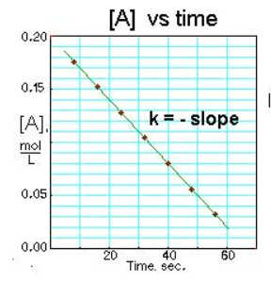
For first order reactions, the concentration does matter, therefore, just simply graphing the concentration of reactant with time will not give a straight line, but rather a nonlinear relationship. This should make sense because as the concentration of reactant decreases, so too should the rate of reaction. These relationships are linear only if you take the natural logarithm (ln) of the concentration of reactant and show it with time like so:
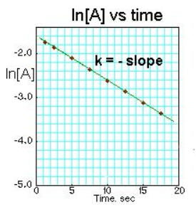
And finally, second order reactions will show up as a line only if you plot 1/[A] or the reciprocal of concentration of reactant with time like so:
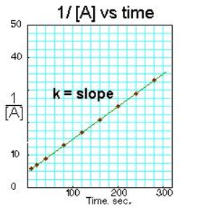
If you do not understand the reasoning behind all of these relationships, do not worry, these are derived from calculus, which is not a requirement for this course. Instead, you can learn the linear graphs with the following acronym: Zeke Couldn’t Find Logan or Sarah Rice. Zeroth Concentration, First Logarithm, Second Reciprocal.

The explicit mathematical formulas for these types of reactions is the following:
$${Zeroeth order: A}_{final}=A_{initial}-kt$$
$$First order:\ln\left(A_{final}\right)=\ln\left(A_{initial}\right)-kt$$
$$Second order:\frac{1}{A_{final}}=\frac{1}{A_{initial}}+kt$$
The most important information that we can glean from this is the expression for reaction half-life for the first order case. When the reaction has consumed half of its initial reactant, that is said to be the reaction half-life time. In other words, the time at which A_{final} = ½ A_{initial} is equal to the reaction half-life. Plugging these numbers into the first order equation gives us:
$$\ln\left(\frac{1}{2}A_{initial}\right)=\ln\left(A_{initial}\right)-kt$$
Isolating –kt gives:
$$\ln\left(\frac{1}{2}A_{initial}\right)-\ln\left(A_{initial}\right)=-kt$$
Using properties of logarithms gives:
$$\ln\left(\frac{\frac{1}{2}A_{initial}}{A_{initial}}\right)=-kt$$
The two A_{initial} values cancel out:
$$\ln\left(\frac{1}{2}\right)=-kt_{\frac{1}{2}}$$
Solving for t_{1/2} gives:
$$-\frac{\ln\left(\frac{1}{2}\right)}{k}=t_{1/2}$$
Using properties of logarithms gives:
$$\frac{\ln\left(2\right)}{k}=t_{1/2}$$
Therefore, we can calculate the reaction half-life for any first order reaction by simply knowing the reaction rate constant.

The final thing that we will have to discuss is how the reaction rate constant can be changed by using a catalyst and changing the temperature. A catalyst is a chemical substance that lowers the activation energy of a reaction. The most frequently encountered catalyst in the biological world is an enzyme. The way that catalysts and temperature change the reaction rate constant is given by the Arrhenius equation, which states that the reaction rate constant is dependent on activation energy and the temperature. This should makes sense however, if a reaction has a smaller barrier to reaction (i.e. the activation energy is lower) the reaction should happen faster because the time required to supply that activation energy is shorter. Likewise, whenever we cook food or do other chemical reactions, we always increase temperature, this is done, again, to increase the rate of reaction so we don’t have to wait eons for our steak to cook and our Maillard reactions (the ones that make our steak or meat brown) don’t take as long to occur. The Arrhenius equation is expressed mathematically like so:
$$k=Ae^{-\frac{E_{a}}{RT}}$$
The A coefficient at the front is a constant that is specific for each reaction and are can only be found experimentally by measuring activation energy, temperature, and reaction rate constants. The R in the equation is the ideal gas constant, but because E_{a} is expressed typically in kJ/mol, the R needs to also be in terms of kJ/molK. The rest is simply plug and chug. What is important to understand here is that the exponential term is raised to a negative power, meaning the larger the numerator, the slower the reaction, which makes sense because E_{a} is our activation energy term and as we had just mentioned, a lower E_{a} will facilitate a faster reaction. Likewise, the larger the denominator, the faster the reaction, which also makes sense because increasing temperature we have seen always increases the reaction rate. Here are some mixed practice questions to test your knowledge about reaction kinetics.

Practice Questions:
- What is the reaction rate constant for a reaction occurring at 23 degrees Celsius, has an activation energy of 22.4 kJ/mol, and has an A coefficient of 0.012 M/s?
- What is the reaction half-life for a first order reaction occurring at 10 degrees Celsius, has an activation energy of 22.3 kJ/mol, and has an A coefficient of 0.1304 s⁻¹?
Answers:
- This is almost as simple as plugging and chugging, however, we do need to keep in mind a few things. First, whenever we have an RT term in our equation, we must convert Celsius to Kelvin. Second, we have to make the energy units of R and E_{a} cancel, which means we either need to convert R to kJ/molK or we convert E_{a} to J/mol. Either way works. First thing is first, we should convert the temperature measurement from Celsius to Kelvin using the following formula:
$$K=273.15+C=273.15+23=296.15K$$
We should also convert our E_{a} to J/mol like so:
$$E_{a}=22.4\frac{kJ}{mol}*\frac{1000J}{1kJ}=22400\frac{J}{mol}$$
Now that we took care of our units issues, we can plug into our equation:
$$k=Ae^{-\frac{E_{a}}{RT}}$$
$$k=0.012\frac{M}{s}*e^{-\frac{\frac{22400J}{mol}}{8.314\frac{J}{molK}*296.15K}}=1.34*{10}^{-6}\frac{M}{s}$$

- WE know how to find the reaction half-life, but only if we know the reaction rate constant. Because that is not given to us, we need to use the Arrhenius equation like before to allow us to calculate it so we can plug it into the reaction half-life equation. Just like before, E_{a} is given as kJ/mol and our temperature is given as Celsius, therefore, we need to convert both of these so that the units in the exponent will cancel. We do the same process as before.

$$k=Ae^{-\frac{E_{a}}{RT}}$$
$$k=0.1304 s^{-1}e^{-\frac{22300\frac{J}{mol}}{8.314\frac{J}{molK}*283.15K}}=1.003*{10}^{-5}s^{-1}$$
Now we can plug that into the reaction half-life equation like so:

$$\frac{\ln\left(2\right)}{k}=t_{1/2}$$
$$t_{1/2}=\frac{\ln\left(2\right)}{1.003*{10}^{-5}s^{-1}}=69107 seconds$$

Chapter 15: Introduction to Redox reactions, LEO says GER

So far the only reactions that we have discussed so far are single displacement, double displacement and combustion reactions. In this chapter we are going to discuss a broader type of reaction, called redox reactions. These reactions involve the loss or addition of an electron to a chemical substance. Reduction is defined as the gaining of an electron, while oxidation is defined as the loss of an electron. Reduction is ALWAYS paired with oxidation because of the law of conservation of charge. This law states that the number of charged particles must remain the same throughout a chemical reaction. What this means is that if there was an electron lost by one compound, that electron must get picked up by another, otherwise there would be a net loss of an electron which would be in violation of the law of conservation of charge. The compound that gets oxidized is referred to as the reducing agent because it is the chemical (or agent) that is reducing something else. Likewise, the compound that gets reduced is referred to as the oxidizing agent because it is the chemical (or agent) that is oxidizing something else.
Now that we have the basic definitions down, we need to find a way to determine if an element is getting oxidized or reduced and to do this we need to determine the element’s oxidation state. To do that, we need to follow some general rules:
- Any element written by itself with no charge written on it has an oxidation state of 0, in other words, all elements in their standard state haven oxidation state of 0.
- Oxygens will always have an oxidation state of -2 to get to their octet configuration
- Halogens will always have an oxidation state of -1 to get to their octet configuration
- Hydrogen will always have an oxidation state of +1 except when with group 1 elements (then it is -1)
- The charge on the element is the same as its oxidation state, for example Cu²⁺ has an oxidation state of 2+ and a charge of 2+.
If we consider the following reaction, we can identify who is getting oxidized and who is getting reduced:
Li + CuCl LiCl + Cu
Initially, the Li has an oxidation state of 0 because there is no charge written over the element and because it is in its standard state. The Cu has an oxidation state of +1 because it is combined with a Cl in a 1:1 ratio and we know halogens will always have a -1 oxidation state when not in their gaseous forms. If we look at the product side, the Li has a +1 oxidation state because it is now with the Cl⁻¹, additionally, the Cu has an oxidation state of 0 because it is in its standard state. Therefore, we can say that Li is getting oxidized because it is losing an electron (its oxidation state is becoming more positive) and we can say that the Cu⁺ is getting reduced (its oxidation state is becoming more negative). This is also an example of a single displacement reaction, therefore single displacement reactions are actually a subclass of redox reactions!
An easy way to remember the oxidation/reduction nomenclature is with the acronym LEO GER. This stands for loss of electrons oxidation, gain of electrons reduction. Remember, electrons are negative, so if you gain electrons then you are gaining negative charge, on the other hand, if you lose electrons then you are losing negative charge. This is why we know that the Li is getting oxidized while the copper is getting reduced. We can also do this with more advanced reactions than just single displacement reactions. Consider the following reaction:
CH₂CH₂ (g) + H₂ (g) CH₃CH₃ (g)
In the above reaction, we should first consider the oxidation states of the carbons and hydrogens on both sides of the reaction. On the reactant side, the hydrogens in CH₂CH₂ are +1 because hydrogens are always +1 unless in the gaseous phase or with group 1 elements. Now we can consider the oxidation state of carbon here by setting up an equation, if each hydrogen contributes +1 charge and the entire compound is neutral then that would mean:
(+1)(4) + 2(x) = 0, the sum of the charges needs to be equal to the charge of the overall compound. Solving for x gives that each carbon has an oxidation state of -2. The gaseous hydrogen on the reactant side has an oxidation state of 0 because that is hydrogens standard state. Now we can consider the oxidation state of the carbon atoms in CH₃CH₃, just like before each hydrogen contributes +1 oxidation state and the overall compound is neutral. Just like before, we can set up an equation to solve for the oxidation state of carbon, (+1)(6) + 2(x) = 0, solving for x gives that the oxidation state of carbon here is -3. Therefore, the carbon is getting reduced because it went from -2 to -3 oxidation state and therefore became more negative and gained electrons while the hydrogen gas was oxidized from 0 to +1 oxidation state. Here are some practice questions for you to determine the oxidation state and the oxidizing and reducing agents present in each reaction.
Practice Questions:
- 2Na₂S₂O₃ + I₂ Na₂S₄O₆ + 2NaI
- 2FeCl₃ + H₂S 2FeCl₂ + S + 2HCl
- 3Mg + N₂ Mg₃N₂
Answers:
- Iodine is getting reduced, goes from 0 (because I₂ is its standard state) to -1 (because group 1 elements are always +1 when in ionic compounds). S is getting oxidized, goes from +2 to +2.5. Because iodine is getting reduced, it would be the oxidizing agent. Because S is getting oxidized, it would be the reducing agent.
- Fe is getting reduced, goes from +3 (because Cl is always -1 in ionic compounds) to +2 and therefore gained an electron. S is getting oxidized from -2 (because each hydrogen is +1 in H₂S) to 0 (because S has no charge indicated on it) and therefore lost electrons. Because Fe is getting reduced, it would be the oxidizing agent. Because S is getting oxidized, it would be the reducing agent.
- Mg is getting oxidized from 0 to +2, N is getting reduced from 0 to -3. Because Mg is getting oxidized, it is the reducing agent and because N is getting reduced, it is the oxidizing agent.
These redox reactions are sometimes quite complex to balance because unlike in the other reactions we had discussed before, where there was no gain or loss of electrons between each compound, these reactions involve the transfer of electrons. Because of this, these require both a mass and a charge balance. The premise of our balancing for the previous reactions that we had done was the law of conservation of matter, now we have to include the law of conservation of charge when we balance. Because of this additional concept that we need to take into consideration, balancing redox reactions is typically done using half reactions. The half reactions are done by isolating the oxidation and reduction portions of the reaction and ensuring that the number of electrons gained is equal to the number of electrons lost so that the overall reaction follows the law of conservation of charge. When we balance reactions using the half reaction method, there turns out to be two different ways to balance them. We can balance in acidic solution or in basic solution. In acidic solution, we will balance with H⁺ and H₂O, while in basic solution, we will balance with OH⁻ and H₂O. Luckily, if we know how to balance in acid, converting to base is trivial as we will see. First we will start with an example and then I will copy and paste my previous explanation from the inorganic chemistry textbook I had written. Consider the following reaction:
MnO₄⁻ + I⁻ Mn²⁺ + I₂
First we should identify the oxidation states of each element on both sides of the reaction. Let’s start with the reactant side. Oxygen always has an oxidation state of -2, so we can effectively ignore that, what is more interesting is the oxidation state of Mn and I on the reactant side. To figure out the oxidation state of Mn in MnO₄⁻, we have to set up an equation like before, each O contributes -2 to the charge of the molecule and the overall compound has a -1 charge, therefore (4)(-2) + x = -1, solving for x, we get that the Mn has a +7 oxidation state. The iodine’s oxidation state on the reactant side is already given to us by its charge, it is in its -1 oxidation state. On the product side, the Mn has a +2 oxidation state given by its charge, meaning that it has gotten reduced and gained 5 electrons. The I has a 0 oxidation state because it is in its standard state, therefore it has gotten oxidized and gained 1 electron. Now that we have identified the chemical getting oxidized and the chemical getting reduced, we can isolate both reactions and balance for mass and charge per normal. Let’s start with the reduction half reaction involving the MnO₄⁻ compound.
Reduction half reaction
MnO₄⁻ + 5e⁻ Mn²⁺
The five electrons are being added to the Mn which is why it goes from having a +7 oxidation state to a +2. But wait, there are oxygens on the left side that are not present on the right, therefore we have a mass balance issue. To fix the number of oxygens, add the same number of H₂O molecules on the opposite side. This gives us the updated reduction half reaction:
MnO₄⁻ + 5e⁻ Mn²⁺ + 4H₂O
But now we have an issue of hydrogens as well, so we need to balance the hydrogens on both sides. On the product side there are 8 hydrogens because 4(2) = 8. To balance the hydrogens, simply add that many H⁺ to the opposite side. The new reduction half reaction becomes:
MnO₄⁻ + 5e⁻ + 8H⁺ Mn²⁺ + 4H₂O
This reaction is now balanced for both mass and charge and so can be left alone. Now we turn our attention to the oxidation half reaction, which currently is:
I⁻ I₂ + e⁻
The electron is lost because the iodine is going from a -1 oxidation state to a 0 oxidation state. However, we have to be wary because the iodines are not balanced yet because there are two on the product side, but only one on the reactant. To fix this, we will simply make the coefficient of I⁻ a 2 like so and add in an additional electron to account for the extra iodine:
2I⁻ I₂ + 2e⁻
Remember, however, the number of electrons gained in the reduction reaction MUST equal the number of electrons lost in the oxidation reaction. Therefore, there is still an issue because as it stands, the Mn gains 5 electrons, while the I only loses 2, therefore, the oxidation half reaction must be multiplied by 5 and the reduction half reaction must be multiplied by 2 to get the number of electrons to equal each other:
10I⁻ 5I₂ + 10e⁻
This gives us the following half reactions:
2MnO₄⁻ + 10e⁻ + 16H⁺ 2Mn²⁺ + 8H₂O
10I⁻ 5I₂ + 10e⁻
Now we can add these half reactions together to get the full reaction. Just like before, if something is on opposite sides of the equations, we can cancel them out, which is why the e⁻‘s will cancel out because there are 5 on each side. When we add the two equations together, we get the following:
2MnO₄⁻ + 16H⁺ + 10I⁻ 2Mn²⁺ + 8H₂O + 5I₂
For most introductory courses, balancing in base is not always taught, if you want to learn how to convert this to basic solution, you can continue reading, however, this is simply being copied and pasted from the inorganic chemistry textbook. So you can skip the rest of this chapter if you do not need to know or do not care to know how to balance in base.
Now let’s look at a more difficult example:
Ce⁴⁺ + I⁻ Ce³⁺ + IO₃⁻
First let’s look at the oxidation state of each element
Ce⁴⁺ is being reduced to Ce³⁺
I⁻ is being oxidized to IO₃⁻, but what is its oxidation state?
Oxygen always has a -2 oxidation state except in organic peroxides and there are three in the compound that has a net charge of -1.
X -3(2) = -1
x-6=-1
x=5
therefore the oxidation state of iodine is +5 in the product side
let’s balance this reaction in acid and then I will show you how to convert this to the reaction in base.
Oxidation half reaction:
I⁻ IO₃⁻ + 6e⁻
Reduction half reaction:
Ce⁴⁺ + e⁻ Ce³⁺
To make the electrons cancel we must multiply the reduction half reaction by 6 to get the right number of electrons giving us
6Ce⁴⁺ + 6e⁻ 6Ce³⁺
But the oxidation half reaction has an issue, there are oxygen’s on the right hand side that we need to take care of, to make the oxygen’s equal we must add 3 H₂O to get both sides to have 3 oxygen’s.
I⁻ + 3H₂O IO₃⁻ + 6e⁻
But we have an issue, we have extra hydrogen’s on the left side that we don’t have on the right side, we will balance this with H⁺ to get equivalency.
I⁻ + 3H₂O IO₃⁻ + 6H⁺ + 6e⁻
Now this reaction can be written as the addition of both half reactions for the balancing in acidic conditions! Anything on the left side that is mirrored on the right side must be subtracted. So let’s recap:
Reduction half reaction:
6Ce⁴⁺ + 6e⁻ 6Ce³⁺
Oxidation half reaction:
I⁻ + 3H₂O IO₃⁻ + 6H⁺ + 6e⁻

Adding these two reaction gives:
6Ce⁴⁺ + I⁻ + 3H₂O IO₃⁻ + 6H⁺ + 6Ce³⁺

This reaction can also be balanced in base by modifying the oxidation half reaction, add an equal amount of OH⁻ where the H⁺ is and add the same amount on both sides. The H⁺ and OH⁻ then combine to give water on that side. In summary the oxidation half reaction would be:
I⁻ + 3H₂O + 6OH⁻ IO₃⁻ + 6H⁺ + 6OH⁻ 6e⁻
I⁻ +3H₂O + 6OH⁻ IO₃⁻ + 6H₂O + 6e⁻
The waters then cancel on either side to give
I⁻ + 6OH⁻ IO₃⁻ + 3H₂O + 6e⁻
As the new oxidation half reaction.
You would then add the two half reactions in the same way as before to give you the overall reaction:
Reduction half reaction:
6Ce⁴⁺ + 6e⁻ 6Ce³⁺
Oxidation half reaction:
I⁻ + 6OH⁻ IO₃⁻ + 3H₂O + 6e⁻
The overall reaction would then be
6Ce⁴⁺ + I⁻ + 6OH⁻ 6Ce³⁺ + 3H₂O + IO₃⁻
This method of balancing redox reactions always works.
Practice Questions:
- Balance the following reaction in acidic and basic conditions:
Al + MnO₄⁻ MnO₂ + Al(OH)₄⁻
- Balance the following reaction in both acidic and basic conditions:
Fe²⁺ + H₂O₂ H₂O + Fe³⁺
- Balance the following reaction in both acidic and basic conditions:
Mn²⁺ + BiO₃⁻ Bi³⁺ + MnO₄⁻
- Balance the following reaction in both acidic and basic conditions:
KMnO₄ + Na₂SO₃ + H₂O MnO₂ + Na₂SO₄ + KOH

Answers:

  - Acidic conditions: 2H₂O + Al + MnO₄⁻ Al(OH)₄⁻ + MnO₂
  - Basic conditions: 2H₂O + Al + MnO₄⁻ Al(OH)₄⁻ + MnO₂

  - Acidic conditions: 2Fe²⁺ + H₂O₂ + 2H⁺ 2Fe³⁺ + 2H₂O
  - Basic conditions: 2Fe²⁺ + H₂O₂ 2Fe³⁺ + 2OH⁻

  - Acidic conditions: 2Mn²⁺ + 5BiO₃⁻ + 14H⁺ 2MnO₄⁻ + 5Bi³⁺ + 7H₂O
  - Basic conditions: 2Mn²⁺ + 5BiO₃⁻ + 7H₂O 2MnO₄⁻ + 5Bi³⁺ + 14OH⁻

  - Acidic conditions: 3Na₂SO₃ + H₂O + 2KMnO₄ 3Na₂SO₄ + 2MnO₂ + 2KOH
  - Basic conditions: 3Na₂SO₃ + H₂O + 2KMnO₄ 3Na₂SO₄ + 2MnO₂ + 2KOH

Chapter 16: Introduction to Equilibrium
So far, we have limited our discussion on reactions that go to completion, that are quantitative. This means that the reactions that we have discussed so far only occur in one direction, but that is not the case for many reactions in chemistry. Oftentimes, reactions are in equilibrium, meaning that they can go both forward and reverse. When a reaction is at equilibrium, it is still occurring, HOWEVER, the rate of the forward reaction is equal to the rate of the reverse reaction. Therefore, we reach a steady-state concentration of products and reactants. Think of it like a hotel, when the hotel is at equilibrium, the guests that are leaving are immediately replaced by new guests and the cycle continues. There is no net gain of new guests, the old guests are simply getting replaced. But how do we describe equilibrium processes, how do we know to what extent the reaction proceeds? For this, we have to introduce the equilibrium constant, K. This K is not to be confused with the kinetics, k, the equilibrium constant is ALWAYS upper case and the rate constant is always lower case. Consider the following generic chemical reaction:
A + 2B C
If that reaction was an equilibrium process, the one directional arrow would be replaced with a double-headed arrow like so to indicate that both directions are possible (both forward and reverse):
$$A+2B↔C$$
The equilibrium constant for this reaction, and ANY reaction for that matter is simply the ratio of the products over the reactants raised to their coefficients in the balanced chemical equation. For this example, it would be:
$$K=\frac{\left[Products\right]}{[Reactants]}=\frac{\left[C\right]}{\left[A\right]{\left[B\right]}^{2}}$$
Both A and C have exponents of 1 because both of them have only a 1 coefficient in front of them, but B has an exponent of 2 because it has a 2 coefficient in the balanced chemical equation. Because K is the ratio of products to reactants, if there are more products than there are reactants, then that reaction is product-favored and K would have to be greater than 1 because big/small > 1. Conversely, if there are more reactants than products, then the reaction is reactant-favored and K would have to be less than 1 because small/big < 1. There are rules that govern what you can write in the equilibrium expression, for example, solids and liquids are NEVER written in the equilibrium expression because their contribution is assumed to be 1. If the reaction is purely in the gas phase, then instead of referring to concentration, instead, we refer to partial pressures, or the pressure exerted by that particular gas in the reaction. This equilibrium constant is referred to as K_{p} because it has pressures in it. In all scenarios, however, equilibrium finds the balance between products and reactants and will make sure that the ratio of the two of them always equals K (AMOLE). Try some practice problems writing out equilibrium expressions for various chemical reactions.
Practice Questions:
Write out the equilibrium expressions for the following chemical reactions.
- N₂ (g) + 3H₂ (g) 2NH₃(g)
- AgCl(s) Ag⁺ (aq) + Cl⁻(aq)
- CH₃CO₂H + CH₃CH₂OH CH₃CO₂CH₂CH₃ + H₂O
- Pb(OH)₂ (s) Pb²⁺(aq) + 2OH⁻(aq)
- 2SO₂(g) + O₂(g) 2SO₃(g)
Answers:
- $K=\frac{{\left[NH_{3}\right]}^{2}}{\left[N_{2}\right]{\left[H_{2}\right]}^{3}}, K_{p}=\frac{P_{NH_{3}}^{2}}{P_{N_{2}}P_{H_{2}}^{3}}$
- $K=\left[Ag^{+}\right][Cl^{-}]$
- $K=\frac{\left[CH_{3}CO_{2}CH_{2}CH_{3}\right]}{\left[CH_{3}CO_{2}H\right][CH_{3}CH_{2}OH]}$
- $K=\left[Pb^{2+}\right]{\left[OH^{-}\right]}^{2}$
- $K=\frac{{\left[SO_{3}\right]}^{2}}{{\left[SO_{2}\right]}^{2}[O_{2}]}, K_{p}=\frac{P_{SO_{3}}^{2}}{P_{SO2}^{2}P_{O2}}$

It turns out that the equilibrium constant is very useful for a wide variety of things. One such thing is determining molar solubility, or the extent of solubility of an insoluble salt like AgCl. When we discussed solubility before, we defined things as soluble and insoluble, however, there is not always a clear distinction between the two, there are areas of gray. When there are areas of gray, we can compare solubility’s quantitatively by determining the molar solubility of a salt. To do this, we write out the ionic dissociation equation, for AgCl, that equation is shown below:
AgCl(s) Ag⁺ (aq) + Cl⁻(aq)
When we discuss the solubility of an insoluble salt, these equilibrium constants are typically written as K_{sp}, but just like all K’s it is simply products over reactants raised to the coefficients in the chemical equation. For AgCl, the K_{sp} is 1.8 * 10⁻¹⁰, this K value being much less than one should come to no surprise because AgCl is an insoluble salt, therefore the reactant side is favored. Once we write out the ionic dissociation equation, we have to construct ourselves a RICE table. RICE stands for reaction, initial concentrations, change in concentration, and equilibrium concentration respectively. The following would be the RICE table for the AgCl dissociation, note that because AgCl does not appear in the K expression we do not have to worry about its values in the RICE table:
R | AgCl(s) | Ag⁺(aq) | Cl⁻(aq)
I | N/A | 0M | 0M
C | N/A | +x | +x
E | N/A | x | X

Initially, there was no Ag⁺ and Cl⁻ in the reaction mixture, therefore, before the AgCl salt dissolves, there is 0M Ag⁺ and Cl⁻, therefore, both Ag⁺ and Cl⁻ get a 0M put in for their initial concentrations. When the AgCl reaches equilibrium, both Ag⁺ and Cl⁻ concentrations will increase by some number, we will call that number x, which we will call the molar solubility, therefore in the C part of the RICE table, both Ag⁺ and Cl⁻ get a +x in their change row. The equilibrium concentration is always going to be the initial plus the change, since both Ag⁺ and Cl⁻ had 0M for their initial, their equilibrium concentration is simply just x because 0+x is x. Now that we know that the concentration of both Ag⁺ and Cl⁻ will be x when the reaction is at equilibrium we can plug these concentrations into the equilibrium expression and solve for x, which is the molar solubility. Whatever is in the E row of the RICE table gets put into the equilibrium expression for K. In this scenario it would be written like so:
$$K_{sp}=\left[Ag^{+}\right]\left[Cl^{-}\right]=x*x=x^{2}$$
We know what the K_{sp} is for AgCl, therefore all we have to do is equate x² with the K_{sp} like so:
$$K_{sp}=1.8*{10}^{-10}=x^{2}, solve for x$$
When you solve for x, we get that the molar solubility for AgCl is 1.34 x 10⁻⁵M.
Now we will do a bit more complicated problem, but the concepts and procedures will be the exact same. Now we will determine the molar solubility of PbCl₂. Like before, we should construct a RICE table like so:
R | PbCl₂ (s) Pb²⁺ (aq) + 2Cl⁻(aq) | Pb²⁺ (aq) | Cl⁻(aq)
I | N/A | 0M | 0M
C | N/A | +x | +2x
E | N/A | x | 2X

We did the same procedure as before, because we know that PbCl₂ does not appear in the equilibrium expression (because it is a solid), we can ignore all of its values in the RICE table. The key difference here is that the Cl⁻ has twice the change of the Pb²⁺ and this should make sense because if the reaction proceeded in the forward direction once, there is twice the amount of Cl⁻ produced because of the coefficient in the chemical equation. We can now plug these values into the equilibrium expression and solve for x, the molar solubility like so:
$$K_{sp}=\left[Pb^{2+}\right]{\left[Cl^{-}\right]}^{2}$$
$$K_{sp}=x{\left(2x\right)}^{2}=x\left(4x^{2}\right)=4x^{3}$$
The K_{sp} for PbCl₂ is 1.7 x 10⁻⁵, we can now plug that in for the K_{sp} value in the above equation to solve for x like so:
$$1.7*{10}^{-5}=4x^{3}, solve for x$$
$$\frac{1.7*{10}^{-5}}{4}=x^{3}$$
$$x=\sqrt[3]{\frac{1.7*{10}^{-5}}{4}}$$
Solving this gives that the molar solubility of PbCl₂ is 0.0162M. Here are some more practice problems for you to try on your own finding molar solubility.
Practice Questions:
Find the molar solubility for all the following ionic compounds.
- Pb(OH)₂, given its K_{sp} is 1.43 x 10⁻²⁰
- BaCO₃, given its K_{sp} is 5.0 x 10⁻⁹
- CuS, given its K_{sp} is 8.0 x 10⁻³⁷
Answers:
- 1.5 x 10⁻⁷ M
- 7.1 x 10⁻⁵ M
- 8.9 x 10⁻¹⁹ M

Another critical component of equilibrium is the Le Chatelier’s Principle, which states that if a system is disturbed in any way from its equilibrium, it will find the balance again and go back to its equilibrium (AMOLE). This brings up a new constant, the reaction quotient, which is Q. The reaction quotient, Q, is the exact same thing as K, but it is the ratio of products to reactants when the process is NOT at equilibrium. If Q is greater than K, then that signifies that there are more products than desirable (the numerator or products are bigger than desired), therefore, the reaction will favor the reverse direction. Conversely, if Q is less than K, then that signifies that there are more reactants than desirable (the denominator or reactants are bigger than desired), therefore the reaction will favor the forward direction. This directly relates to the Le Chatelier’s Principle because, for example, if product is added to an equilibrium process, then there is an excess amount of product present (Q > K), therefore, the reaction will be pushed to the reactant side to compensate for the excess product present. Conversely, if reactant is added to an equilibrium process, then there is an excess amount of reactant present (Q < K), therefore, the reaction will be pushed to the product side to compensate. This occurs with many other things as well. For example, if a reaction is exothermic, meaning it releases heat and warms the surroundings, if that reaction is cooled, the reaction will be pushed to the product side to maintain its favorable temperature. Equilibrium ALWAYS finds the balance (AMOLE). I like viewing Le Chatelier’s principle as a push and pull relationship, if equilibrium is disturbed then the reaction will naturally go back to equilibrium in the same way that if you are pushed you will naturally tend to find your balance, the same happens with reactions. Here are some practice questions for you to test your knowledge.
Practice Questions:
Consider the following changes to an equilibrium process, describe how these changes would effect the favorability of one side over the other in the reaction.
- An exothermic reaction is heated
- An endothermic reaction is cooled
- An endothermic reaction is heated
- Product is removed from reaction mixture
- Reactant is removed from reaction mixture
- Product is added to reaction mixture
- Reactant is added to reaction mixture
- A reaction that produces more gas has its pressure increased
- A reaction that produces more gas has its pressure decreased
Consider how you would fix these issues as a chemist.
- You are working on an enzyme that does a useful catalytic reaction that forms carbon-nitrogen bonds and in doing so, it produces acetone (a volatile organic substance that easily boils). However, you aren’t getting enough of your desired product from the process because it is in equilibrium. How would you propose we solve this issue?

- You are performing an organic chemistry reaction to make a new perfume product, however, this reaction is in equilibrium and you aren’t getting enough of your desired perfume product. The products of the reaction are the perfume and liquid water. The boiling point of the water is lower than the boiling point of the perfume. Propose two ways in which you could increase yield of the perfume product.

Answers:
- If an exothermic reaction is being heated, then it is getting hotter than it normally wants, therefore, it would want to cool itself down. Because the forward direction is exothermic and would only heat everything up, to cool it down, the reverse direction would have to be favorable because the reverse reaction would be endothermic (recall that the change in enthalpy is of opposite sign when going in the opposite direction).
- If an endothermic reaction is being cooled, then it is getting colder than it wants, therefore, it would want to heat itself up. Because the forward reaction is endothermic and would decrease temperature further, the reverse reaction must be favorable because this would be exothermic and heat the reaction up to get it back to equilibrium temperature.
- If an endothermic reaction is being heated, then it is hotter than it wants, the forward direction will decrease temperature and get it closer to its equilibrium temperature, therefore the forward direction would be favorable.
- If product is removed from the reaction mixture, then there are less products than it wants, therefore to get it back to equilibrium the system will favor the forward direction.
- If reactant is removed from the reaction mixture, then there are less reactants than it wants, therefore to get it back to equilibrium, the system will favor the reverse direction.
- If product is added to the reaction mixture, then there is an excess of products, therefore the system will want to get rid of its excess product and make the reverse reaction more favorable to make more reactant and find the balance.
- If reactant is added to the reaction mixture, then there is an excess of reactants, therefore, the system will want to get rid and use up its excess reactants and make the forward direction more favorable.
- If a reaction produces more gas molecules, then the pressure will increase because P and the number of moles of gas are directly related (recall the ideal gas law), therefore, if pressure increases beyond that desired value, then the pressure is higher than it wants at equilibrium. To make the pressure go back to its desired value, the reverse reaction will become favorable to minimize the moles of gas present in the reaction mixture.
- If the pressure is below the desired value for a reaction that produces more gas molecules, then the forward reaction will be favorable because the net production of gas molecules will increase the pressure and get it closer to its desirable equilibrium pressure.
Scenario Answers:
- Acetone is a side-product of the reaction and can be easily vaporized, because of this, we can just simply boil off the acetone and that will drive the reaction forward because we are taking away products.
- There are two easy ways to fix this. The first way is to vaporize the water and boil it off because then only the perfume product would remain, this takes away product because water is also a product and pushes the reaction forward. The second way would be to simply add more of the reactant. This would also push the reaction forward.

Equilibrium also relates to thermodynamics, and the spontaneity of a reaction, given by G, will change depending upon the concentration of products and reactants. In the thermodynamics chapter, we only discussed reactions under standard conditions, where all reagents were 1M and it was at STP, however, that is not always the case, and if you wanted to calculate the G for the nonstandard case, you would have to use the following equation:
$$∆G= ∆G°+RTln\left(Q\right)$$
The $∆G°$ is the change in Gibbs Free Energy at standard conditions and this would be calculated the same way as we did in the thermodynamics chapter ($∆G= ∆H-T∆S$). The R is again the ideal gas constant and this, because we are talking about energy, must be in units of Joules. The Q is the reaction quotient like we had previously discussed and the T is the temperature in Kelvin. When a reaction is at equilibrium, the reaction quotient, Q, is equal to K, and neither direction of the reaction is spontaneous, meaning that ΔG is 0. This should make sense because in all chemical reactions, we always strive towards minimizing energy, if ΔG was negative, then the forward reaction would occur because it is spontaneous in that direction. If ΔG was positive, then the reverse reaction would occur because it is spontaneous in that direction. If the ΔG is 0, however, then neither direction is favorable and both directions occur with the same likelihood and rate. This perfectly describes equilibrium because at equilibrium both directions take place and at equal rates. We can use this knowledge to find a formula to get K from thermodynamic data like so. If the ΔG is 0 and Q = K, then we simply have to solve for K in the above expression:
$$0=∆G°+RTln\left(K\right)$$
$$-∆G°=RTln\left(K\right)$$
$$-∆G°/RT=\ln\left(K\right)$$
To undo the natural logarithm, we simply ‘big e’ both sides because exponents are the inverse operation of logarithms. Doing that gives us the following equation for K:
$$K=e^{-∆G°/RT }$$
We can rationalize this equation by looking at the various signs $∆G°$ could have. If the change in Gibbs Free Energy is negative, that means the reaction is spontaneous. Because the reaction is spontaneous in the forward direction, that should mean that K > 1 and that the exponent of e in the equation should be positive. Well, if we look, RT has to be strictly positive because T is in Kelvin which is always positive, therefore, the only way the sign could be negative is if the numerator of the exponent was negative. This is not the case because there are two negatives on the top, the negative that was already there and the negative value for $∆G°$, therefore, when the reaction is spontaneous in the forward direction, the K is greater than one like expected. Here are some practice problems so you can get used to using the formula.
Practice Questions:
- Calculate the $∆G°$ of a reaction with equilibrium constant, K = 1.2 x 10³ at 25 degrees Celsius
- Calculate the K of a reaction with $∆G°$ of -12 kJ/mol at 25 degrees Celsius
- Calculate the $∆G°$ of a reaction with equilibrium constant, K = 2.56 x 10⁻⁵ at 25 degrees Celsius
- Calculate the K of a reaction with $∆G°$ of +25.7 kJ/mol at 25 degrees Celsius

Answers:
- -17.6 kJ/mol
- 127
- 26.2 kJ/mol
- 3.14 x 10⁻⁵

Chapter 17: Introduction to Electrochemistry, What is a Battery?

Electrochemistry is the study of how we can use chemical reactions to produce electricity. We will start our discussion by addressing voltaic cells, better known as batteries. All batteries have three things to function:
- Anode, the site of oxidation, this portion of the battery loses mass over time and anions flow towards it.
- Cathode, the site of reduction, this portion of the battery gains mass over time and cations flow towards it.
- Salt bridge, the portion of the cell that allows for cation and anion exchange from both sides of the cell.
A schematic view of a voltaic cell is shown below:

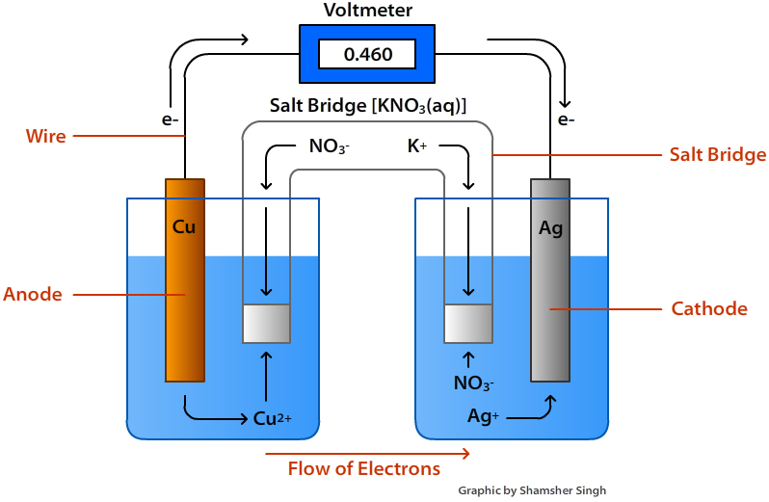
The cathode increases in mass over time because in the example cell shown above, the Ag⁺ is being reduced to metallic solid silver metal. The anode decreases in mass over time because as shown in the example above, the metallic Cu is being oxidized to Cu²⁺, this mobilizes the copper cation and allows it to enter solution. There is a nice pneumonic device to help you remember the components of a battery and how they work. Fat Red Cat Purrs. This means that the Reduction end of the battery is the Cathode, the Cathode gets Fat because it gains mass, and it attracts positively charged ions, P for positive.
In order for a voltaic cell to function, there must be a positive cell potential or voltage denoted as E_{cell}, this is because of the following equation:
$$∆G= -nFE_{cell}$$
Where F is Faraday’s constant which is 96485.332 C/mol, and n is the number of electrons involved in the redox process.
But wait a second, what is E_{cell}, well E_{cell} can be very simply calculated by using the Standard reduction potentials which are well defined constants based off the Standard Hydrogen Electrode (SHE). The more positive the reduction potential, the more thermodynamically favorable the reduction reaction is. Within the reduction potential table, there are negative entries, these chemicals are very resistant to reduction and prefer to be oxidized instead. Here is an example table for these standard reduction potentials:
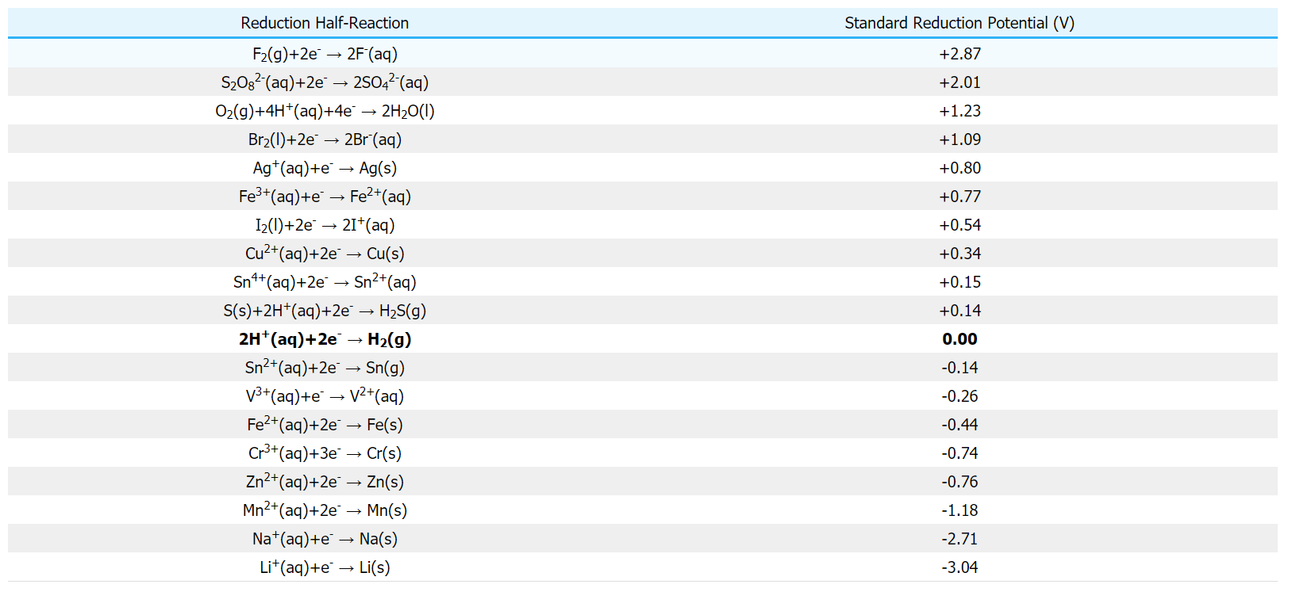
All of these reduction potentials are scaled to hydrogen, which is defined to have a reduction potential of 0. Here are some practice questions to help you get acquainted with reading this chart.
Practice Questions:
- Which element is more easily reduced, Br or I?
- Which element is more easily oxidized, Mn or Li?
- Why do you think F has the highest reduction potential?
Answers:
- Br has a more positive reduction potential than I, therefore Br would get reduced more easily.
- Li has a more negative reduction potential than Mn, therefore Li would get oxidized more easily.
- F has the highest electronegativity and one of the highest electron affinities, therefore, it REALLY wants to get that extra electron through a reduction reaction, additionally, the F-F bond is extremely weak and F⁻ is exceptionally stable because of the full octet it has (AMOLE).
In summary:
    - E_{cell} and the sign of ΔG will always be opposite
    - Positive reduction potential means you are a good oxidant, prefer to be reduced.
    - Negative reduction potential means you are a good reductant, prefer to be oxidized.
To determine the E_{cell} of a reaction, figure out which element is being oxidized and which element is being reduced. For the element that is being reduced you can just take the entry from the table directly, for the element that is being oxidized, the entry must be negated. These two number will then just be added together to get the standard cell potential, E_{cell}. These values only work at room temperature and at solutions of 1M concentrations. In order to find the cell potential at nonstandard conditions, you must use the Nernst Equation. This equation can be derived by some thermodynamic trickery:
$$∆G= ∆G^{0}+RTln\left(Q\right)$$
$$∆G^{0}=nFE_{cell}^{0}$$
$$∆G=nFE_{cell}$$
$$nFE_{cell}=nFE_{cell}^{0}+RTln\left(Q\right)$$
$$E_{cell}=\frac{nFE_{cell}^{0}}{nF}+\frac{RT}{nF}\ln\left(Q\right)$$
$$E_{cell}=E_{cell}^{0}+\frac{RT}{nF}\ln\left(Q\right)$$
Q is the ratio of product concentrations raised to their respective coefficients to the reactant concentrations raised to their respective coefficients and is referred to as the reaction quotient. This equation can be used for any reaction that is not done at standard conditions. Here are some practice questions.
Practice Questions:
- Calculate the cell potential of a battery with a Fe³⁺ cathode and Zn anode at standard conditions
- Calculate the cell potential of a battery with a Ag cathode and Cr anode at standard conditions
- Calculate the cell potential of a battery with a Cu²⁺ cathode and a Sn anode at standard conditions.
Answers:
- First identify which element is getting oxidized and reduced. Remember that the cathode is the site of reduction, therefore the FeCl₃ cathode has Fe³⁺ getting reduced to Fe²⁺, which has a standard reduction potential of 0.77V. The Zn anode is therefore the site of oxidation, where the Zn is getting oxidized to Zn²⁺ and this has a standard reduction potential of -0.76V, but this sign must be flipped because Zn is getting oxidized not reduced. Now the E_{cell} = 0.77V + 0.76V = 1.53V
- We do the same as before, reduction potential of Ag⁺ is 0.80V, reduction potential of Cr³⁺ is -0.74V, but this must get flipped because the Cr is getting oxidized not reduced. Now the E_{cell} = 0.80V + 0.74V = 1.54V
- We do same thing as before, E_{cell} = 0.34V + 0.14V = 0.48V

Chapter 18: Acid-Base Chemistry and Titrations
Acid-base chemistry is arguably the most important unit in this textbook and of the entire General Chemistry curriculum. There are several definitions of what an acid is and we will discuss the three main definitions here and provide examples of each. For general chemistry, you are mainly concerned with Bronsted-Lowry and Arrhenius acids and of those acids, only the strong ones are generally of interest with only a few notable exceptions. The three types of acids are as follows:
- Arrhenius acids
- Bronsted-Lowry acids
- Lewis acids
We will discuss each of them in turn.
Arrhenius acids are H⁺ or proton donors, something like HCl would be an H⁺ donor because when it dissolves in water, the H⁺ is separated from the Cl⁻. Arrhenius bases are OH⁻ donors, something like NaOH would be an OH⁻ donor because when it dissolves in water, the Na⁺ and OH⁻ get separated. The Arrhenius definition is limited to chemical reactions occurring in water, that is why I refer to the dissociation, or breaking up, of chemicals in water.
Bronsted-Lowry acids are a wider range of acids, they are not confined to water, but are just simply H⁺ or proton donors in general. Bronsted-Lowry bases on the other hand are exceptionally broad, they are any compound that can accept the proton the acid donates. An example of a Bronsted-Lowry base is NH₃. The key difference between the Bronsted-Lowry and Arrhenius definitions of acids is that Bronsted-Lowry is more broad and is not defined with water as the solvent. Bronsted-Lowry bases also do not have to generate OH⁻ upon dissolving, they only have to accept the H⁺.
Lewis acid/bases are the black sheep of these definitions, but it encompasses the widest range of compounds. These types of acids and bases are of most interest to organic chemists. Lewis acids are compounds that can accept electrons, while Lewis bases are compounds that donate electrons. This is essentially the exact opposite of the Bronsted-Lowry definition because in the Bronsted-Lowry case, acids are proton donors and bases are proton acceptors. Well the opposite of a proton is an electron because they have opposite charges and the opposite of donor is acceptor, so Lewis acids are electron acceptors. An example of a Lewis acid would be BF₃ because the B is partially positive due to the electronegativity of the F’s to which it is bonded. Because it is partially positive, that boron is electron deficient and wants to accept an external source of electrons. An example of a Lewis base would be anything with a lone pair, so NH₃ or H₂O would be an example of a Lewis base because the N and the O have 1 and 2 lone pairs which can be used to “attack” an incoming Lewis acid. Generally speaking, good Lewis bases will be negatively charged. If you are interested in specific characteristics of Lewis bases, I have some guidelines written in the Organic Chemistry textbook.

Here are some example problems where you will do reaction classification.
Practice Questions:
- NaOH + HCl NaCl + H₂O
- NH₃ + HCl NH₄Cl
- NH₃ + BF₃ H₃NBF₃
- NaBF₄ + AlF₃ NaAlF₄ + BF₃
Answer:
- Arrhenius acid/base reaction
- Bronsted-Lowry acid/base reaction
- Lewis acid/base reaction
- Lewis acid/base reaction

Before we begin our discussion of acid/base chemistry further, it is important that you know the strong acids and bases. The strong acids are all of the haloacids except HF because the HF bond is too strong to donate its proton effectively. Strong acids also include the oxyacids, HNO₃, H₂SO₄, and HClO₄. The full list is therefore as follows:
- HCl
- HBr
- HI
- HNO₃
- H₂SO₄
- HClO₄
The strong bases are a bit easier to memorize because they form a sort of Tetris block in the periodic table and they are all ionically bonded to OH⁻. These are as follows:
- LiOH
- NaOH
- KOH
- Ca(OH)₂
- Sr(OH)₂
- Ba(OH)₂

Now for most of the reactions that you will do in General Chemistry, acid base reactions are generally not too difficult to spot because when an Arrhenius acid reacts with an Arrhenius baes (which occurs like 99% of the time since this is the main class of acids and bases at this level), they form a salt and water. If we consider the following reactions, we can see this to be true:
NaOH + HBr NaBr + H₂O
AB AA salt water
Ca(OH)₂ + 2HBr CaBr₂ + 2H₂O
AB AA salt water

Strong acids are called strong acids because they completely donate at least one of their acidic protons when they dissolve. For example, 1M HCl will give 1M H⁺ and 1M Cl⁻ because when it dissolves it breaks up COMPLETELY to H⁺ and Cl⁻. For the strong acids that have more than one acidic proton, like H₂SO₄, they DO NOT donate both protons, instead it donates its first and some portion of its second. We will get to why it does not donate both when we discuss weak acids, but suffice it to say that when it donates its first proton it becomes negatively charged and because it is negatively charged, it does not want to become more negatively charged by donating its second proton (AMOLE). Remember, we always want to minimize charge and energy wherever possible, if donating a proton will not give sufficient energy advantage, it will not want to become more charged.
Like strong acids, strong bases are so called because they are efficient OH⁻ donors. All group 1 salts are soluble, so LiOH, NaOH, and KOH will completely dissociate into their cations and OH⁻, meaning that if we had 1M NaOH, we would have 1M Na⁺ and 1M OH⁻.

One of the most useful indicators of acidity is pH. Whenever there is a lower case p in chemistry, that always means –log, so the pH is the –log(H⁺). The pH scale ranges from 0-14, with 0 being the most acidic and 14 being the most basic. The pH of a strong acid solution can be easily calculated, for example, if we have a solution of 0.01M HCl, we can calculate the pH of that solution by writing out the dissociation equation for HCl like so:
HCl H⁺ + Cl⁻
Recall that M means moles of solute over liters of solution, meaning we have 0.01 moles of HCl in every liter of solution. If we have 0.01 moles of HCl, we also have 0.01 moles of H⁺ because they are in a 1:1 ratio according to the dissociation equation. Because of this, we can say that the molarity of HCl is equal to the molarity of H⁺ and we can use this information to plug into the formula.
$$pH= -\log\left(H^{+}\right)=-\log\left(0.01M H^{+}\right)=2$$
Therefore, like expected, when we have an acidic solution, our pH is closer to 0. There is also another metric of acidicity that is not as commonly used, but is related to pH, this is pOH. Just like with pH, whenever there is a lower case p in front of something in chemistry, it always means –log. So just like pH was –log(H⁺), pOH is –log(OH⁻). The pH and pOH are related by a simple formula, the rationale for which will be provided after:
$$pH+pOH=14$$
This is only true for aqueous systems (systems where water is the solvent). This is true because water will autoionize with an equilibrium constant of 10⁻¹⁴. Autoionization means that the molecule separates into its ions, auto means self and ionization means becoming an ion. The autoionization of water chemical reaction is shown below:
H₂O H⁺ + OH⁻
Like the double arrow would suggest, this is an equilibrium process and because H₂O is FAR more stable than either H⁺ or OH⁻, the equilibrium constant is EXTREMELY small at 10⁻¹⁴. This equilibrium constant is called K_{w} and it is the premise behind how the pH and pOH add to 14. If we were to write out the equilibrium expression, this will be clear to see:
$$K{}_{w}=\frac{\left[products\right]}{\left[reactants\right]}=\left[H^{+}\right][OH^{-}]$$
Notice that water is not included in the equilibrium expression because it is a liquid and therefore has no effect on the equilibrium expression. If we were to take the –log of both sides, we would get the following expression:
$$-\log\left(K_{w}\right)=-\log\left(\left[H^{+}\right]\left[OH^{-}\right]\right)$$
Using the properties of logs, we know that the log of a product is the same as the sum of the logs, therefore that expression becomes:
$$-\log\left(K_{w}\right)= -\log\left(\left[H^{+}\right]\right)+ -\log\left(\left[OH^{-}\right]\right)$$
Well the two terms on the right side are the pH and the pOH, so we can write that in their place like so:
$$-\log\left(K_{w}\right)=pH+pOH$$
But we already know what the equilibrium constant is for the autoionization of water, it is 10⁻¹⁴, the negative log of which is 14, therefore the equation becomes:
$$pH+pOH=14$$
Here are some practice problems to get you acquainted with using these formulas.
Practice Questions:
Determine the pH and pOH for the following solutions
- 0.127M NaOH
- 1.23M HCl
- 0.0982M KOH
- 0.0264M HI
- 1.672M LiOH
Answers:
- pH = 13.10, pOH = 0.896
- pH = -0.0900, pOH = 14.1
- pH = 12.97, pOH = 1.03
- pH = 1.58, pOH = 12.4
- pH = 14.22, pOH = -0.223
One of the most useful aspects of acid-base chemistry is titrations. A titration is a way of determining the concentration of an unknown acid or base by reacting it with its opposite (acids react with bases and bases react with acids). A titration is typically done using a pH indicator, which will change color when you have reached the equivalence point. The equivalence point is the point at which the moles of acid equal the moles of base. The equivalence volume is the volume of titrant (the compound you are reacting with the unknown) that is required to get to the equivalence point. The following is a graph of pH of solution as the volume of titrant increases:
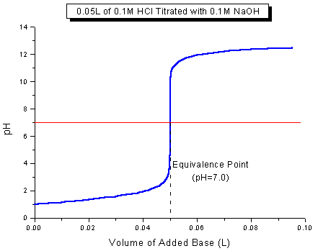
An example titration will be done with you and then I will give you example problems for you to do by yourself. Suppose we are titrating an unknown concentration of a 10 mL NaOH sample with 5M HCl and that it takes 26 mL of HCl to reach the equivalence point. We can calculate the molarity of NaOH with this information. The first thing that we must do is calculate the moles of HCl that were used to reach the equivalence point because this number is the same as the moles of NaOH that were present in the initial 10 mL. To do this, we must multiply the concentration of HCl by the equivalence volume like so:
$$\frac{5 moles HCl}{1L}*\frac{1L}{1000mL}*26mL=0.13 moles HCl$$
Since we know that there are 0.13 moles of HCl present at the equivalence point, there are also 0.13 moles of NaOH present in the original sample. Now we can calculate the concentration of the unknown NaOH by dividing the number of moles by the volume of solution that was there initially like so:
$$\left[NaOH\right]=\frac{0.13 moles NaOH}{10mL }*\frac{1000mL}{1L}=13M NaOH$$
Here are some practice problems that involve titrations of strong acids and bases.
Practice Questions:
- How many mL of 0.2M HI is needed to reach the equivalence point when titrating 25mL of 0.5M NaOH?
- What is the concentration of a 32.4 mL sample of HCl if it takes 12.6 mL of 5M NaOH to titrate it?
- What is the concentration of a 65.82 mL sample of LiOH if it takes 45.82 mL of 2M HBr to titrate it?
- What is the pH of at the equivalence point for any strong acid-strong base titration?
- What is the pH of a solution to which 12 mL of 0.2M HCl is added to 24 mL of 0.4M NaOH?
Answers:
- At the equivalence point, the moles of acid is equal to the moles of base, therefore, to get the volume necessary to titrate 25 mL of 0.5M NaOH, we can use the equation:
$$M_{a}V_{a}=M_{b}V_{b}$$
This formula works because it is the mathematical way of expressing that the moles of acid must equal the moles of base. This can be seen by looking at the units, M_{a} has units moles acid/volume acid, V_{a} is volume acid therefore the product would be simply moles of acid. This same logic can be applied to the base side of the equation. We want to solve for the volume of acid, therefore, we isolate V_{a} in the equation:
$$V_{a}=\frac{M_{b}V_{b}}{M_{a}}$$
Now we can substitute in the values that we know to get V_{a} like so:
$$\frac{\left(0.5 M\right)\left(25mL\right)}{0.2M}=62.5 mL HI$$
- This is again at the equivalence point, so we can use the same equation as before, but instead of solving for V_{a}, we solve for M_{a} like so:
$$M_{a}=\frac{M_{b}V_{b}}{V_{a}}=\frac{\left(5M\right)\left(12.6mL\right)}{32.4mL}=1.94M HCl$$
Alternatively, you can solve for the moles of base like so:
$$\frac{5 moles NaOH}{1L}*\frac{1L}{1000mL}*12.6mL=0.063 moles NaOH=0.063 mole HCl$$
Now that we have the moles of acid, we can simply divide by the volume it was in initially when converted to L like so:
$$\frac{0.063mole HCl}{32.4mL}*\frac{1000mL}{1L}=1.94M HCl$$
- We apply the same procedure as before, but instead of isolating M_{a}, we isolate M_{b}.
$$M_{b}=\frac{M_{a}V_{a}}{V_{b}}=\frac{\left(2M\right)\left(45.82mL\right)}{65.82mL}=1.39M$$
- AT the equivalence point, the moles of acid equal the moles of base. For strong acids and strong bases, this means that the moles of H⁺ equal the moles of OH⁻ because the definition of strong acids and bases is that they dissociate completely into H⁺ and OH⁻, therefore, they would form water, which has a pH of 7. Therefore, all strong acid-strong base titrations will give a pH of 7 at the equivalence point.

- First, we must recognize that we are not at the equivalence volume yet. This can be easily seen by looking at the moles of acid and moles of base, they are clearly not the same. This is actually the first step in solving this problem. First, we will solve for moles of acid by multiplying the concentration of the acid by the volume of acid added converted to L like so:

$$\frac{0.2moleHCl}{1L}*\frac{1L}{1000mL}*12mL=0.0024 moles HCl=0.0024 moles H^{+}$$
Because we have 0.0024 moles of HCl, we also have 0.0024 moles of H⁺ because HCl is a strong acid and therefore will completely dissociate to H⁺ and Cl⁻. Now we can solve for base like so:
$$\frac{0.4moleNaOH}{1L}*\frac{1L}{1000mL}*24mL=0.0096 mole NaOH=0.0096 moles OH^{-}$$
We solved for the moles of NaOH the same way that we solved for the moles of HCl. Just like with HCl, NaOH is a strong base and therefore will dissociate into OH⁻ completely, therefore the moles of NaOH will equal the moles of OH⁻. The OH⁻ that comes from the NaOH is constantly reacting with the H⁺ that is coming from the HCl to form water like so:
$$H^{+}+OH^{-}→H_{2}O$$
therefore we must subtract away all of the moles of H⁺ that the OH⁻ interacted with like so:
$$0.0096 moles OH^{-}-0.0024 moles OH^{-}=0.0072 moles OH^{-}$$
Now that we have the moles of OH⁻ that are present in solution, we must find the concentration by dividing by the total volume of solution, which is the volume of the acid added and the volume of base that was there initially:
$$\frac{0.0072 moles OH^{-}}{12mL+24mL}*\frac{1000mL}{1L}=0.2M OH^{-}$$
Now that we found the concentration of OH⁻, we can find the pOH by taking the negative like so:
$pOH=-\log\left(\left[OH^{-}\right]\right)=-\log\left(0.2M\right)=0.699$
Now we can solve for the pH by plugging into the formula:
$pH+pOH=14, solve for pH$
$$pH=14-pOH=14-0.699=13.3$$
This should make sense because there is an excess amount of base, therefore the pH should be above the neutral 7.

Now that we have discussed strong acids and strong bases, we should turn our attention to weak acids and weak bases. Weak acids and weak bases are all of the compounds that are NOT listed as strong. These compounds are weak because unlike the strong compounds they DO NOT dissociate completely to H⁺ or OH⁻ instead they are at equilibrium. Because they are at equilibrium, only a portion of the acidic proton is donated. The degree to which the proton is donated is referred to as the K_{a} of the acid and this is the equilibrium constant for the following chemical reaction for a generic weak acid called HA:
$$HA ↔H^{+}+A^{-}$$
The equilibrium expression for this reaction would be as follows:
$$K_{a}=\frac{\left[products\right]}{\left[reactants\right]}=\frac{\left[H^{+}\right]\left[A^{-}\right]}{[HA]}$$
A more common way of expressing acid strength is done with the pKa because K_{a} values are typically relatively small numbers and are hard to work with oftentimes. Just like the pH and the pOH, the pKa is simply the –log(K_{a}) because remember whenever you see a lowercase p, it means –log. The smaller the pKa the stronger the acid. Just as there is a K_{a} for acids, there is a K_{b} for bases. The K_{b} constant is for the following reaction for a generic base called B:
$$B+H_{2}O↔HB^{+}+OH^{-}$$
Because H₂O is the solvent and is a liquid, we can ignore it in the equilibrium expression, therefore the equilibrium expression for the above reaction is:
$$K_{b}=\frac{\left[products\right]}{\left[reactants\right]}=\frac{\left[HB^{+}\right]\left[OH^{-}\right]}{[B]}$$
Any weak base and weak acid will have corresponding K_{a} and K_{b} values, the product of which will always be K_{w}, this is expressed mathematically as:
$$K_{a}K_{b}=K_{w}$$
This can be transformed into a nicer equation by taking the –log of both sides like so:
$$-\log\left(K_{a}K_{b}\right)=-log⁡(K_{w})$$
Using the properties of logarithms, we know we can separate the product of two things inside the log as the sum of two individual logs like so:
$$-\log\left(K_{a}\right)+ -\log\left(K_{b}\right)=-\log\left(K_{w}\right)$$
We know that the –log(K_{w}) = 14 and we defined pKa as the –log(K_{a}) and therefore the pKb would be –log(K_{b}), this now makes this equation:
$$pKa+pKb=14$$
Here are some practice questions to help you solidify your knowledge about weak acids and bases.
Practice Questions:
- Which acid is stronger, acetic acid (pKa = 4.75) or benzoic acid (pKa = 4.20)
- What is the K_{b} of acetic acid?
- What is the K_{b} of benzoic acid?
- Which compound is a stronger base, formic acid (pKa = 3.75) or thiophenol (pKa = 6.6)?

Answers:
- Lower pKa means stronger acid, therefore benzoic acid is a stronger acid because its pKa is lower than acetic acid’s pKa.
- To solve for the K_{b} of acetic acid, you would first have to determine the pKb by using the formula:
$$pKb=14-pKa=14-4.75=9.25$$
We know that the pKb is the –log(K_{b}), therefore we need to isolate K_{b} by multiplyinb both sides by -1 and raising both sides to the power of 10 since exponents are the inverse operation of logarithms:
$$-\log\left(K_{b}\right)=9.25$$
$$\log\left(K_{b}\right)= -9.25$$
$$K_{b}={10}^{-9.25}=5.62*{10}^{-10}$$
- We solve this the same way as before:
$$pKb=14-pKa=14-4.20=9.80$$
$$-\log\left(K_{b}\right)=9.80$$
$$\log\left(K_{b}\right)=-9.80$$
$$K_{b}={10}^{-9.80}=1.58*{10}^{-10}$$
- If you are a stronger acid, you are a weaker base, because formic acid has the smaller pKa, it is the stronger acid and therefore the weaker base. Thiophenol is the stronger base.

Strong and weak acids could have multiple acidic protons, for example, citric acid is a triprotic weak acid because it has three acidic protons and sulfuric acid is a diprotic strong acid because it has two acidic protons. When a compound has more than one acidic proton to give away, then a single K_{a} or pKa is not enough to describe the acidity of the compound. This is because when an acid gives up its proton, it becomes negatively charged, therefore, it is less willing to give up another proton. This is for two reasons 1. Opposite charges attract and 2. We want to minimize charge (AMOLE). If a weak acid is negatively charged and gives up a proton, it would become more negatively charged AND would be attracted to the positively charged proton and want to steal it back. This is why despite sulfuric acid being a strong acid, it does not donate BOTH protons, it donates only one completely and then only a portion of the second. The following are the Lewis structures for H₂SO₄, HSO₄⁻, and SO₄²⁻:

When an acid acts as an acid and gives away its acidic proton, it forms its conjugate base. This conjugate acid-base pair is very useful for determining acid strength. This is because stronger acids will give weaker conjugate bases and stronger bases will give weaker conjugate acids. This should make sense because if you are a strong acid, then you really want to give away that proton, therefore when you are the conjugate base, you aren’t going to want to accept the proton again. Here are some practice problems to help you solidify your knowledge of conjugate acid-base pairs and polyprotic acids.
Practice Questions:
- Which is a stronger base, OH⁻ or NH₂⁻?
- Which is a stronger base, O²⁻ or OH⁻?
- Which is a stronger base, Cl⁻ or F⁻?
Answers:
- The conjugate acids for these are H₂O and NH₃, because NH₃ is less acidic (more basic) than H₂O, NH₂⁻ is a stronger base.
- The conjugate acids for these are OH⁻ and H₂O, because OH⁻ is less acidic (more basic) than H₂O, O²⁻ is a stronger base.
- The conjugate acids for these are HCl and HF, because HF is less acidic (more basic) than HCl, F⁻ is a stronger base.

Just as we can titrate strong acids and strong bases, we can titrate weak acids and weak bases. Weak acids/bases, however, are actually more resistant to pH change over a wide range of pH values. This is because strong acids give terrible conjugate bases, so when they are reacted with OH⁻, the conjugate base does not play a role in determining pH because it is so weak. This is not the case for weak acids/bases. Weak acids/bases form buffer systems with their conjugate acid/base pair. This is actually how our blood pH is regulated, using the bicarbonate (HCO₃⁻) conjugate acid/base system. Weak acids are the strongest buffers when the pH is around their pKa(s). Therefore, the shape of the titration curve for weak acid/bases is much different than the strong acid/bases case. A stereotypical titration curve for a weak acid titration is shown below:
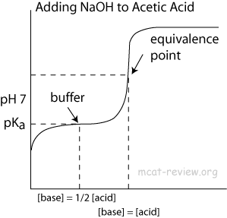
As the graphic above points out, when half the equivalence volume is added, the pH is equal to the pKa of the acid being titrated. The equivalence volume is still calculated the same way as before, using the M_{a}V_{a} = M_{b}V_{b} formula. As you can also see, the solution resists changes in pH most strongly around the pH that is closest to the pKa of the acid. This trend continues with polyprotic acids, in addition to getting one pKa value when the volume of titrant is half the equivalence volume, you can get more than that at 3/2 the equivalence volume for a diprotic acid or 5/2 the equivalence volume for a triprotic acid for pKa₂ and pKa₃ respectively. If you would like to calculate the pH of a solution of a weak acid with its conjugate, then you must use the Henderson-Hasselbach equation:
$$pH=pKa+\log\left(\frac{A^{-}}{HA}\right)$$
Where HA is a generic acid and A⁻ is its conjugate base. The pKa that you use must be the pKa closest to the volume that you are working with. For example, all titrant volumes that are less than one equivalence volume would be using pKa₁, if the titrant volume is between one and two times the equivalence volume, use pKa₂, so on and so forth. Make sure the pKa that you are using makes SENSE.
Here are some practice problems dealing with weak acid/base titrations and calculating pH.
Practice Questions:
- What is the pKa(s) of this weak acid according to the titration curve shown below:
- What is the pH of a 0.5M acetic acid solution, K_{a} = 1.8x10⁻⁵
- What is the equivalence volume for titrating 23.4 mL of 0.0215M benzoic acid solution with 0.2M NaOH solution? What is the pH at half the equivalence volume if the pKa of benzoic acid is 4.20?
- What is the pH of a solution with 25 mL 0.5M acetic acid and 12 mL of 0.12M sodium acetate? The pKa of acetic acid is 4.80.
Answers:
- The equivalence volume here is 10 mL, therefore the volumes of 5 and 15 mL will get the pKa’s of the unknown acid. At 5mL, the pH is about 2.2, therefore pKa₁ = 2.2. At 15 mL, the pH is about 5.7, therefore pKa₂ = 5.7.
- First we should start off by writing out the dissociation equation for acetic acid like so:
$$CH_{3}COOH ↔H^{+}+CH_{3}COO^{-}$$
We know that this is an equilibrium process, therefore we should make a RICE table like so:
R | CH₃COOH | H⁺ | CH₃COO⁻
I | 0.5M | 0 | 0
C | -x | +x | +x
E | 0.5-x | x | x
Now we can write out the equilibrium expression like so:
$$K_{a}=\frac{\left[products\right]}{\left[reactants\right]}=\frac{\left[H^{+}\right]\left[CH_{3}COO^{-}\right]}{[CH_{3}COOH]}$$
We can plug in the values that we know like so:
$$K_{a}=\frac{x*x}{0.5-x}=\frac{x^{2}}{0.5-x}$$
We know what K_{a} is, so we can plug that in like so:
$$1.8*{10}^{-5}=\frac{x^{2}}{0.5-x}$$
We want to solve for x because we want to know the pH and we can only know the pH if we know the concentration of H⁺, which is x. There is no easy way to solve this algebraically, but first, we should bring everything to one side like so:
$$1.8*{10}^{-5}\left(0.5-x\right)=x^{2}$$
$$9.0*{10}^{-6}-1.8*{10}^{-5}x=x^{2}$$
$$x^{2}+1.8*{10}^{-5}x-9.0*{10}^{-6}=0$$
Now that we have a polynomial (and a quadratic at that) that is equal to 0, all we have to do is graph the function and see where it crosses the x-axis. The x value that you should get is 0.00299M. Now that we know the concentration of H⁺, we can get pH by taking the negative log of that number like so:
$$pH= -\log\left(0.00299101\right)=2.52$$
Now initially, you may have thought to use the Henderson-Hasselbach equation, however, the reason why that is not a viable route here is because we do not know how much conjugate base there is in solution, nor do we really care, we just want H⁺, which we can get directly from the K_{a}. The Henderson-Hasselbach equation is typically used when you do a titration or when you add a known amount of conjugate base into the solution.
- We solve for the equivalence volume the exact same way as before, using the following formula:
$$M_{a}V_{a}=M_{b}V_{b}$$
We are titrating an acid with a base, therefore, we must solve for V_{b} like so:
$$V_{b}=\frac{M_{a}V_{a}}{M_{b}}=\frac{0.0215M\left(23.4mL\right)}{0.2M}=2.52mL$$
Therefore, the equivalence volume is 2.52mL. At half the equivalence volume, the Ph = pKa, because the pKa of benzoic acid is 4.20, the pH at 1.26 mL would also be 4.20.
- Here is where we use the Henderson-Hasselbach equation, we are given the concentrations of the conjugate acid/base pair and their volumes, therefore, to use the Henderson-Hasselbach equation, we must find the number of moles for the conjugate acid and base like so:
$$\frac{0.5 mole acetic acid}{1L}*\frac{1L}{1000mL}*25mL=0.0125 mole acetic acid$$
$$\frac{0.12 mole acetate}{1L}*\frac{1L}{1000mL}*12mL=0.00144 mole acetate$$
Now we can substitute in what we know to the Henderson-Hasselbach equation to determine the pH:
$$pH=pKa+\log\left(\frac{A^{-}}{HA}\right)=4.8+\log\left(\frac{0.00144 mole}{0.0125 mole}\right)=3.86$$

Chapter 19: Introduction to Molecular Orbital Theory and Hybridization

In the bonding chapter we had discussed the various types of bonds and the various types of orbitals, however, in this chapter, we will be discussing how atomic orbitals (s, p, d, and f) interact to form covalent bonds in molecules. But first, we need to discuss the shape that these orbitals have.
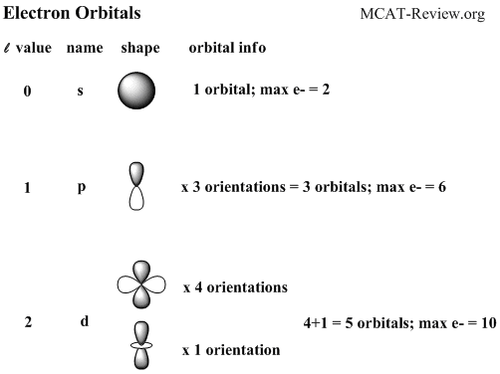
For most purposes in this course, we only have to consider the s and p orbitals. Notice how in the figure, the p and d orbitals have different shades in the different areas. On the top lobe of the p orbital, it is dark, while the bottom is light. These colors represent the different phases that the electrons can be in. Electrons behave both like particles and like waves depending on the context. In the context of bonding, they act like waves, therefore they can constructively interfere or destructively interfere, this is shown below:
Just as the figure notes, if two atomic orbitals combine such that they are in-phase, meaning that they have the same color, they will form bonding interactions. The constructive interference of two s orbitals forms sigma bonds. The constructive interference of two p orbitals forms pi bonds. Something else that you should notice from the first figure is that the number of different orientations of the atomic orbitals is equal to the number of horizontal lines we drew for each type of orbital. This should makes sense because each orientation will have a dark and a light phase, the dark phase will have one electron occupying it and the light phase will have the other electron in the orbital occupying it. If we take two s orbitals of the same phase and bring them close to each other, a sigma bond will form, if the two s orbitals are out of phase and we bring them together, we have a sigma antibond form like so:
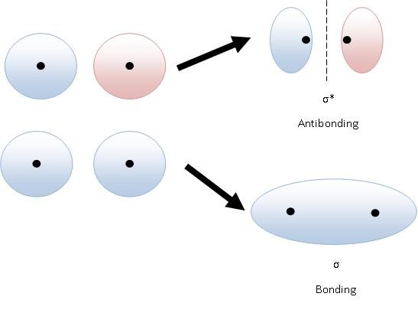
As you can see from the antibonding, there is a line where there is no electrons in between the two nuclei. This region where there is absolutely no electron/electron density is referred to as a node. Because bonding results in electrons being spread out over a larger area, bonding is always lower in energy than antibonding, it is easier for two things to combine than for them to resist each other’s influence. The sigma bond is always the first bond to form in a molecular compound because the s orbitals are generally easier to overlap than the p orbitals. This is because the s orbital is a sphere while the p orbitals are dumbbell-shaped, which makes them harder to orient properly. Just as the s orbitals can combine constructively (to bond to each other) or destructively (to antibond), the same can be done with p orbitals like so:
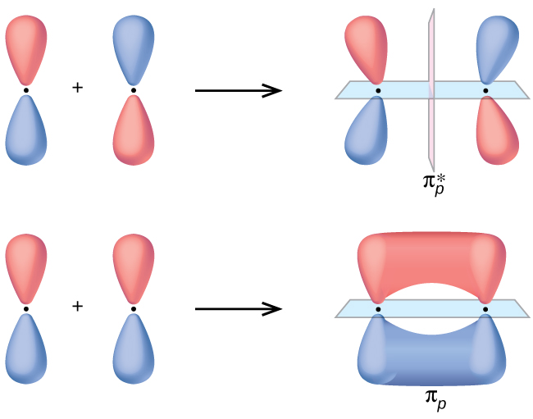
Just as before, when an antibond forms, a nodal plane is created in between the two nuclei (black dots in between the two portions of the p orbital), this destabilizes antibonding interactions because it causes the electrons to repel each other based off charges (AMOLE). Note that in all of the cases above, we combined individual atomic orbitals to form molecular orbitals that were either bonding or antibonding depending on how they interacted. This is always the case, therefore, the number of atomic orbitals will ALWAYS equal the number of molecular orbitals because whenever a bonding molecular orbital is formed, so too is an antibonding molecular orbital. Now that we have discussed the general molecular orbital theory, which says that electrons behave like waves and combine constructively to form bonds and combine destructively to form antibonds, we can construct molecular orbital diagrams for various molecules. We can start by constructing the molecular orbital diagram for O₂ gas, the molecular orbital diagram should tell us the number of bonding and antibonding interactions based on the number of electrons present in the two atoms that are combining. Just like we did with the Lewis structures, we only have to care about the valence electrons because these are the ones that are actually involved with bonding and these are the ones that are the farthest away from the nucleus of the atom. Both O’s in O₂ have 6 valence electrons, 2 in their 2s orbitals and 4 in their 2p orbitals. The first thing that we must do when constructing an MO diagram is to write out the atomic orbitals for both of the elements involved like so:

Now we have to combine the different atomic orbitals. When the s atomic orbitals overlap, they form sigma bonds and antibonds, each having one MO each like so:
There are four electrons that we can distribute into these sigma and sigma* orbitals and each of those MOs can hold two electrons each. Just as before when we constructed our atomic orbital diagrams, we start by filling our lowest energy first and then fill the higher energies like so:
There is only one sigma and sigma* orbital formed by the overlap of the s orbitals because the s orbitals are spherical and therefore only have one orientation. Now we can discuss the overlap of the p orbitals for the two oxygen atoms. These will form the pi MOs, these pi MOs have more than one orientation because the p orbitals have three possible orientations (x, y, and z), these orientations are shown below:
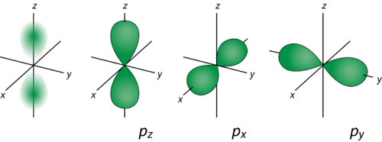
Because they have three possible orientations, they will form three bonding MOs and three antibonding MOs like so. The reason why not all of the orbitals that form are pi orbitals is because the z-axis is defined as the internuclear axis, meaning that overlap of these atomic orbitals results in a SIGMA bond, not a PI bond:
Same as before, we simply fill in the MOs starting from the lowest energy like so:
This is the finished MO diagram for O₂ gas, if you recall the Lewis structure for O₂ is this:
Therefore, in the MO diagram, we should see that the overall bond order is 2. To calculate bond order, there is a simple formula:
$$Bond order=\frac{\#bonding e^{-}-\#antibonding e^{-}}{2}$$
The division by two is because each bond has two electrons in it and the numerator gives the number of electrons that are available for bonding after considering those that form antibonding interactions. This bond order should ideally be a whole number, if it is not a whole number, then the molecule is not stable! The bond order here would be:
$$Bond order=\frac{8-4}{2}=\frac{4}{2}=2$$
Which is exactly what we suspected based off the Lewis structure since there is a double bond! Keep in mind, these two systems were developed entirely independently of each other, so the fact that both come to the same conclusion is remarkable and shows the powerful nature of Lewis structures and molecular orbital theory (since let’s be honest, drawing Lewis structures is WAY easier than drawing MO diagrams). Here are some practice problems to help you brush up on drawing MO diagrams and predicting stability based off the MO diagram.
Practice Questions:
- Draw the MO diagram of Mg₂ and predict whether or not this compound could exist
- Draw the MO diagram for HeH and predict whether this compound could exist
- Draw the MO diagram for H₂ and predict whether this compound could exist
Answers:

The overall bond order for this compound is 0:
$$Bond order=\frac{bonding e^{-}-antibonding e^{-}}{2}=\frac{2-2}{2}=\frac{0}{2}=0$$
Therefore, this compound could not exist according to MO theory because there is no bond between the two Mg’s.

The overall bond order for this compound would be 0.5, so if it did exist it would be EXTREMELY unstable:
$$Bond order=\frac{bonding e^{-}-antibonding e^{-}}{2}=\frac{2-1}{2}=\frac{1}{2}=0.5$$

The overall bond order for this compound would be 1, so it would exist and be relatively stable. This is also confirmed by the Lewis structure, which has a single sigma bond between the two H’s:
$$Bond order=\frac{bonding e^{-}-antibonding e^{-}}{2}=\frac{2-0}{2}=\frac{2}{2}=1$$

We have limited ourselves to simply diatomic molecules for a reason. This can get really complicated, REALLY quickly, so for a general chemistry course, you will mainly deal with diatomics because they are the simplest.

This view of atomic orbitals combining to form molecular orbitals is somewhat simplified, what actually happens when they combine is that the orbitals essentially hybridized to lower the energy gap between the s and p orbitals. This process is called hybridization. The actual mechanics of hybridization is not super important to know, but know that the overall reason for it is that the p orbitals have three subshells due to their three possible orientations, while the s orbital only has one subshell, therefore it is favorable to blend the orbitals together to reduce energy (AMOLE). An example of hybridization is shown below:
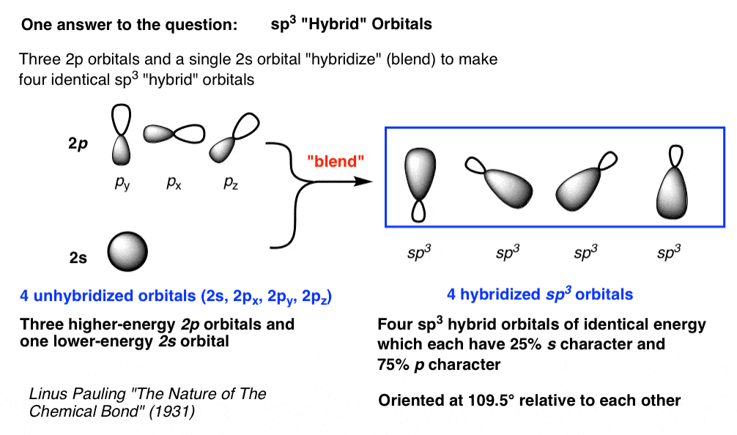
This theory of hybridization accounts for the fact that the molecular orbitals that we see in molecules are of a lower energy than we had anticipated, this can only be explained if we consider hybridization. This begs the question, however, how do we determine the hybridization of an atom in a molecule given its Lewis structure? This turns out to be quite simple, simply count the number of lone pairs and atoms to which the atom in question is attached. For example, if we look at CH₄, we can get that the hybridization of the C is sp³ because it has four hydrogens attached to it and 0 lone pairs. The way we come to this conclusion is that the s will always have the first bond, then the p’s will have a maximum of three because of the three orientations of the p orbitals, the d’s will have a maximum of five and f’s will have a maximum of seven as the superscript. Then it is simply addition, the s has an invisible 1 on top and the p has the 3, 1+3 = 4, which is exactly the number of atoms attached to the carbon and its lone pairs. Here are a couple more examples that we can work out together using the following formula:
$$Hybridization number=number of lone pairs+number of atoms attached$$
Let’s do the following molecules: NH₃, H₂O, HF, C₂H₄
First we start by drawing the Lewis structures for all of the molecules like so:
Now we determine the hybridization number for each atom that is not H by counting its lone pairs and number of atoms attached to it, this gives us the following:
Now that we have the hybridization number for each atom, we can assign the hybridization. The first number in each will go to the s, then the remainder will go to the p if the remainder is not more than 3 (that is not the case here, but could be for other molecules like XeF₄ for instance). Therefore, the hybridization for each element is as follows:
Note that in all cases, the number on the bottom is the same as the hybridization number. This is always the case because we are making it the case. This is a good way to double check that you did it correctly. Here are some practice problems for you to do.
Practice Questions:
Assign the hybridization to all non-hydrogen atoms in the following molecules:
- SOCl₂
- H₂SO₄
- XeF₄
- XeF₆
- HNO₃
- NO₂⁺
- AlH₄⁻
Answers:

Chapter 20: Introduction to Nuclear Chemistry
This chapter sounds very intimidating, but this is probably one of the easiest chapters if you can do simple arithmetic. Nuclear chemistry is the chemical reactions that involve the decay or emission of nuclear particles (protons, neutrons, and electrons). These reactions are incredibly useful for determining how old something is (we will get to that at the end of the chapter) and tracking things in the body through radiolabeling. These nuclear reactions come in a couple of different flavors:
- Alpha decay
- Beta decay
- Electron capture
- Gamma emission
In an alpha decay, an alpha particle is emitted from a radioactive substance. An alpha particle is essentially a helium nucleus, it is comprised of two protons and two neutrons. A beta decay is the emission of an electron. An electron capture is exactly what it sounds like, an electron is taken into the nucleus. And finally, gamma emission is the odd ball of these, this reaction is simply the emission of energy from the nucleus to make the atom more stable. An example of these reactions are shown below:
Alpha decay: ${}_{94}^{240}{Pu→{}_{92}^{236}U+{}_{2}^{4}{He}}$
Beta decay: ${}_{11}^{22}{Na}→{}_{12}^{22}{Mg+{}_{-1}^{0}e}$
Electron capture: ${}_{36}^{81}{Kr+{}_{-1}^{0}{e→{}_{35}^{81}{Br+{}_{0}^{0}ν}}}$
Gamma emission: ${}_{90}^{234}{Th→{}_{90}^{234}{Th+{}_{0}^{0}γ}}$
As you may have noticed by looking at these reactions, the numbers on the top and bottom of both sides add up to be the same number. For example, with the alpha decay example, 240 = 236 + 4 and 94 = 92 + 2. This also works for the beta decay example, 22 = 22 + 0 and 11 = 12 + -1. As long as you can add, you should be able to do any of these questions within two seconds because all you need to do to check them is see if the top numbers add up the same and if the bottom numbers add up the same. Just as a refresher, the top numbers are the mass numbers, they tell you the number of protons AND neutrons in the atom, while the bottom numbers are the atomic numbers, they tell you the number of protons. Since electrons have a -1 charge, they get a -1 for their atomic number to signify that they are negatively charged. Here are some practice questions with these reactions.

Practice Questions:
- Alpha decay of ${}_{92}^{238}U$
- Electron capture of ${}_{92}^{238}U$
- Beta decay of ${}_{35}^{81}{Br}$
- Alpha decay of ${}_{84}^{210}{Po}$
Answers:
- ${}_{92}^{238}U→{}_{90}^{234}{Th}+{}_{2}^{4}{He}$
- ${}_{92}^{238}U+{}_{-1}^{0}e →{}_{91}^{238}{Pa+ν}$
- ${}_{35}^{81}{Br}→{}_{36}^{81}{Kr}+{}_{-1}^{0}e$
- ${}_{84}^{210}{Po}→{}_{82}^{206}{Pb}+{}_{2}^{4}{He}$

Like we said previously, radioactive decay is useful for radioactive dating. All decay processes follow first order kinetics according to the rate law:
$$Rate=k[Radioactive element]$$
Because it follows first order kinetics, we can use all of the equations that we know about for first order kinetics, namely:
$$\ln\left(A_{final}\right)= -kt+\ln\left(A_{initial}\right)$$
$$t_{half life}=\frac{\ln\left(2\right)}{k}$$

Another useful formula is the following:
$$A\left(t\right)=\left[A_{initial}\right]{\left(\frac{1}{2}\right)}^{\frac{t}{t_{half life}}}=\left[A_{initial}\right]{\left(\frac{1}{2}\right)}^{n}$$

Together, these formulas can be used to calculate the amount of time something has decayed for. We can do an example together and then I will give you some final practice problems and finally general chemistry is over for you . Suppose we wanted to determine the age of an ancient artifact that has 2 grams of carbon-14 if initially it had 32 grams of carbon-14 given that the half life of carbon-14 is 5700 years. The first thing we have to determine is how many half lives passed, to do this, we can use the last formula and isolate n like so:
$$A_{final}=A_{initial}{\left(\frac{1}{2}\right)}^{n}$$
$$\frac{A_{final}}{A_{initial}}={\left(\frac{1}{2}\right)}^{n}$$
We want to isolate n, but n is in the exponent so we must natural log both sides to bring the exponent down like so:
$$\ln\left(\frac{A_{final}}{A_{initial}}\right)=nln\left(\frac{1}{2}\right)$$
$$\frac{\ln\left(\frac{A_{final}}{A_{initial}}\right)}{\ln\left(\frac{1}{2}\right)}=n=\frac{t}{t_{halflife}}$$
When we plug in what we know, we get the following:
$$\frac{\ln\left(\frac{2grams}{32grams}\right)}{\ln\left(\frac{1}{2}\right)}=n=4$$
Now we can isolate t, which is the total time that has passed:
$$n=\frac{t}{t_{halflife }}$$
$$4=\frac{t}{t_{halflife}}$$
$$t=4*t_{halflife}$$
$$t=4\left(5700\right)years=22800 years$$
Here are some practice problems for you to try.
Practice Questions:
- How much of a 64 gram sample of carbon-14 will remain after 32450 years?
- How long would it take a sample of cobalt-60 to decay to 10% of its initial value if its half-life is 5.27 years?
- How old is a rock that contains 1.52 x 10⁻⁷ grams of uranium-238 and 2.61 x 10⁻⁹ grams of thorium-234 if all the thorium-234 came from the alpha decay of uranium-238? The half-life of uranium-238 is 4.5 x 10⁹ years.
Answers:
- First we have to determine the number of halflives the occurred, this is done by dividing the time by the halflife time like so:
$$n=\frac{t}{t_{halflife}}=\frac{32450years}{5700years}=5.693 half lives$$
Now we can plug this n value in to the equation:
$$A_{final}=A_{initial}{\left(\frac{1}{2}\right)}^{n}$$
We want to know how much remains after that amount of time, so this is as simple as plugging in the values, no rearrangement is required:
$$A_{final}=32grams{\left(\frac{1}{2}\right)}^{5.693}=0.6186 grams Carbon-14$$
- We have to convert these sentences into math, if the final amount of cobalt-60 is 10% of its initial value that means that $A_{final}=0.10\left(A_{initial}\right)$, therefore, all we have to do is isolate t in the equation
$$A_{final}=\left[A_{initial}\right]{\left(\frac{1}{2}\right)}^{\frac{t}{t_{half life}}}$$
$$\frac{A_{final}}{A_{initial}}={\left(\frac{1}{2}\right)}^{\frac{t}{t_{halflife}}}$$
We want to isolate the t, but it is in the exponent so we must natural log both sides like so:
$$\ln\left(\frac{A_{final}}{A_{initial}}\right)=\frac{t}{t_{halflife}}\ln\left(\frac{1}{2}\right)$$
$$\frac{\ln\left(\frac{A_{final}}{A_{initial}}\right)}{\ln\left(\frac{1}{2}\right)}=\frac{t}{t_{halflife}}$$
We want to solve for t, so we just need to multiply by the halflife which they gave us:
$$\frac{\ln\left(\frac{A_{final}}{A_{initial}}\right)}{\ln\left(\frac{1}{2}\right)}*t_{halflife}=t$$
Now we can substitute in what we know like so:
$$t=\frac{\ln\left(\frac{0.10A_{initial}}{A_{initial}}\right)}{\ln\left(\frac{1}{2}\right)}*5.27years$$
The two A_{initial} cancel out because they are on the numerator and denominator, therefore:
$$t=\frac{\ln\left(0.10\right)}{\ln\left(\frac{1}{2}\right)}*5.27 years=17.5 years$$
- The first thing we have to do is convert the grams of thorium-234 to moles because the chemical reaction has the uranium-238 and thorium-234 in a 1:1 mole ratio (see equation below)
$${}_{92}^{238}U→{}_{90}^{234}{Th}+{}_{2}^{4}{He}$$
We can convert to moles like so:
$$2.61*{10}^{-9}grams thorium*\frac{1mole thorium}{234grams}=1.12*{10}^{-11}moles thorium-234$$
Now that we have the moles of thorium, we can convert that to the moles and mass of uranium that have decayed through the chemical equation like so:
$$1.12*{10}^{-11}*\frac{1mole uranium}{1mole thorium}*\frac{238grams }{1mole uranium}=2.65*{10}^{-9}grams uranium$$
Now that we know how much uranium was lost by mass, we can find out the total amount of uranium that was there initially by adding this number to the amount there currently like so:
$$A_{initial}=A_{final}+A_{decayed}=1.52*{10}^{-7}+2.65*{10}^{-9}=1.55*{10}^{-7}grams$$
Now that we know what was there initially and what was there after a certain time, t, we can determine the number of half lives that have occurred and therefore the total amount of time passed using the same procedure as before.
$$A_{final}=A_{initial}{\left(\frac{1}{2}\right)}^{n}$$
$$\frac{A_{final}}{A_{initial}}={\left(\frac{1}{2}\right)}^{n}$$
$$\ln\left(\frac{A_{final}}{A_{initial}}\right)=nln\left(\frac{1}{2}\right)$$
$$n=\frac{\ln\left(\frac{A_{final}}{A_{initial}}\right)}{\ln\left(\frac{1}{2}\right)}=\frac{\ln\left(\frac{1.52*{10}^{-7}grams}{1.54*{10}^{-7}grams}\right)}{\ln\left(\frac{1}{2}\right)}=0.0250 half lives$$
$$\frac{t}{t_{halflife}}=0.0250$$
$$t=0.0250*4.5*{10}^{9}years=112,403,543 years$$

I hope that you found this textbook useful and that it helped you understand general chemistry to a greater extent than you already did. I wish you luck in your future coursework. I know you can do amazing!

